Open the TI-Nspire document One_Small_Bite_For_Man.tns.  You are a horticultural engineer on the International Space Station (ISS) and have been researching food production for extended space exploration missions.  You have been tasked with designing and building a model for investigating and experimenting with the food needs of an astronaut. You will use your model and a simulation to investigate how Body Mass Index (BMI) and activity level affect how quickly food energy (calories) is consumed. | 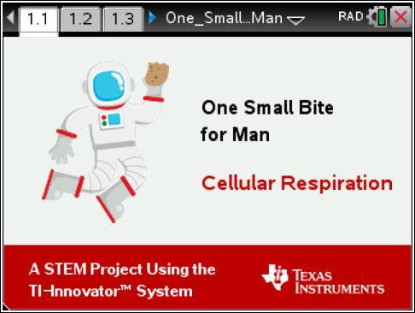
Move to pages 1.2 - 1.5 in TI-Nspire Document.
- Background: Read the background information on Pages 1.2 through 1.5.
You will design and build a model of an astronaut and use the model to explore the impact of daily activities and BMI on an astronaut’s daily food requirements. You will investigate how much food (measured in yams) an astronaut needs to consume in 24 hours to support daily activity.
- Identify: You have an engineering goal and a science research question.
- The engineering goal is to design and build a model for investigating and experimenting with the food needs of the astronaut.
- Your science research question is to find the relationships between Body Mass Index (BMI) and daily food requirements.
Identify two experimental questions you want to investigate and answer. Be sure to include the manipulated, measured, and constant variables in your questions.
A)

B)

Move to pages 2.1 - 2.9 in TI-Nspire Document.
- Research: Use appropriate internet resources and the simulation in Problem 2 to learn about animal cells and cellular respiration in preparation to solving your engineering problem.

- Sketch the animal cell and the major organelles. Write a brief description of the organelle(s) that are important to the process of cellular respiration.
Q1. Which organelle did you NOT see in the animal cell?
- Golgi apparatus
- Chloroplast
- Mitochondria
- Endoplasmic Reticulum
Q2. Which organelle in the animal cell is the power house (site of respiration)?
- Golgi apparatus
- Chloroplast
- Mitochondria
- Endoplasmic Reticulum
Q3. Cellular Respiration…
- produces energy.
- produces carbon dioxide.
- consumes oxygen.
- all of the above.
Q4. _______ uses the carbon dioxide and water produced by ________ to produce glucose and oxygen.  - Cellular Respiration, Photosynthesis  - Cellular Respiration, light energy  - Photosynthesis, Cellular Respiration  - None of the above | 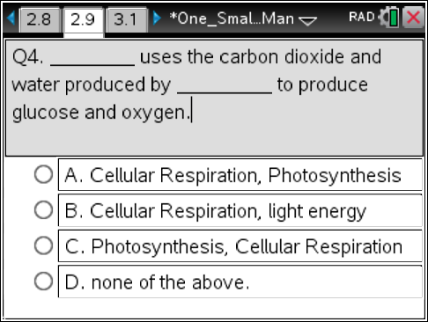
Move to pages 3.1 – 3.4 in TI-Nspire Document.
- Task 1: Design and Build a Model Astronaut
You will design and build a model astronaut to explore the food energy (calories) needs of an astronaut in outer space. Using “Test Mode”, see how the sensors work before designing and building your model.
Move to page 3.4 in TI-Nspire Document.  Connect input/output devices to the TI-Innovator™ Hub.  - Connect the LED to OUT1 on the TI-Innovator Hub. This will represent the astronaut’s thinking.  - Connect the vibration motor to OUT2 on the  TI-Innovator Hub. This will represent the astronaut’s BMI.  - Connect the servo motor to OUT3 on the  TI-Innovator Hub. This will represent the astronaut’s physical activity level.  - Connect the power supply to the TI-Innovator Hub where it says PWR.  - Connect your TI-Innovator™ Hub to the TI-Nspire CX. Insert the “B” connector on the unit-to-unit cable into the DATA port at the bottom of the TI-Innovator™ Hub. | 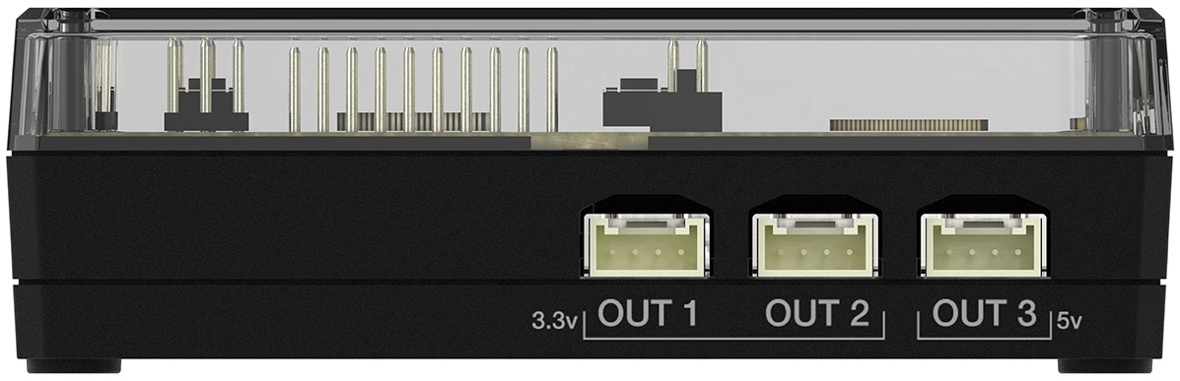  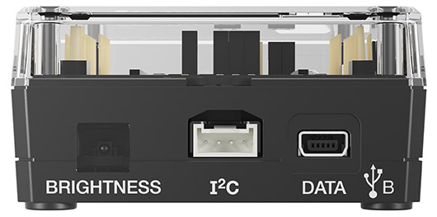  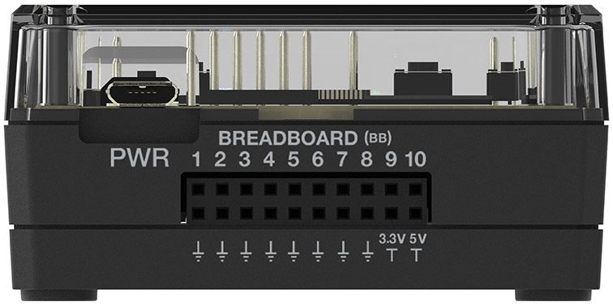
Note: You should see a green line at the top of
TI-Nspire CX screen to show you are connected.
Before designing your model, you should test each sensor using “Test Mode”. Go to menu> Test I/O Modules> Test Servo Motor  Consider the movements of each sensor, and how to best incorporate them into the design of your astronaut model.  Be sure to test all three sensors. If any of the sensors do not appear to be working properly, check with your teacher for help. | 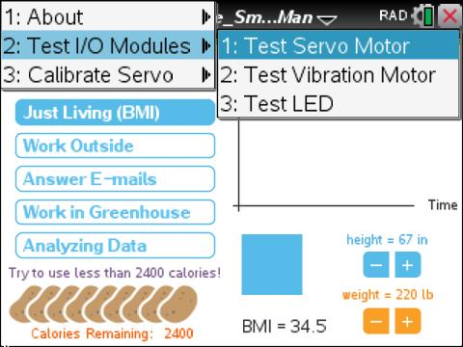
- Design/Prototype: Create a plan for the building of your model astronaut. Label your sketch below with the materials you will be using and where each sensor will go on your design.
- Build: Use your design sketch and the materials available to build your model astronaut. Remember, you will need to use the following input/output devices in your model:
- The servo motor represents the astronaut’s movements.
- The vibration motor represents the astronaut’s BMI (“Just Living”).
- The LED represents the astronaut’s thinking.
Make sure the placement of devices causes your astronaut to move. This will allow you to observe the differences between your trials, as you make changes in the simulation.
Safety: Be careful with any tools your teacher has provided.
Move to pages 3.5. – 3.7 in TI-Nspire Document.
- Task 2: Investigate relationships using your model.
Remember that the astronaut model uses energy produced from eating the allotted yams (calories). The goal is to have the “astronaut” use no more than 2400 calories (per day).
From a food production standpoint, 2400 calories breaks down to: 3 plants yielding 800 calories (of yams) per plant. Remember that food is not in large abundance on the ISS and must be planned carefully to make sure there is enough for the individuals on board.
Use your model astronaut to investigate how BMI and activity level affect how quickly food energy (calories) is consumed.
Setting up the experiment: Read the Task 2 on Page 3.5.
Connect your astronaut model to your TI-Nspire CX as you did during Test Mode. The steps are repeated here:
  - Connect the LED to OUT1 on the TI-Innovator™ Hub.
  - Connect the vibration motor to OUT2 on the TI-Innovator Hub.
  - Connect the servo motor to OUT3 on the TI-Innovator Hub.
  - Connect the power supply to the TI-Innovator Hub.
  - Connect the TI-Innovator Hub to the TI-Nspire CX.
Note: You should note a green line appears at the top of screen to show you are connected.
Now you will adjust the BMI and choose different combinations of astronaut activities, then run the simulation.
Observe how the BMI impacts food needs (calories).
- Read Page 3.5 in TI-Nspire Document. Record at least three different trials with different height, weight, and astronaut activities on Page 3.4. After each time trial, go to Page 3.7 to analyze the data. Add a moveable line (menu> Analyze> Moveable Line) and find the slope. Make sure at least one of your trials has the astronaut surviving.
- Trial 1: Height: ______ ; Weight ______ ; Slope ______ ;
◻Work Outside ◻Answer Emails ◻Work in Greenhouse ◻ Analyzing Data
Survive? ◻yes ◻no
- Trial 2: Height: ______ ; Weight ______ ; Slope ______ ;
◻Work Outside ◻Answer Emails ◻Work in Greenhouse ◻ Analyzing Data
Survive? ◻yes ◻no
- Trial 3: Height: ______ ; Weight ______ ; Slope ______ ;
◻Work Outside ◻Answer Emails ◻Work in Greenhouse ◻ Analyzing Data
Survive? ◻yes ◻no
Move to pages 4.1. – 4.5 in TI-Nspire Document.
Q5. Your Body Mass Index (BMI)  - Is calculated using the surface area of your body.  - Is calculated using the weight of your body.  - Is related to how many calories needed each day.  - All of the above. | 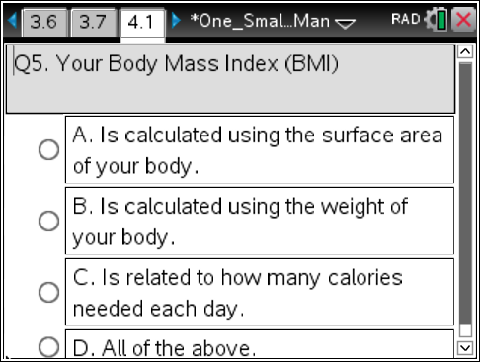
Q6. The number of calories (energy) a person uses is related to...  - their body type (BMI).  - the amount of activity they do.  - how much oxygen they breath in.  - All of the above. | 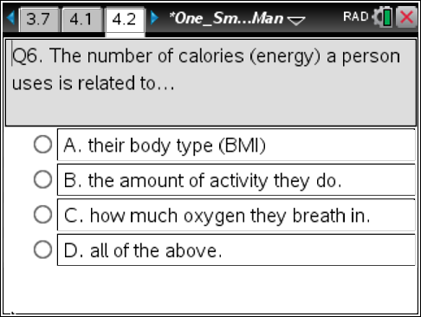
Q7. The slope of the energy (calories) vs. time graph represents the...  - the BMI of the astronaut.  - the activity of the astronaut.  - the rate the astronaut uses energy (calories).  - the number yams they eat. | 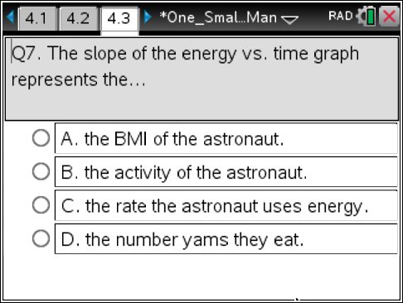
Q8. Cellular respiration consumes food (energy) and...  - uses oxygen and makes CO₂.  - uses CO₂ and makes oxygen.  - uses both CO₂ and Oxygen.  - Has no affect on either gas. | 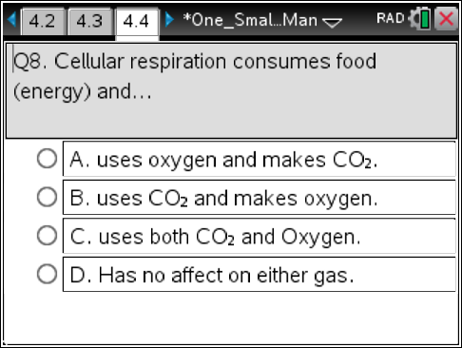
Q9. Calculate the number of plants needed to keep a crew of 6 alive for 90 days. Show work in calculator and write answer below. | 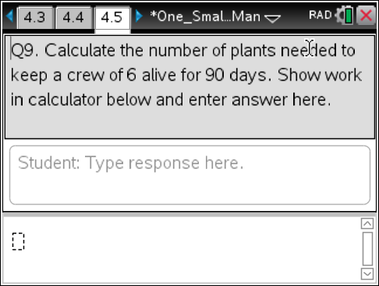
- Conclusion: Explain the relationships between Body Mass Index (BMI), activity level, and necessary daily food requirements. Based on your model and exploration, what recommendation might you make to an astronaut, in regard to their daily activity, to stay within the daily limits of the calories?

