Open the TI-Nspire document Sinusoidal_Modeling.tns.  The ‘average temperature’ for any given day in a weather forecast is obtained by consolidating (and averaging) data over a long period of time. In this activity, you will use average monthly temperature data over the course of a year to write an equation for predicting the temperature in future months. | 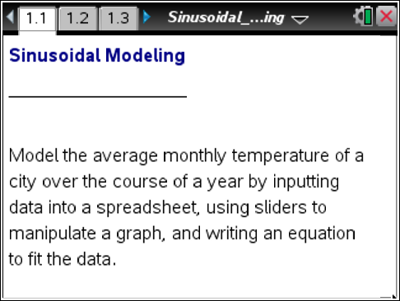

1. You will be modeling the average monthly temperature of a city over the course of a year. Your teacher will explain how you will obtain the data for this activity.
a. What city have you chosen?

b. For what year(s) was your data gathered?

Move to page 1.2.
2. Enter your data into the spreadsheet on this page, using t = 1 to represent the month of January.
a. What is the highest temperature in your list?

b. What is the lowest temperature in your list?

Move to page 1.3.
3. A scatter plot of your data will be generated automatically on Page 1.3. What type of function do you think could be used to model this data? Why does this make sense?

Move to page 1.4.
4. In addition to the scatter plot, the graph of the function has been added to this page. Answer the following questions, and then use the sliders to fit a curve to the data.
Tech Tip: With sliders, you can use e and the arrows to easily change the value. Also you can click on the value and type in the number.
Tech Tip: Tap on the arrows to change the values of the slider.
a. How high will your graph go? How low?

b. Assuming a > 0, do you expect there will be a negative sign proceeding a? Why or why not?

c. Starting with the graph of will you have to stretch or compress your curve to fit the data? If so, how many months are needed to complete one cosine curve?

d. Starting with the graph of will you have to move your function vertically? If so, what vertical shift is needed?

e. Starting with the graph of will you have to move your function horizontally? If so, what horizontal shift is needed?

f. Write the equation you have obtained to fit the data.

5. Utilizing your spreadsheet from Page 1.2 of your Sinusoidal_Modeling.tns document, or your scatter plot from Page 1.3, determine the following information:

Highest Temperature
Lowest Temperature
Midline
Amplitude
Period
Frequency
Horizontal Shift

6. Use the information from the table above to write an equation in the form to fit the data.
a. Write the equation that you obtained, and enter it onto Page 1.4 as f2(x).

b. How does this equation compare to the one you obtained in question #4?

7. What is the practical significance of these:
a. amplitude?

b. midline?

c. period?

d. horizontal shift?

8. Based on the equation that you wrote for question #6, during what month(s) would the average monthly temperature be 65°?

9. Based on the equation that you wrote for question #6, what would the average temperature be in February?

10. Is your answer to question #9 the same temperature as the value you entered into the spreadsheet? Why or why not?

11. Rewrite your equation for question #6 in terms of sine. What is the relationship between the two equations?

12. If your city was located in the northern hemisphere, but you looked up temperatures for a city in the southern hemisphere that had approximately the same temperatures as your city, how would that graph differ from your graph? How would that equation differ from your equation?

13. The function, can be used to model the average monthly temperatures in a city over the course of a year. Without using a calculator or a pen or pencil, determine the average maximum and minimum monthly temperatures in this city. Where would you expect this city to be located?

