Open the TI-Nspire document Falling_Objects_and_More.tns.  In this simulation, you will observe differences between two objects falling to Earth. You will change variables such as height, elasticity, and air pressure. Then, you will observe how these changes affect velocity and acceleration over time. |  |  | 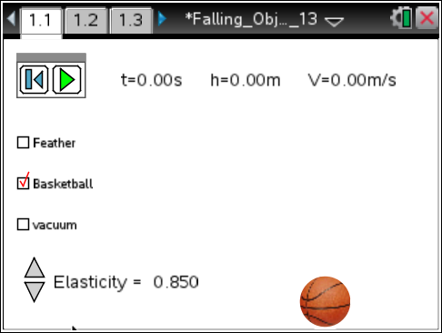
In this investigation you will drop a basketball and a feather from various heights and observe how they fall (position, velocity, and acceleration) under varying conditions (elasticity and air resistance). You will then analyze data displayed in a table and on various graphs in order to form conclusions about how objects fall to Earth.
Part 1: Exploring the Simulation and Identifying Variables
1. When you first open the Nspire document you will see a directions box explaining how to use the simulation. Read the directions and check with your classmates or your teacher on any items you don’t understand. |  |  | 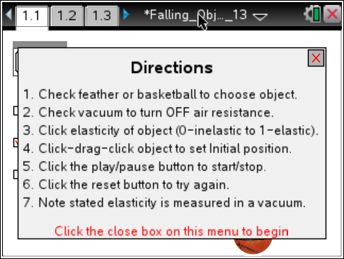
2. Close the pop-up directions box when you are finished.
 | Tech Tip: To access the Directions again, select 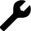> Falling Objects and More > Directions
 | Tech Tip: To access the Directions again, select b or Document Tools () > Falling Objects and More > Directions.
3. Note the default settings that appear on the screen when you press the reset button . Choose an object, air resistance, and elasticity value. Now press the play button to start the animation by dropping the object. You will need to press the pause button to stop the object.

Tech Tip: To position the object, hover the cursor over it and when you see the hand ÷, press click a. Click a again to release.
Q1. What are the default settings for this simulation?

4. Starting on page 1.1 explore the simulation. Start with the settings in the table given below. After you conduct each trial, record your observation, and move to pages 1.2 and 1.3 to see the data and the graph of the data.
For this first round of data collection, be sure to leave the “vacuum” box unchecked to create air resistance.
Object | Air Resistance | Elasticity | Observation
Basketball | Yes | 0.8
Basketball | Yes | 0.3
Feather | Yes | 0.0
Feather | Yes | 0.5

5. Now try several different settings of your own. Be sure to leave the “vacuum” box unchecked to create air resistance. (Part 2 will explore objects falling in a vacuum.)

Take note of what patterns you see to share with your teacher, team members, and the class.
Q2. Note three things that you learned about falling objects from your exploration. Share these with the class on a Notes page as instructed by your teacher.

6. Next, identify the variables in this simulation. Then, consider how each variable affects an object falling to Earth.

Q3. In the first column of the table on the next page, list the variables that affect an object falling to Earth. In the second column of the table, describe how each variable changes the fall of the object. In the last column, indicate whether or not the variable you identified can be controlled.

Variable | How does it change the falling object? | Can you control this variable?

Part 2: Exploring Falling Objects in a Vacuum
Now you can compare the patterns you have already observed with those for the same objects falling in a vacuum.
7. Go to back page 1.1. Select the basketball and check the vacuum box. Set the elasticity value to 0.80. Move the ball to a height of 2.00 meters and drop it. Pause the simulation just after it hits the ground. |  |  | 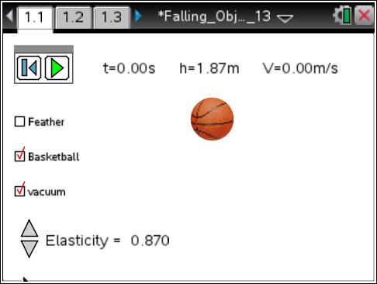
Move to page 1.2.  8. On page 1.2 you will find data in a spreadsheet for the object you just dropped. This spreadsheet contains the time, height, and velocity of the object as it falls and bounces.  Examine the data for this drop.  Remember: This data clears each time you reset the simulation. |  |  | 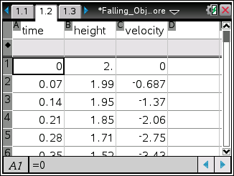
Q4. Answer the following questions:
a. Using the data shown on page 1.2, approximately how many seconds did it take for the ball to fall 2.00 meters?

b. What was the initial velocity of the object?

c. How fast was the ball traveling right before it hit the ground?

d. Explain why some of the velocity values are positive and others are negative.

Move to page 1.6.  9. Look at the plot of height vs. time on page 1.6. Look at any three drop points in a row on the graph. Note that the points become further apart as the object approaches the ground. |  |  | 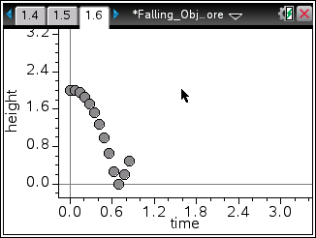
Q5. Fill in the table below using information from the spreadsheet on page 1.2. In the first column select three points during the fall but before the bounce. Record Time 1 and Height 1 from the row before your selected point. Record Time 2 and Height 2 from the row after your selected point. Next, complete the calculations and fill in the table below using time and height data.

Data Value Row # | Time 1 | Time 2 | Time 2 – Time 1 | Height 1 | Height 2 | Height 2 – Height 1

Since the time intervals are the same for the data displayed, it can be said that the object is falling a larger distance in the same time interval as it approaches the ground.
Move to page 1.7.  10. The change in distance divided by the change in time is called speed. Velocity is speed in a particular direction. On page 1.7, observe the graph of time vs. velocity.  Look at the plot and note the points that represent the time intervals you explored above. |  | 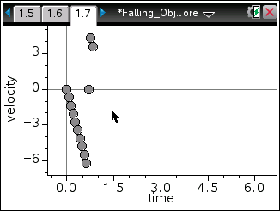
A velocity at any given instant is known as instantaneous velocity. The velocities given in the spreadsheet on page 1.2 are instantaneous velocities. Now you will find the average velocity for an interval and compare it to an instantaneous velocity in the middle of the interval.
11. Calculate the average velocity for the three intervals from the table in question 5 using the formula below and see if it is close to the velocity shown in the spreadsheet on page 1.2. Use the Scratchpad » or insert a Calculator page (/ I).  In the example shown to the right, the data value in the 9th row is selected. The data values in the 8th and 10th rows are used to determine the average velocity. On the handheld, the calculation uses the cell reference from the spreadsheet. Height [8] is the value in the height column, 8th row. |  | 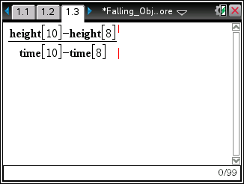
Q6. Fill in the table with the average velocity you calculated and the velocity on page 1.2 for each data value selected in question 5.

Data Value Row # | Average Velocity Calculated | Velocity of Data Value

Q7. How does the velocity you calculated compare to the velocity reported in the spreadsheet?

Q8. Notice that the distance between the points on the velocity vs. time plot on page 1.7 is constant, but this is not the case for the height vs. time plot on page 1.6. What do you think this means?

Q9. Calculate the change in velocity over time using the formula to the right. Get an assigned time interval from your teacher. Fill in the table below.
Time 2 = | Velocity 2 =
Time 1 = | Velocity 1 =
Calculated change in velocity =

A change in velocity over time is acceleration. On Earth the acceleration due to gravity is 9.81 m/s/s. Since the acceleration of a falling object is downward toward the Earth, it has a negative value.

Move to page 1.8.
Q10. Look at the graph of acceleration vs. time. How would you describe this graph?

Move back to page 1.1.
You will now explore a falling feather. Reset the simulation, and then check the box for “feather” and for “vacuum.” See if you can determine the differences between the falling feather and the falling basketball in a vacuum. Answer the following questions based on your exploration.

Q11. a. How much longer than the basketball did the feather take to fall to the ground?

b. How much slower than the basketball was the feather moving right before it hits the ground?

c. How much slower than the basketball was the acceleration of the feather?

Part 3: Falling Objects in Air
Now see how falling objects behave when they are not in a vacuum. Objects not in a vacuum are subject to air resistance. You should have observed that objects like a basketball and a feather are different, yet in a vacuum they have the same acceleration due to gravity. In this section, you will observe the same falling objects with air resistance.
12. Your teacher will assign you both an object to drop and an initial position. This drop will NOT be in a vacuum. Record your assigned values below. Recall that you need to pause the simulation just after the object hits the ground. If you start again, be sure to reset the simulation.

Your assigned object: ______________________

Your assigned height: ______________________
Q12. How long did it take your object to fall to the ground? Compare this with others in the class having similar heights.

13. Look at the spreadsheet and the plot of height vs. time on page 1.6, and compare it to the plot for the objects dropped in a vacuum. Share your results with the class.

14. Now look at the velocity vs. time plot on page 1.7. Make an observation about the plot. Share your results with the class.

Q13. Terminal velocity is the constant speed that a falling object reaches. When air resistance is a factor, objects may reach different terminal velocities, and therefore, fall to the ground at different times.

- Determine the terminal velocity for a feather.

- What is the acceleration of the feather when it reaches its terminal velocity?

- Why?

