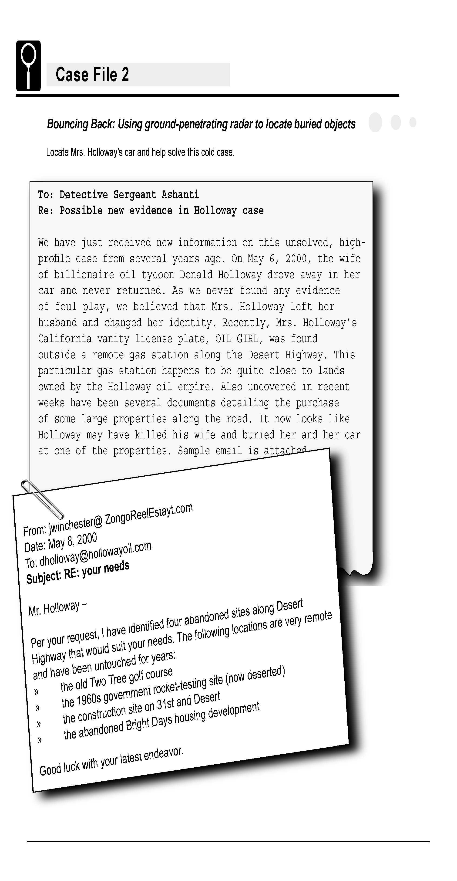

Science Objectives
- Explore the use of ground-penetrating radar (GPR) to find buried materials.
- Detect the presence of an object using a motion detector.
- Distinguish between different-shaped objects using a motion detector.

Activity Materials
- TI-NspireTM Technology  - Case_2_Bouncing_Back.tns file  - CBR 2™  - meter stick | - several large boxes (each containing an unknown object)  - small box or block of wood
Procedure
Open the TI-Nspire document Case_2_Bouncing_Back.tns.

In this activity, you will be using the motion sensor as a sonar detector, through air to locate and identify a missing object in a box.
Part 1 – Preparing for Data Collection
Move to pages 1.2–1.3.
1. Read the directions on these pages to become familiar with how to collect the data.

Move to page 1.4.
2. Prepare the Motion Detector for data collection.
- If your Motion Detector has a switch, set it to Normal.
- If you are using a TI-Nspire handheld, make sure the lab cradle is connected to the handheld. Connect the Motion Detector to DIG 1 of the lab cradle. or use the CBL-2.
3. Get to know how a Motion Detector displays data.
- Place a block of wood or a small box on your desk. Make sure that there is nothing else on the surface of your desk.
- Hold the Motion Detector about a meter above your desktop and toward one end of your desk. Make sure that the round screen on the detector is facing the desktop.
- With the Motion Detector in place, press b and choose Experiment >Set Up Sensors > Zero.

- Start data collection by clicking .  - When data collection begins, slowly move the Motion Detector, at a constant height above the desktop, from one end of your desk to the other end.  - When data collection is complete, the displayed graph should look similar to the graph to the right. |  | 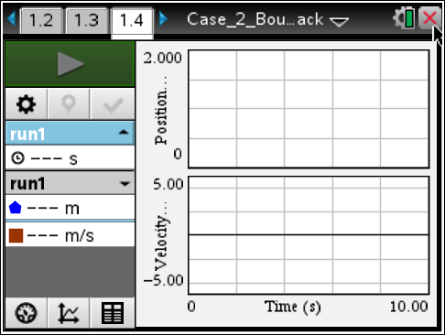
Part 2 – Collecting and Analyzing the Data
Your teacher will direct your group to move to one of the suspected “burial sites” for the car. Record the location of the site in the Evidence Record.

Move to pages 2.1–2.2.
4. Without looking inside the box, explore each of the suspected burial sites.
- Set a meter stick across the opening of the box.
- Rest the Motion Detector on the meter stick starting at one end of the box, with the round screen on the detector facing the bottom of the box.
- With the Motion Detector in place, zero it again as you did in Step 3c.
- You need to move the Motion Detector at a speed that will let you move from one end of the box to the other in about 10 seconds. Practice slowly moving the Motion Detector along the meter stick at the correct constant speed.
- When you are ready, start data collection by clicking . Begin moving the detector just after data collection begins.
- Examine the shape of the displayed graph. Repeat Step 4e to see if you get a similar shape again. If not, continue repeating until you get a consistent shape. If you are having trouble, ask for assistance.
- Make a sketch of the displayed graph in the Evidence Record. Store this picture by clicking . Notice the color change, and that run 1 changed to run 2.
- Reposition the meter stick and repeat Steps 4 a – g.
- Repeat several times to create different “slices” of the picture.

Evidence Record

Site Probed by Detector | Sketch of Shape Found by Detector

Case Analysis
Move to pages 3.1 – 3.8.
Answer the following questions here, in the .tns file, or both.
1. Analyze your sketches. Which site contains the buried car? Explain your reasoning.

2. Using the figures shown below, determine the height of the object. The cursor location is indicated by an arrow. The time and position values are shown for each cursor location.
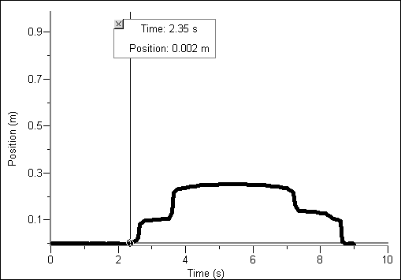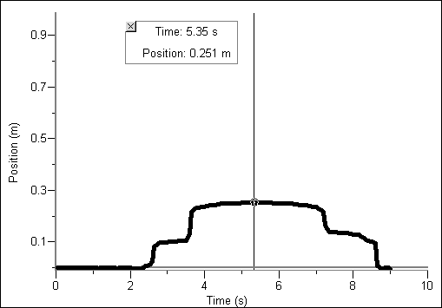

3. Why is it important to move the Motion Detector slowly but at a constant speed? What would happen if you did not move the Motion Detector at a constant speed?

4. What can make the Motion Detector image (or a real GPR image) of an object look different from the actual profile of the object?

5. How could someone get a more complete image of the object if he or she used real GPR?

