Problem 1 – Law of Sines
Open the Cabri Jr. application by pressing  and selecting CabriJr. Open the file LAW1 by pressing □, selecting Open…, and selecting the file. You are given ABC with the measure of all angles and sides calculated.
1. Grab and drag point B (use the  button to grab the point), and record the values of a, b, c, ∠A, ∠B, and ∠C. Repeat this three more times.
Position | a | b | c | A | B | C
1
2
3
4

2. On the calculator home screen calculate sin(A), sin(B), and sin(C). Then, calculate the following ratios: , , and .
Position | sin(A) | sin(B) | sin(C)
1
2
3
4

3. What do you notice about the last three columns of the table in Question 2?

4. Make a conjecture relating , , and .

Problem 2 – Application of the Law of Sines
5. State the Law of Sines.

6. The distance between two fire towers is 5 miles. The observer in tower A spots a fire 52° SE and the observer in tower B spots the same fire 29° SW. Find the distance of the fire from each tower.
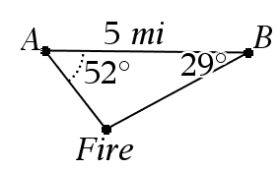

7. A tree leans 20° from vertical and at a point 50 ft. from the tree the angle of elevation to the top of the tree it 29°. Find the height, h, of the tree.

8. A boat is spotted by lighthouse A at 25° NE and spotted by lighthouse B at 50° NW. The lighthouses are 10 miles apart. What is the distance from the boat to each lighthouse?

Extension – Proof of the Law of Sines
We will now prove the Law of Sines. We will prove that . You can use similar methods to show that and . You are given ABC, altitude BD, and sides a and c.
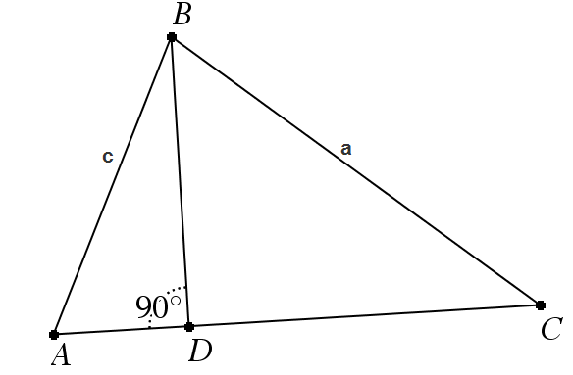
9. Using right triangular trigonometry, what is the sine ratio for ∠A?

10. Using right triangular trigonometry, what is the sine ratio for ∠C?

11. What side is common to the sine of A and the sine of C? Solve for this common side in the ratio for sine of A and sine of C.

12. Since the side from Exercise 13 is common to both equations we can set them equal to each other. Set your two equations equal and try to show that .

