Open the TI-Nspire document Writing_Chemical_Formulas.tns.  In this activity you will practice writing chemical formulas for ionic binary compounds. | 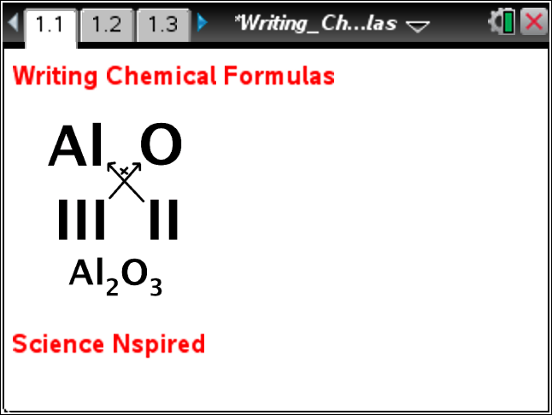
Move to page 1.2.

1. Review the directions for this part of the activity. You can close the directions box by selecting . In this part of the activity you will write a chemical formula for a given cation and anion pair.  Answer questions 1 – 4 here on the activity sheet. | 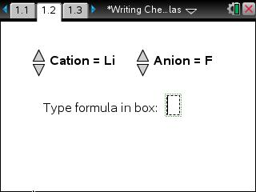
Tech Tip: To access the Directions again, select b or Document Tools () > Writing Chemical Formulas > Directions.
Tech Tip: To access the Directions again, select > Directions.
Q1. Using the Periodic table, determine the valence of Li and F and record it in the table on the next page in the corresponding boxes. Explain your answer.

Q2. What are ionic charges of the given cation and anion, Li and F? Why?

Q3. What is the simplest ratio of positive and negative ions that is needed to produce a neutral compound?

Q4. Determine the chemical formula for the Li and F compound. Check your answer by typing the formula in the ChemBox on page 1.2. Then write correct formula in the corresponding box in the table below.
 | Anions - | F | Cl | Br | O | S | N | P
Cations +
Li
Na
K
Mg
Ca
Sr
Al

2. Click the up or down arrows to select different cation and anion combinations.

Answer questions 5 – 7 here on the activity sheet.
Q5. Determine the valence of the cation and anion and record them in the table above in the corresponding boxes. Explain your answers.

Q6. Determine the chemical formula for each cation and anion combination. Check your answer by typing the formula in the ChemBox on page 1.2. Then write correct formula in the corresponding box in the table above.

Q7. Explain how to choose the subscripts in a chemical formula of an ionic compound given the valences of the anion and cation.

Move to page 1.3.  3. Review the directions for this part of the activity. You can close the directions box by selecting . In this part of the activity, you will determine the charge of the transition metal in the given compound.  Answer questions 8 – 12 here on the activity sheet. | 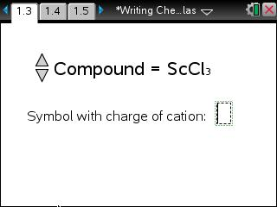
Q8. Given the correct chemical formula for a compound containing transition metal, how can you determine the charge of the metal cation?

Q9. What is the ionic charge of the anion in the given compound ScCl₃? Explain your answer.

Q10. What is the ionic charge of the cation in the given compound ScCl₃? Explain your answer

4. In order to check your answer, type it in the ChemBox on page 1.3. Make sure to use l to insert superscript for the charge.

5. Click the up or down arrows to select all available compounds.

Q11. For each given compound, complete the table below and determine the ionic charge of the metal in the compound. Check your answer by typing the ion formula in the ChemBox on page 1.3.

Compound | Anion |  |  | Cation
Compound | Ionic Charge | Number of Elements | Total Charge | Total Charge | Number of Elements | Ionic Charge | Formula
ScCl₃
CoF₂
VCl₄
CrBr₃
MnCl₂
FeCl₂
Cu₂O
ZnF₂
FeCl₃
MnCl₄
MnBr₄
CrP₂
MnS₅
Mn₂O₇
CuCl₂

Q12. Explain why you could not use periodic table to determine ionic charge of the metal in these compounds.

Move to page 1.4.  6. Review the directions for this part of the activity. In this part of the activity you will write the chemical formula given the name of a compound.  Q13. Determine the chemical formula for each compound given in the table below. Record your formula in the table. Check your work by typing the formula in the ChemBox. | 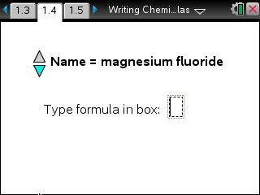
Magnesium fluoride | Barium nitride | Sodium bromide | Lithium chloride
Calcium iodide | Aluminum iodide | Calcium oxide | Magnesium sulfide
Lithium oxide | Cesium nitride | Aluminum oxide | Lithium nitride
Calcium nitride | Aluminum chloride | Calcium phosphide | Iron (II) chloride
Zinc (II) oxide | Magnesium bromide | Tin (II) sulfide | Tin (IV) bromide
Copper (I) oxide | Silver (I) bromide | Iron (III) sulfide | Nickel (III) sulfide
Manganese (II) bromide | Sodium nitride | Mercury (II) oxide | Mercury (I) oxide
Tin (IV) oxide | Potassium iodide | Potassium nitride | Barium sulfide
Nickel (II) oxide | Aluminum nitride | Lead (II) sulfide | Lead (IV) sulfide
Cadmium sulfide | Tin (II) nitride | Strontium sulfide | Cobalt (III) oxide
Barium hydride | Iron (II) iodide | Silver (I) chloride

Move to page 1.5.
7. Review the directions for this part of the activity. You can close the directions box by selecting . In this part of the activity you will name the given ionic binary compounds.

Answer questions 14 – 16 here on the activity sheet.
Tech Tip: The names of compounds should be entered in small case letters with a single space between each word. For transition metals use Roman numerals in parentheses to indicate the charge.
Q14. How many elements are in binary ionic compounds? What are they?

Q15. For each given formula, record the names of the metal element, non-metal element, and the chemical name of the compound. Check your answer by typing the name of the compound at the cursor next to “Type name:” Then complete the table on the following pages.
Chemical Formula | Cation | Anion | Chemical Name
MgF₂
Ba₃N₂
NaBr
LiCl
CaI₂
AlI₃
CaO
MgS
Li₂O
Cs₃N₂
Al₂O₃
Li₃N
Ca₃N₂
Ca₃P₂
FeCl₂
ZnO
MgBr

Chemical Formula | Cation | Anion | Chemical Name
SnS
SnBr₄
Cu₂O
AgBr
Fe₂S₃
Ni₂S₃
MnBr₂
Na₃N
HgO
Hg₂O
SnO₂
KI
K₃N
BaS
NiO
MgS
AlN
PbS
PbS₂
CdS
Sn₃N₂
Sr₂S
Co₂O₃
BaH₂
FeI₂
AgCl

Q16. What is the general rule for naming binary chemical compounds?

