Open the TI-Nspire document CLT_and_Related_Properties.tns.  In this lesson, you will examine the shapes of sampling distributions (the distributions of sample means of random samples of size n from four different populations) as sample sizes increase. | 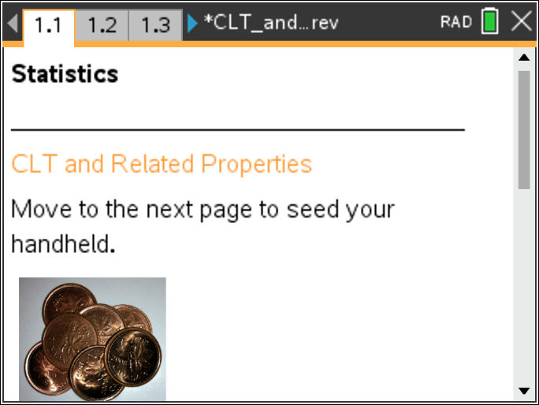

Move to pages 1.2 and 1.3. | Press / ¢ and / ¡ to navigate through the lesson.
This activity involves generating a number of random samples from a population. In order to avoid having your results be identical to those for another student in the room, it is necessary to “seed” the random number generator. Read the instructions on page 1.2 for seeding your random number generator, then carry them out on page 1.3.

Move to page 2.1.

1. a. The graph on the top of Page 2.1 represents a population that is uniformly distributed—digits from zero to nine. Describe the shape of the population distribution.

b. The lower half of the screen shows 200 random samples of size n = 1 from the population. Is this simulated sampling distribution similar to the population distribution? Explain.

c. Click on the right arrow to generate the means of 200 random samples of size n = 2 from the population. Describe how the shape and spread of the simulated sampling distribution changed and how it compares to the normal curve displayed with the simulated distribution.

d. Click on the right arrow to generate the means of 200 random samples of size n = 5 from the population. Describe how the shape and spread of the simulated sampling distribution changed.

2. a. Continue to click on the right arrow to generate 200 random samples of size n = 10, 15, 20, and 30 from the population. Describe how the shape and spread of the simulated sampling distributions changed as the size of the samples increased.
Note: Clicking on the left arrow will generate a new random sample of the next smaller size. You might want to click back and forth between sample sizes to better see the pattern.

b. How does the simulated sampling distribution of sample means with samples of size 30 compare to the population distribution?

Move to page 3.1.

3. a. The histogram on Page 3.1 represents the heights of young men. Their heights are normally distributed with a mean of 70 inches and a standard deviation of 2.5 inches. Describe the shape, center, and spread of the histogram of heights.

b. The lower half of the screen shows 200 random samples of size n = 1 from the population. How does the simulated sampling distribution compare to the population distribution? Explain.

c. Click on the right arrow to generate 200 random samples of size 2 and size 5 from the population of heights. Describe how the shape and the spread of the simulated sampling distributions change with these two sample sizes and how they compare to the normal curve displayed with the simulated distribution.

4. a. Click on the right arrow to generate 200 random samples of increasing size (from 10 to 30) from the population of heights. Describe how the shape and the spread of the simulated sampling distributions change with increasing sample size and how they compare to the normal curve displayed with the simulated distribution.

b How does the simulated sampling distribution of sample mean heights with samples of size 30 compare to the population distribution of heights?

Move to page 4.1.

5. a. The histogram on Page 4.1 represents the ages of pennies collected by an AP Statistics teacher. Describe the shape, center, and spread of the histogram of penny ages.

b. The lower half of the screen shows 200 random samples of size n = 1 from the population. How does this simulated sampling distribution compare to the population distribution? Explain.

c. Click on the right arrow to generate 200 random samples of sizes 2 and 5 from the population of penny ages. Describe how the shape and the spread of the simulated sampling distributions change with increasing sample size.

6. a. Click on the right arrow to generate 200 random samples of increasing size (from 10 to 30) from the population of penny ages. Describe how the shape, the center, and the spread of the simulated sampling distributions change with increasing sample size and how they compare to the normal curve displayed with the simulated distribution.

Tip: The handheld (or software) is drawing 200 random samples from a population of over 6000, which takes some time. It might seem like the handheld is frozen
b. How does the shape of the simulated sampling distribution of sample mean penny heights with samples of size 30 compare to the population distribution of penny ages?

c. How do the center and spread of the simulated sampling distribution of sample mean penny ages with samples of size 30 compare to the population distribution of penny ages?

7. a. Imagine that you roll a die once and calculate the proportion of times a 2 landed face up. What are the possible proportions you can get?

b. In six rolls, about how often would you get a proportion of 0? of 1? What would the distribution of the proportions look like?

Move to page 5.1.

c. The histogram on the top of Page 5.1 represents the proportion of dice rolls that are a 2 on a fair die. Describe the shape of the histogram of proportions. Does this match what you predicted in part b?

d. Click on the bar at 1. Explain what the percentage means in context. Does this match what you predicted in question 7b?

Tip: Be careful not to drag the bar as you click on it
e. The lower screen on Page 5.1 shows 200 random samples of size n = 1 from the population. How does this simulated sampling distribution compare to the population distribution? Explain.

f. Click on the right arrow to generate 200 random samples of increasing size (size 2 and size 5) from the population of dice rolls. Describe how the shape and the spread of the simulated sampling distributions of sample proportions change with increasing sample size.

g. For your samples of size 5, what does the bar over 0.2 represent?

8. a. Click on the right arrow to generate 200 random samples of increasing size (from 10 to 60) from the population of dice rolls. Describe how the shape, the center, and the spread of the simulated sampling distributions of sample proportions change with increasing sample size.

b. How does the shape of the simulated sampling distribution of sample proportions with samples of size 60 compare to the population distribution of proportions?

c. How do the center and spread of the sampling distribution of sample proportions with samples of size 60 compare to the population distribution of proportions?

9. Describe what happens to the shape of the sampling distribution when you take large samples from a population (the Central Limit Theorem).

