Open the TI-Nspire document Distributive_Property.tns.  Distribution of multiplication over addition maintains equality of expressions. In this activity, you will explore the property of distribution. | 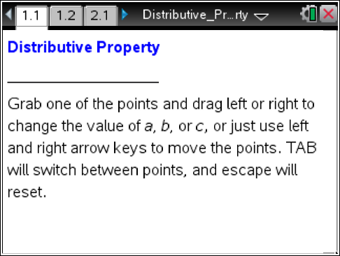

Move to page 1.2.
1. As you grab a point to move an arrow beneath the number line, what do you observe about the value of the expressions as you change the value of a? b? c?

2. Place b and c so that their sum is a positive number. For positive values of a, what is the sign of the answer? Why?

3. Place b and c so that their sum is a negative number. For positive values of a, what is the sign of the answer? Why?

4. Describe the first step used to evaluate each expression.

5. Compare the two expressions. How are they similar? How are they different?

- Do you think these expressions will always have the same value? Why or why not?

Move to page 2.1.

7. Drag the points to change the values of a and c. Notice that the expression on the left is still equal to the expression on the right. The answer is a simplified expression instead of a value. Write an equivalent expression for each expression below.

a.

b.

c.

d.

e.

f.

g.

8. The Distributive Property states are equivalent for all real numbers a, b, and c because they are equal for all possible values of the variables. Use the Distributive Property to write an equivalent expression for each expression below.

