Open the TI-Nspire™ document Reflections_and_Rotations.tns.  In this activity, you will reflect and rotate two-dimensional figures about different parts of a coordinate plane. You will explore the images of these transformations and determine a set of rules that maps the pre-image coordinates to the image coordinates for different types of transformations. | 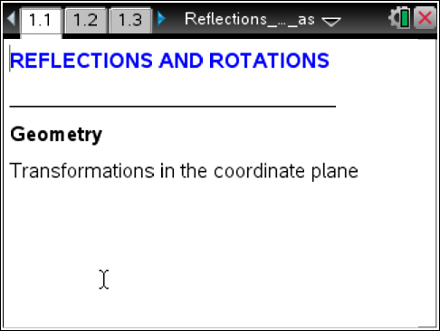

Problem 1 – Reflections
To reflect a figure, use the Reflection tool from the Transformation menu. First select the figure to reflect and then select the line over which you will reflect the figure. Record the coordinates in the blanks below. Sketch the shapes and their image. Label the points.
Tech Tip: To determine the coordinates of the points in each figure, select MENU or  > Actions > Coordinates and Equations. Then, select each point to view the coordinates. Select a location near each point to place the coordinate labels.

ABC (page 1.2) |  |  | 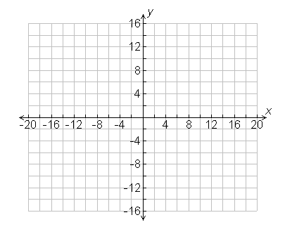
Pre-image: | Reflection over the x-axis:
A _______  B _______  C _______ | A′ _______  B′ _______  C′ _______
DEF(page 1.3)
Pre-image: |  | Reflection over the y-axis:
D _______  E _______  F _______ |  | D′ _______  E′ _______  F′ _______
1. What is the relationship between the x-coordinates of the pre-image and image when you reflect the figure over the x-axis?

2. What is the relationship between the y-coordinates of the pre-image and image when you reflect the figure over the x-axis?

3. What is the relationship between the x-coordinates of the pre-image and image when you reflect the figure over the y-axis?

4. What is the relationship between the y-coordinates of the pre-image and image when you reflect the figure over the y-axis?

Summarize:
Reflecting a point (x, y) over the x-axis: (x, y) → _________
Reflecting a point (x, y) over the y-axis: (x, y) → _________

Problem 2 – Rotations
To rotate a figure, first select the center of rotation. Then select
the figure to be rotated. Last, identify the angle of rotation.
Quadrilateral ABCD(page 2.1) |  | 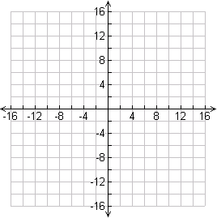
Pre-image: | Rotation 90° counterclockwise about the origin:
A _______  B _______  C _______  D _______ | A′ _______  B′ _______  C′ _______  D′ _______
Quadrilateral EFGH (page 2.2)
Pre-image: | Rotation 180° counterclockwise about the origin:
E _______  F _______  G _______  H _______ | E′ _______  F′ _______  G′ _______  H′ _______

Quadrilateral JKLM(page 2.3)
Pre-image: | Rotation 270° counterclockwise about the origin:
J _______  K _______  L _______  M _______ | J′ _______  K′ _______  L′ _______  M′ _______
For each rotation, consider the relationships between the x-coordinates of the pre-image and image figures as well as the y-coordinates of the pre-image and image figures just as you did in Problem 1. Summarize:
Rotating a point (x, y) 90° counterclockwise about the origin: (x, y) → _________
Rotating a point (x, y) 180° counterclockwise about the origin: (x, y) → _________
Rotating a point (x, y) 270° counterclockwise about the origin: (x, y) → _________

Problem 3 – More Reflections and Rotations
Use the diagrams on pages 3.1 through 3.3 to explore even more reflections and rotations. On 3.1 you can grab and move the line y = x to explore reflections around lines other than the x- and y-axes. On page 3.3, you can move point P to explore rotations about other points.

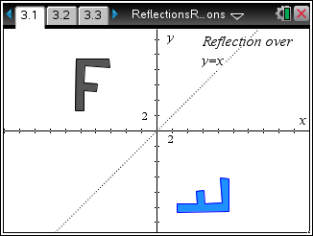 |  | 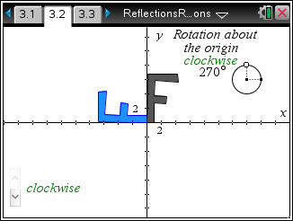 |  | 