Open the TI-Nspire document Factoring_Trinomials_1.  The trinomial x² + 3x + 2 is the product of (x + 1) and (x + 2).These expressions are called the factors of the trinomial. In this activity, you will use an area model to factor trinomials such as x² + 3x + 2. | 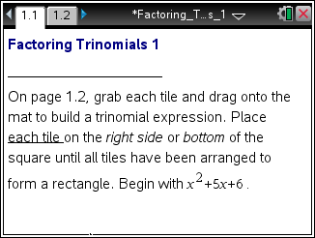

Move to page 1.2. | Press / ¢ and / ¡ to navigate through the lesson.
Follow the onscreen instructions to construct trinomial x² + 5 ∙ x + 6.

1. Arrange all the tiles to form a rectangle with the area x² + 5x + 6. What are the dimensions of the rectangle?

2. a. Multiply the dimensions you found for the rectangle to prove that x² + 5x + 6 is the area of the rectangle.

b. How do the dimensions of the rectangle relate to the numbers 5 and 6?

Click the Reset box in the lower left portion of the screen.

Construct the trinomial x² + 7 ∙ x + 6.

3. a. Arrange all the tiles to form a rectangle with area x² + 7x + 6. What are the dimensions of the rectangle?

b. How do the dimensions of the rectangle relate to the numbers 7 and 6?

4. For each of the following, move the correct tiles to the mat. Factor each trinomial by arranging all the tiles to make a rectangle. Verify that your answer for each one is correct by finding the product.
a. x² + 5x + 4

b. x² + 4x + 4

5. The trinomial x² + 6x + 4 cannot be factored.
a. How does the TI-Nspire document illustrate that it cannot be factored?

b. How can the constant term be changed so that the trinomial can be factored?

c. State your new trinomial, and show its factors.

6. a. Find the factors of each of the following trinomials.

Trinomial | Factored Form
x² + 4x + 3
x² + 8x + 15
x² + 9x + 20
x² + 12 x + 20
b. Explain how you know you have factored each trinomial correctly.

7. Suppose x² + bx + c = (x + m)(x + n). How are m and n related to b? How are m and n related to c?

