Open the TI-Nspire document Hare_Today_Gone_Tomorrow.tns.  In this activity, you will determine how to graph the relationship between populations of lynx and snowshoe hare, and then analyze the data about the populations. | 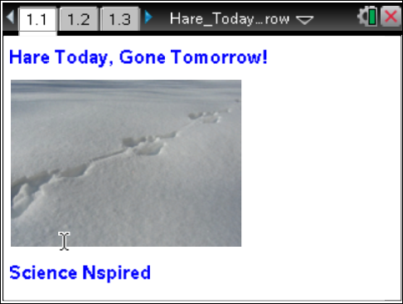

Pre-lab Information
All ecosystems have predator/prey relationships at work in them. The predator and the prey depend on each other to keep their populations healthy and their gene pools strong. Predators and prey depend on each other so much that the population numbers of one directly affect the numbers of the other, and this results in what are called wildlife population cycles.

The lynx-snowshoe hare relationship is one that has been well documented. The lynx is a large cat that can be found mainly in Alaska and Canada. It can grow to be about a meter in length, with an adult mass of 10–15 kg. Usually living 10–15 years, lynx are solitary animals that stalk and ambush their favorite prey, the snowshoe hare. Female lynx give birth to 2–3 kittens in the spring of the year, and the kittens remain with their mother for several months. The Snowshoe hare are very closely related to rabbits, and grow to be about half a meter in length and have a mass of 1–2 kg during their 2–4 year lifespan. They get their name from their huge hind feet, which can be up to 15 cm long. During the course of the year, the snowshoe hare gradually change color from a summer brown to a winter white. Females have 2–3 litters each year, each litter consisting of 3–4 young.

For decades, the population cycling of the lynx and the snowshoe hare has been well documented. As long ago as the early 1800s, fur traders kept track of the populations of these two animals, and as the years passed, they started to notice a trend in the population of each. The snowshoe hare populations go through dramatic peaks and crashes, with one such cycle usually lasting 7–10 years. When the hare population is at its peak, the lynx population is on the rise, too, but the peaks and crashes in the lynx population lag behind those of the hare by a couple of years. As the lynx numbers drop, the hare numbers rebound—and on and on. If these population cycles are graphed, you can see the graph of the predator population chasing the graph of the prey population, but always staying a couple of years behind.

Move to page 1.3.  1. Review the data on the graph. The populations of lynx and snowshoe hare are given for a period of 20 years.  Move to page 1.4.  2. View the spreadsheet data to observe how the population numbers fluctuate over this time period. | 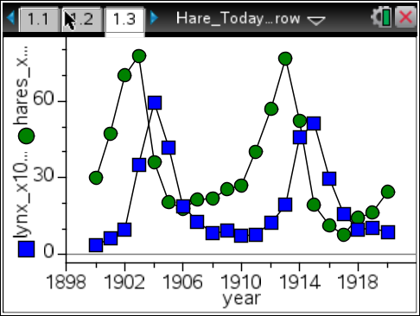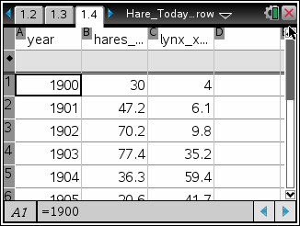
Move to pages 2.1–2.3.
3. Equations can be used to model the populations of the lynx and the snowshoe hare. On the next two pages, you will play with an iterative model for lynx and hare populations from 1990 on. The model uses two formulas:
hare: b2=b1+0.1*(a*b1+b*b1*c1)
lynx: c2=c1+0.1*(c*c1+d*b1*c1)
In the spreadsheet, Menu > Data > Fill was used to copy the formulas down the columns. The values of cells b1 and c1 were set to the starting populations (the variables h0 and lx0). Then b2 and c2 were calculated from the values of cells b1 and c1, and so on. On pages 2.2 or 2.3, use the left and right arrows to experiment with changing the values of h0, lx0, a, b, c, and d.
Move to page 2.3.
4. Review the graph produced by the spreadsheet. Decide how you might improve the model by adjusting the variables or formulas. See if you can make a graph that shows fluctuating populations!
Use your model results to help answer the following questions.
Q1. How did you determine how to produce a fluctuating graph? Describe the method used. Sketch the best graph of the lynx and hare population cycling that you were able to produce.

Q2. As the hare population increases, why does the lynx population increase?

Q3. Hares are herbivores (plant eaters) and tend to stay in the same general location throughout their lives. At the peak of their population cycle, hares can reach a population density of up to 1500 per square kilometer. Besides predation, describe another factor that might affect the hare population.

Q4. How does your answer to Question 2 affect the lynx population?

Q5. In the arctic, there is a chicken-sized bird called a ptarmigan (pronounced TAR-muh-gun) that is also a food source for the lynx. Describe how the fluctuations in the snowshoe hare population numbers might affect the population of ptarmigan.

Q6. Why do the crashes in lynx numbers lag behind the crashes in hare numbers?

Q7. When female lynx are in poor condition, fewer will breed, and those that do, breed may not even have any kittens. Why might this occur? How would this affect the lynx population? How would this affect the hare population? When might the females start producing kittens again?

Q8. Choose ecosystems from two other biomes and describe a predator/prey interaction that might occur there.

