Open the TI-Nspire document Its_Just_a_Lunar_Phase.tns.

Astronomical observations and measurements have played a big part in the development of both science and mathematics. In this activity, you will examine images of the Moon to estimate, graph, and analyze its illumination. You will then use an animation of the Moon’s orbit to investigate the cause of lunar phases.

Move to page 1.2.

1. Read the background on page 1.2. Then examine the images on the handout titled “The Lunar Cycle.” For each day, estimate and record the percentage of the Moon that is illuminated, or visible, then write your percentages as decimals filling in the missing data as shown in the following table.

Day | Illumination |  | Day | Illumination |  | Day | Illumination |  | Day | Illumination
1 | 1% | 0.01 | 8 |  |  | 15 |  |  | 22 | 39% | 0.39
2 |  |  | 9 | 72% | 0.72 | 16 | 95% | 0.95 | 23
3 |  |  | 10 |  |  | 17 |  |  | 24 | 24% | 0.24
4 | 19% | 0.19 | 11 | 89% | 0.89 | 18 | 82% | 0.82 | 25
5 |  |  | 12 |  |  | 19 |  |  | 26
6 | 39% | 0.39 | 13 | 98% | 0.98 | 20 | 62% | 0.62 | 27 | 5% | 0.05
7 |  |  | 14 |  |  | 21 |  |  | 28
Move to page 1.3.

2. Enter your illumination data (% value) into the spreadsheet. | 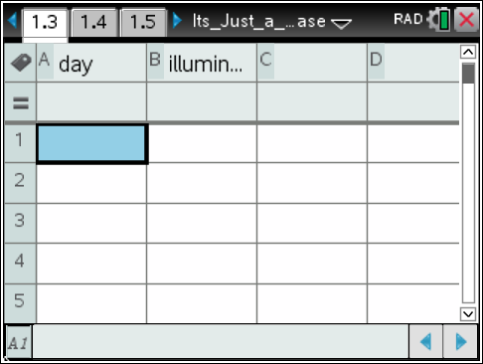
Q1. What general patterns do you see in the table or spreadsheet?

Move to page 1.4.
3. The data in your spreadsheet is plotted on the graph. The day is the independent variable, or a variable that isn’t changed by another, and illumination is the dependent variable, a variable that does change based on another. | 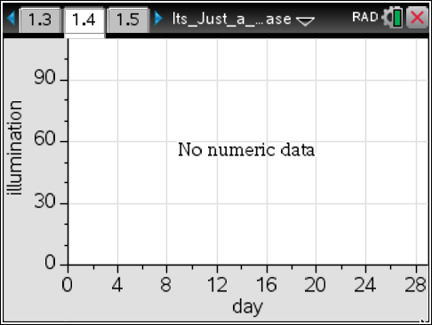
Q2 How does the graph change your ability to spot a pattern?

Move to page 1.5.
Tech Tip: Selecting the button will reset the simulation and clear the data,
4. Page 1.5 shows the illuminated portion of the Moon, along with its position relative to Earth and the Sun. Run the simulation to observe the position of the Moon, the Sun, and Earth at different phases. | 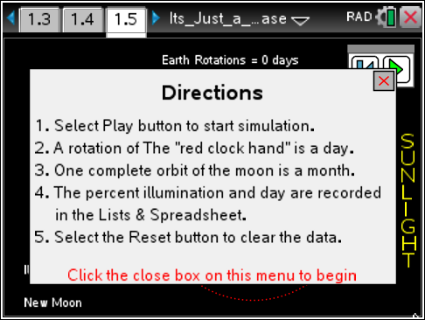
Q3. How does the Moon's location around Earth affect its phase?

Move to page 1.6.

4. Using the simulation, try to discover when a lunar eclipse occurs! You can grab and drag the blue point to adjust the incline of the moon’s orbit. One complete orbit of the moon is a month. You can click the play button to start the simulation, and pause it as well. | 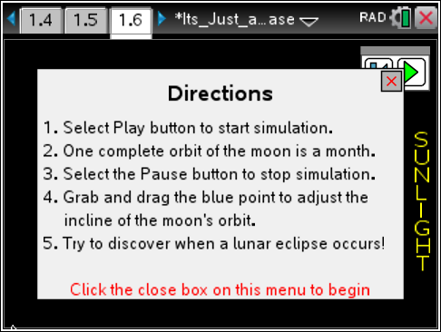  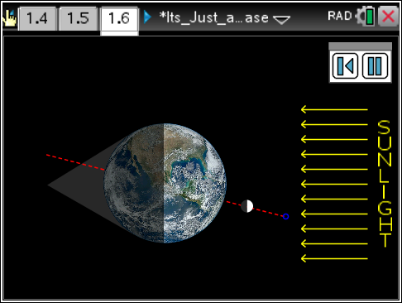
Q4. What are the requirements of the orbital angles of the Moon and Earth for an eclipse to happen?

Move to page 1.7.

5. Page 1.7 contains a graph of an actual lunar cycle. When taking a measurement, there may be a difference between a measured value and an actual or accepted value. Percent error is a measure of how close the values are. It is calculated using the following equation: | 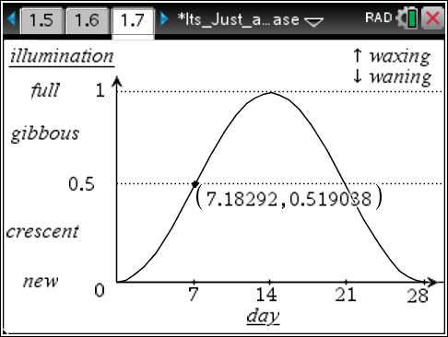
Since only estimates were used in Step 1, the measured value from page 1.7 will be called the actual value.
Q5. Choose a day, (one you calculated, not one that was given to you), from the table completed in Step 1, and record your estimated illumination (in decimal form) below. On the graph, click on the Day value (x-value) inside the ordered pair and re-type the whole number day you have chosen. Record the y-value, or the second value in the ordered pair, of the point as the actual illumination (decimal). Use the Scratchpad » to calculate percent error.

Day: __________ Estimated illumination: __________ Actual illumination: __________

Percent error __________

Move to page 1.8. Answer question 6 here and/or in the .tns file.
6. The lunar phase determines whether a solar eclipse or a lunar eclipse might happen.

Q6. The image shows a solar eclipse. During what lunar phase might a solar eclipse happen? Explain your reasoning.

