Overview  In this activity, you will test ordered pairs to determine if they are part of the solution set to an inequality.  Materials  - TI-Nspire™ handheld or computer technology  - Exploring_Graphs_of_Inequalities.tns | 

Move the Point  Step 1: Move the cursor until ÷ and point appear around the point on the grid.  Step 2: To grab that point, press / x .The ÷ will change to {.  Step 3: Use the Touchpad or Clickpad to move the point around the screen. Notice that the coordinates change as you move the point.  Step 4: Press d to stop moving the point. | 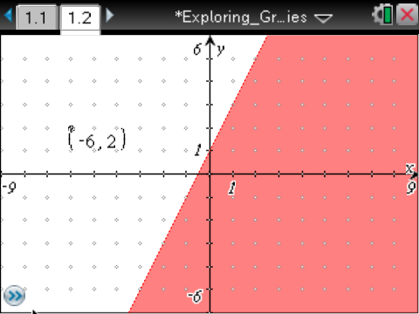
Test Ordered Pairs
Step 1: Given the inequality y < 2x + 1, move the point as indicated in Column 1 of the table on the next page of this worksheet.
Step 2: Complete Columns 2, 3, and 4 on this worksheet.

Change the Inequality Sign
Step 1: Show the entry line by pressing / G.
Step 2: Press £ to display the current relation.
Step 3: Press ¡ until the cursor is between < and 2
Step 4: Press .to erase the <. A menu will pop up showing inequality options.
Step 5: Press the ¤ until the ≥ symbol is highlighted. Press ·.
Now complete columns 5 and 6 on this worksheet.

Column 1 | Column 2 | Column 3 | Column 4 | Column 5 | Column 6
Location of the Point | Coordinates of the Point (x, y) | Substitute the coordinates in the inequality.  y < 2x + 1  True or False? | What observations can you make about the point in relation to the shaded area of the graph? | Substitute the coordinates in the inequality.  y ≥ 2x + 1  True or False? | What observations can you make about the point in relation to the shaded area of the graph?
Move the point to Quadrant I | (1,5)
Move the point to Quadrant II | (–3,2)
Move the point to Quadrant III | (–1,–2)
Move the point to Quadrant IV | (3,–1)
Move to a location on the line y = 2x + 1 | (1,3)

