Open the TI-Nspire document Terminal_Velocity.tns.  In this experiment, you will explore the idea of terminal velocity. What is terminal velocity, and what causes it? Is there a maximum speed for all objects? |  | 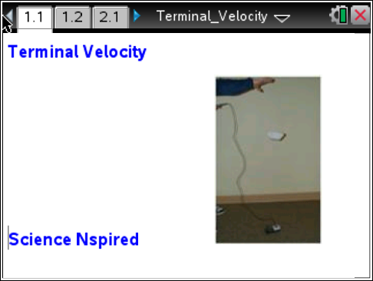
Move to page 1.2.

When you drop an object, it accelerates due to gravity. Its speed increases due to gravitational acceleration.

But as an object drops, the wind pushes in the opposite direction, slowing it down.

When wind resistance equals the downward force of gravity, there are no net forces acting on the object. It stops accelerating. It moves with a constant downward speed called the terminal velocity.
Although the force of gravity works on any object, the force of wind resistance is different. For example, dropping a cannonball and a feather results in the feather floating, while the cannonball drops straight down. The force of wind resistance on the feather is much greater, even though each object feels the same force of gravity. | 
In this experiment, you’re going to drop coffee filters from a height and measure their terminal velocity. A coffee filter has a wide area and will have more wind resistance. (For example, dropping a pencil and a coffee filter will result in the pencil hitting the ground first.)

Move to page 2.1.
1. Connect a CBR 2™ to the TI-Nspire™ handheld.
2. Place the CBR 2 on the floor facing upward.
3. Hold a coffee filter directly above the probe at your shoulder height.
4. Click the Start button in the DataQuest app to begin sampling.
5. When you hear the CBR 2 begin clicking, drop the coffee filter.
6. When the coffee filter lands on the CBR 2, click the Stop button in the DataQuest app.
7. On the main screen, select graph view and then select the region that represents the coffee filter falling by moving your cursor to the start point of the drop and clicking to set the left bound.  8. Move the cursor to the right to expand the selection region, and click to select the right bound. |  | 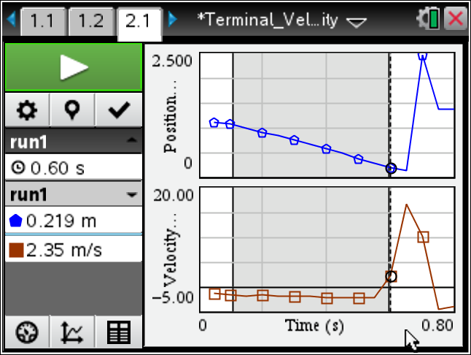
9. Select MENU > Data > Strike Data > Outside Selected Region.  10. Analyze the Linear segment by selecting MENU > Analyze > Curve Fit > Linear and finding the velocity of the single coffee filter. |  | 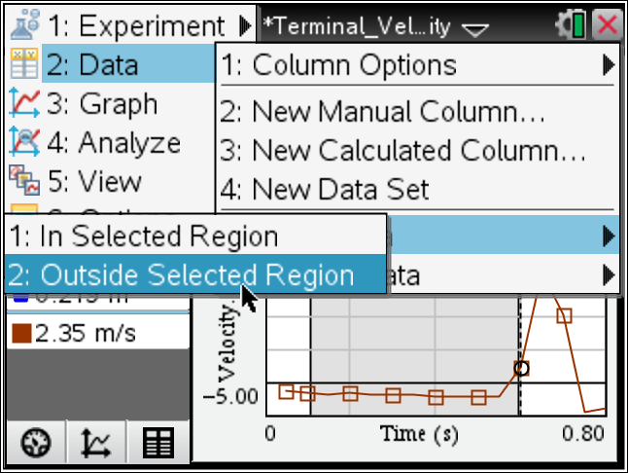
Move to page 3.1.
11. You will see a Lists & Spreadsheet page with the columns filter and velocity. Enter the number of filters in the Filter column and the corresponding velocity in Velocity column.
12. Repeat the data collection process by dropping 2, 3, 4, 5, and 6 filters stacked together.
Move to page 3.2.
13. You will see a Data & Statistics page with the plot of velocity vs. filters. Place a linear regression on the velocity vs. filters data by selecting Menu > Analyze > Regression > Show Linear (mx + b).

Move to page 4.1. Answer questions 1–3 here and/or in the .tns file.
Q1. What relationship is there between the mass of the objects dropped (number of coffee filters) and the velocity?

Q2. What would the velocity of the filters be if there were 8 filters? (Hint: Find the value of the linear regression when x = 8.)

Q3. What is the ratio of velocities between 2 filters and 4 filters?

