Overview
In this activity, you will create a family of t-curves and compare them to the normal distribution.

Materials
• TI-Nspire™ handheld or Computer Software

Part 1—Preparing the document
1. Open a new document by pressing c > New Document > Add Notes.
2. Type Family of t-Curves.  3. Press ~ > File > Save As … and type the file name Family of t-curves. e to ¾ , and press ·.  Note: To obtain capital letters on the handheld, press the g key, then the letter. | 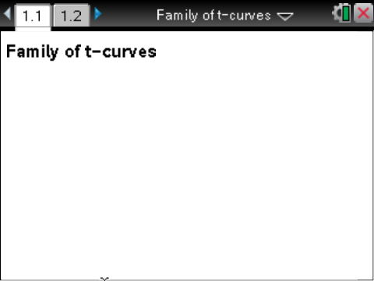
Part 2—Creating the graphs  4. Add a new page by selecting / ~ > Add Graphs. | 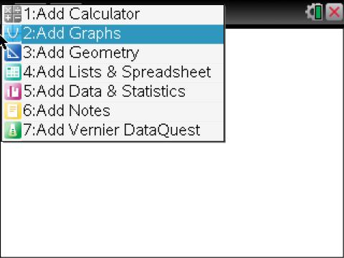
- On the function entry line for f1(x), type normPdf(x,0,1) to draw a normal probability distribution with mean 0 and standard deviation one. | 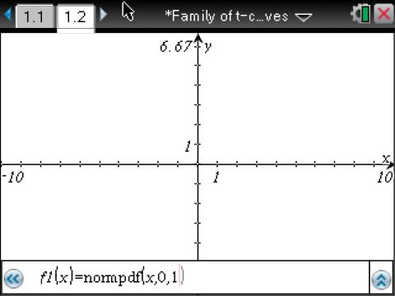  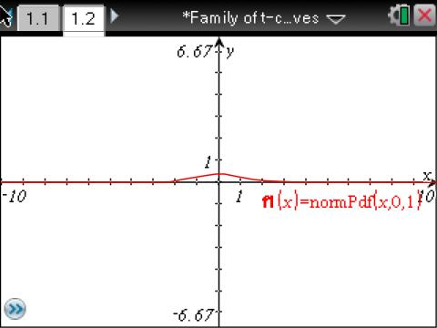
5. To set the window, select MENU > Window/Zoom > Window Settings… Use the following settings:  - XMin: -6  XMax: 6  - XScale: 1  YMin: -0.1  - YMax: 0.5  - YScale: Auto | 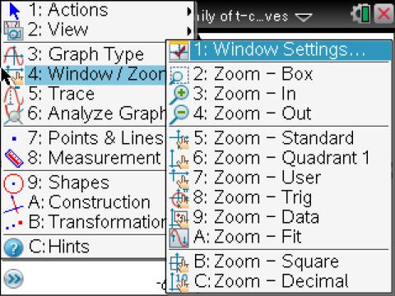  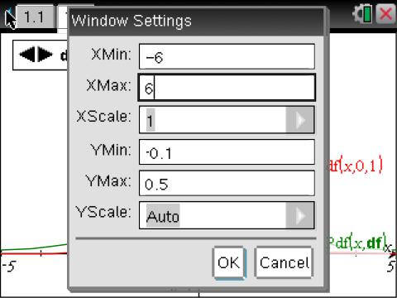  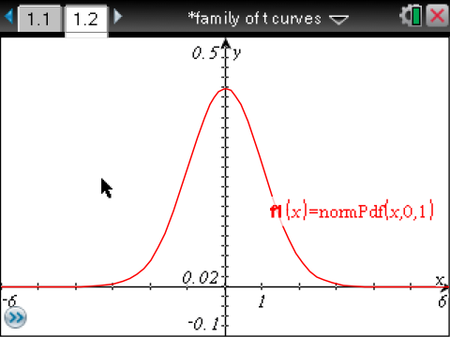
6. Press / G to retrieve the entry line. To graph a t-distribution for f2(x), type tpdf(x,df) and press ·.  - This will define the function in terms of degrees of freedom, df, so the graph will not be displayed until you give an input for df as described below. | 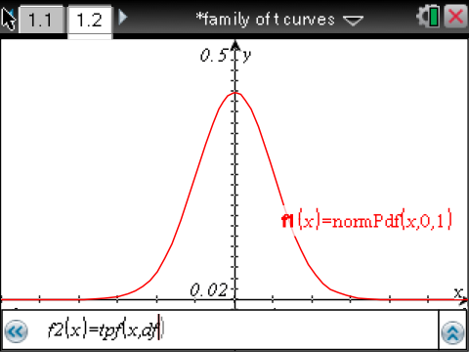

Part 3—Creating a Slider for df  7. Select MENU > Actions > Insert Slider.  8. Drag the slider box to the upper left corner, and click to position the box. | 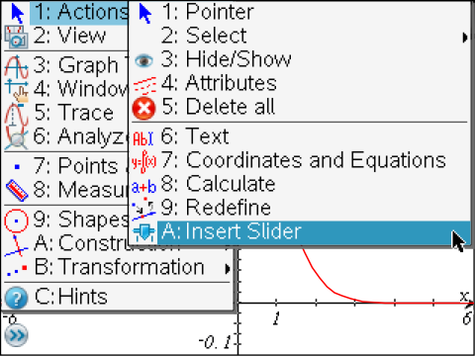  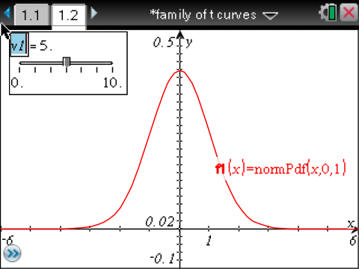
9. Replace the v1 by typing df and pressing ·. | 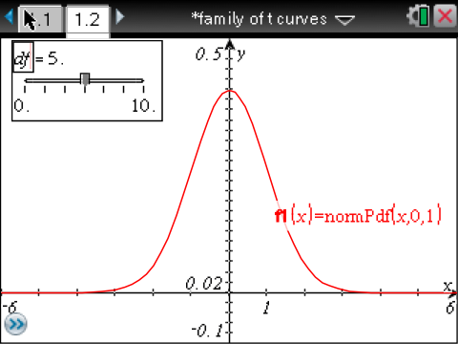
10. With the slider box still active, press / MENU > Settings… Use the following settings:  - Variable: df  - Value: 0  - Minimum: 0  - Maximum: 50  - Step Size: 1  - Style: Horizontal | 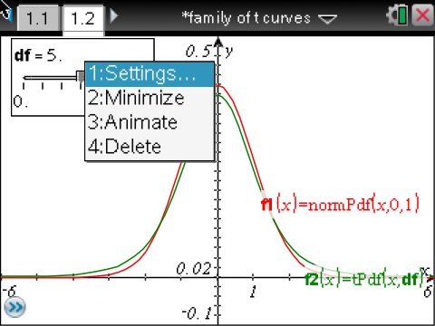  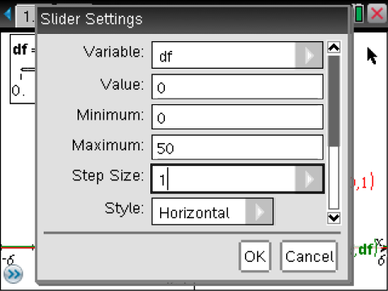
10. Use the scroll bar at the right to scroll down to the bottom of the settings page. Check Minimized, and tab to OK.  - The graph will not show a t-distribution until you use the arrow to assign a value for the degrees of freedom, df. | 