Open the TI-Nspire document Points on a Line.tns.  One way to move from point A to point B is by first going in a vertical direction and then horizontally. When points A and B are on the same line, a special relationship exists between the vertical and horizontal moves. In this activity, you will use coordinates to better understand that relationship. | 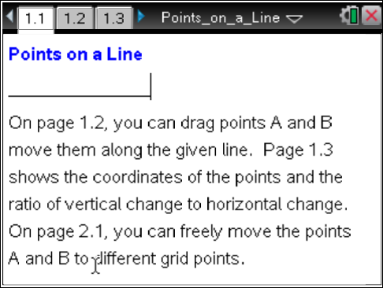

Move to page 1.2. | Press / ¢ and / ¡ to navigate through the lesson.
Suppose you wanted to go from A to B, but you could only make a vertical move up or down or a horizontal move right or left. Notice there is an arrow for the vertical trip from A to C and an arrow for the horizontal trip from C to B.
1. Describe the vertical and horizontal moves you would make to get from point A to point B.

2. a. Move point A until the vertical path from point A to point C is up 2 spaces. Describe the horizontal move to get to point B from point C.

b. Move point A until the vertical path is up 3 spaces. Describe the horizontal move to get to point B from point C.

c. What horizontal move will correspond to a vertical move of up 6? Move the point to check your answer.

3. Make an educated guess about the relationship between the number of units and the direction from A to C and from C to B. Choose some new points for A and B, and verify your conjecture.

4. What happens when point A is above and to the right of point B? Try several points for which this is true. Do the results support your conjecture? Why or why not?

In a coordinate system, a move up is considered a positive vertical change; a move down is a negative vertical change; a move right is considered a positive horizontal change; a move left is a negative horizontal change.
5. Using correct signs, find the ratio of vertical change to horizontal change for several pairs of points on the line. What do you observe about the ratios?

Move to page 1.3. | Press / ¢ and / ¡ to navigate through the lesson.
6. Move points A and B to fill in the missing information in each line of the table below. Explain your reasoning.

 | Coordinates of Point A | Coordinates of Point B | Vertical Change (A to C)  Horizontal Change (C to B)
1 | ( -8 , ) | ( , 5 )
2 | ( -6 , ) | ( , )
3 | ( , 3 ) | ( , )
4 | ( 6 , ) | ( , )

7. Describe how the information in the table in question 6 relates to your observations in question 5.

8. Suppose points A and B are on the line but not displayed in the window of the document. If the vertical change from point A to point B is 50, what is the horizontal change? Explain your reasoning.

9. For a different line, the coordinates of point A are (-3, -4), and the ratio of the vertical change to the horizontal change is equivalent to . Find the coordinates of another point on the line. Explain how you found your answer.

Move to page 2.1. | Press / ¢ and / ¡ to navigate through the lesson.
10. Place points A and B so the move from point A to point B could be described as “down 4 and right 2.” Give the coordinates of your points.

11. a. Siree chose two points on a line, and Paul chose two other points on the same line. Could they get different ratios for the vertical change to the horizontal change? Why or why not?

b. Tamera and Sam each have a line. Tamera chooses two points on her line, and Sam chooses two points on his. They find they have the same ratio of vertical change to horizontal change. Did their lines have to be the same? Why or why not?

