Open the TI-Nspire document Sound_Waves.tns.  In this investigation you will explore a simulation of a sound wave. Sound waves are longitudinal waves, also called compression waves. The waves oscillate between high and low pressure and the vibration of the medium through which the wave is traveling causes the sound we hear. Sound travels differently depending upon the material it vibrates in (metal, water, air, etc.) as well as the frequency and the intensity of the vibration. |  | 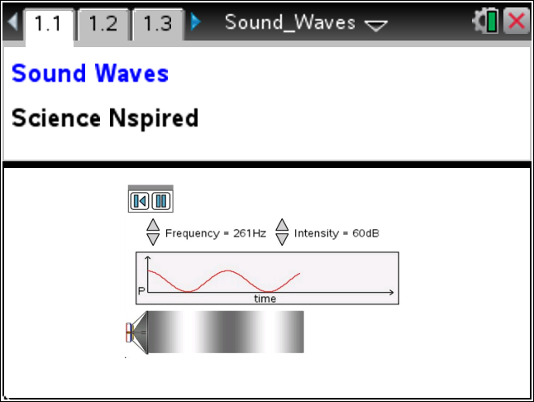
You will take note of changes in the sound wave as you modify the frequency or intensity of the sound. You will then calculate the period and determine the wavelength of the sound from its graph.

As you explore the sound waves, you will determine the relationship between the frequency, wavelength, and period of a wave as well as the relationship between the pressure, intensity, and amplitude.

Part 1: Exploring Sound Waves
1. After reading the instructions on page 1.2, close the directions box by selecting .  2. The graph will show the pressure (vertical axis) of the sound wave over time (horizontal axis). Select the Play button  and observe the sound wave. To pause the simulation select . To reset select . |  | 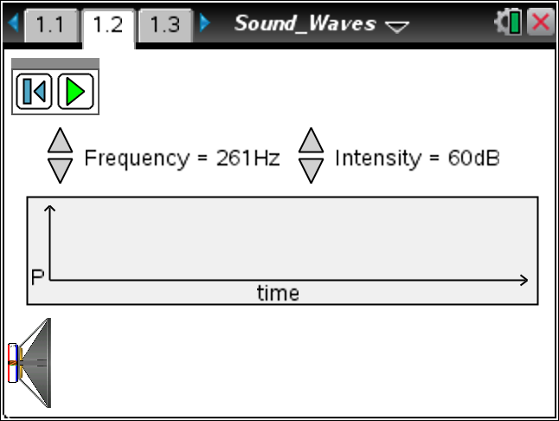
Q1. What do you observe as you run the simulation? Write down your answer and share this with a neighbor and the class as requested.

3. Now explore the simulation of the sound wave by holding the frequency constant and adjusting the intensity. Get your assigned frequency from the teacher and run the simulation with different values for the intensity. Answer the question below and then check your answer with other students that have the same assigned frequency as you.

Q2. How do the two plots change as you change the intensity of the sound?

Q3. Now check with students who had a different frequency as you and explain how their results differ from yours.

4. Now explore the changes in the sound when holding the intensity constant but adjusting the frequency. Get your assigned intensity from the teacher and explore the simulation. Answer the question below and then check your answer with other students that have the same assigned intensity as you.

Q4. How did the two plots change as you held the intensity constant and adjusted the frequency?

Q5. Now check with other students that had a different assigned intensity as you and explain how their results differ from yours.

Q6. Summarize the way sound travels in relation to the intensity and frequency settings.

Q7. What are the units used to report the frequency of a wave, and what exactly do they measure?

Q8. Can you determine the time that is shown before the simulation clears and repeats? Explain.

Part 2: The Wavelength and Period
Move to page 1.3.  5. Examine the graph. You may change the values for f and a to get different graphs. Explore this and share with the class as requested. |  | 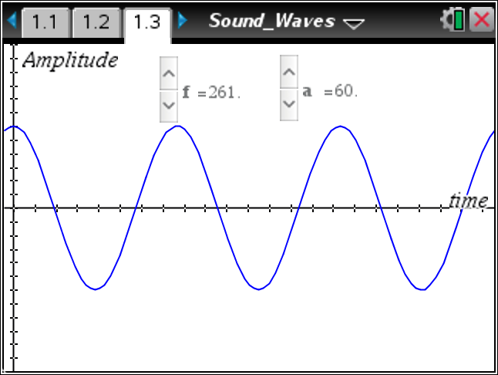
Q9. What do you think the a and f stand for? Why?

6. Now your teacher will assign you a value for a and f. Adjust your settings to create the assigned wave.
Q10. Sketch your graph and draw lines on it showing a horizontal line at the peak and vertical lines at two successive peaks or troughs. Label these lines. To get the values for the times off of the graph select Menu > Trace > Graph Trace and use the right and left arrows (¡ and ¢) to move along the wave. Select · to leave a set of coordinates on the screen. |  | 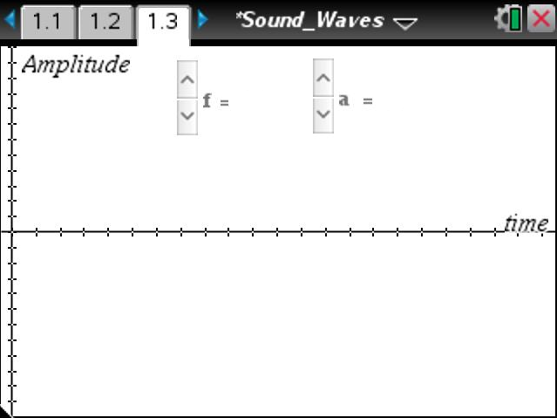
 | Tech Tip: To obtain values for time, select  > Trace > Graph Trace. You may need to back-out to the main Tools Menu to see the desired menu option. To move along the wave, select the cursor and drag it left or right along the wave.
7. To determine the wavelength (λ) of this sound wave, you can subtract the two successive times from your graph to calculate how long it takes to complete one cycle. If you know the speed of sound, you can just multiply this time by the speed of sound to get the wavelength, (distance = rate X time). Since the speed of sound changes depending on the material it vibrates in and the temperature, we will assume that we are in air at 20 degrees Celsius and that the times reported are in seconds. This makes s = 343 meters/second.

Q11. What is the wavelength of your sound wave in meters? (Calculate using the Scratchpad » or insert a Calculator page.)

 | Tech Tip: To insert a Calculator page, select  > Calculator.
8. You may also use the formula where s is the speed of sound and f is the frequency to determine the wavelength (λ).

Q12. What is the wavelength of your sound wave using this formula? (Calculate using the Scratchpad » or insert a Calculator Page.)

Q13. How do the two wavelength values, from questions 11 and 12, compare? How can one account for any differences?

