Open the TI-Nspire document How_Cool_It_Is.tns.  In this activity, we will use the EasyTemp™ temperature probe to collect and model data on the temperature of water as it cools. | 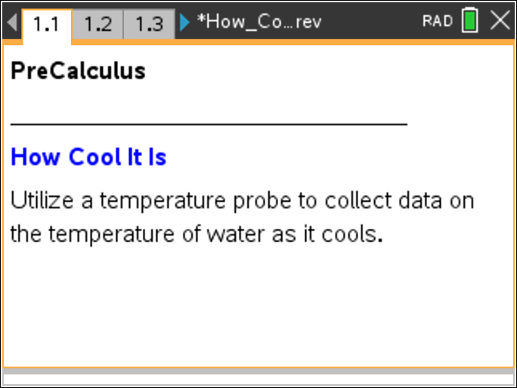

In addition to your TI-Nspire, you will need an EasyTemp™ temperature probe and a cup of hot water.

Move to page 1.3. | Press / ¢ and / ¡ to navigate through the lesson.
Connect the EasyTemp™ temperature probe to the mini-USB port of your TI-Nspire. Place the sensor in a cup of hot water, and leave it there for about 30 seconds.
Remove the temperature probe from the water, and rest it on the edge of a table. Do not let anything touch the tip of the probe. Click the green arrow in the bottom left-hand corner of the page to begin data collection.
Data will be collected for three minutes. You can then disconnect the EasyTemp™ probe, and carefully clear away the hot water.
1. What type of function appears to be a good model for the data? Explain your reasoning.

2. To generate a regression equation, select MENU > Analyze > Curve Fit. Select a curve fit option, and press ·.
a. Write the regression equation.

b. Do you think the regression equation will be a good model for t > 180 seconds? Why or why not?

3. a. If we continued to take readings of the temperature of the water, what is the lowest temperature the water would reach?

b. Is this value consistent with the regression equation? Explain.

Move to page 1.4.

Columns A and B of the spreadsheet contain the data from the lab. Column C is the difference between the temperature of the water at time, x, and the room temperature.
In the shaded formula cell for the difference column, type: = /L. Choose “run1.temperature.” Subtract the room temperature from “run1.temperature.” Thus, this column now contains the values of the difference between the run1.temperature and room temperature, i.e.,
We can now obtain a regression equation for
Move to page 1.5.

Use this Calculator page to find the regression equation for Select MENU > Statistics > Stat Calculations > Exponential Regression. Choose run1.time for X List, difference for Y List, and Save RegEqn to: f1.
4. Write the regression equation for

Move back to page 1.3.

Use the equation for to create a better model to fit the data using the form Select MENU > Analyze > Model. Enter the information for , and press ·.
5. Write the equation that you entered as your model.

6. Explain the similarities and differences between this equation and the original exponential regression equation.

You might want to try to create your own model of the function

Move to page 1.6.

The data from the original data set is shown and labeled as (run1.time, run1.temperature) and is modeled by the equation
The Sum of Squares due to Error, SSE, is also given on this page and can be used to measure how well the model fits the data. Smaller values indicate that the model fits the data better.
Click on the arrows of the sliders to change the values of the variables a and b. Try to find values for a and b such that the SSE is as small as possible.
7. Write the equation that has the smallest SSE value. How does your equation compare to the regression equation that you entered as your model on Page 1.3?

8. Based on the equation that you created, what would the temperature be three minutes after the water begins to cool?

9. a. Based on the equation that you created, how long would it take for the temperature of the water to reach 78°F?

b. When would the temperature reach 32°F?

c. Explain your answers.

10. If the initial temperature of the hot water in a room with temperatureis and it cooled 1% every second, write an equation that would model the water temperature as the water cools. What do the two parameters represent?

11. Hot drinks such as coffee, tea, and hot chocolate seem to cool slowly when we have to wait to drink them and then cool rapidly once they reach the temperature at which we would like to drink them.
a. Is it true that very hot drinks cool very slowly at first, and then cool rapidly after reaching a more reasonable temperature?

b. Explain your answer through use of the cooling data, the graph, and/or the equations you generated for this activity.

