Open the TI-Nspire document Eating_and_Exercise.tns.  In this simulation, you will observe the impact that eating and exercise can have on weight. This will include exploring Body Mass Index (BMI), and the long term consequences of diet and exercise choices. | 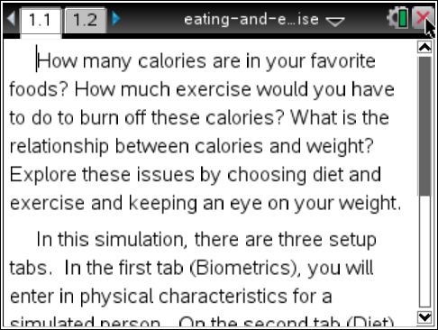
Why is having a healthy weight important?
Maintaining a healthy weight is an easy and important way to decrease your risk for many ailments, like heart disease and diabetes. It also is important for maintaining high energy levels. Being overweight puts physical stress on your heart and lungs as they try to provide energy for a much greater mass. In addition the increase weight stresses your whole body, such as your knees and feet. Being underweight puts stress on these systems as they try to perform their job without sufficient energy.
Although things like family history and environment can influence weight, you can control what you eat and the exercise you do to maintain a healthy weight. In this activity, you will explore the roles eating and exercise play on healthy weight.
Start on page 1.2 Tab 1: Biometrics.
On page 1.2, you can input biometric information, or unique physiological features such as height and weight. This simulation allows you to adjust multiple factors, some of which influence BMI. Start by adjusting the variables to see which ones influence BMI.

- Adjust the values for gender, lifestyle, height, and weight to explore the effect each has on the BMI.
- A healthy weight is influenced by both weight and height. Weighing 150 pounds would be healthy if you were 5’10”, but obese if you were 4’10”. The formula to calculate BMI is:
. Use this formula to calculate your own BMI manually.
- Set the options for gender, lifestyle, and height to represent yourself. Find weights that fit into the category of underweight (< 18.5 BMI), normal, or healthy, weight (18.6 – 24.9 BMI), overweight (25 – 29.9 BMI) and obese (> 30 BMI).
Tech Tip: When you select Age, Height, or Weight, the keyboard will appear on the screen. To enter numerical values, select the button “.?123” to the left or right of the space bar. After you have entered the numerical value, select “return” to return to the main screen.
Q1. Adjust the variables for height and weight to calculate your own BMI. What range does your BMI fall in?  Q2. Which variables do not seem to influence the BMI? What are the implications of those variables not being included in BMI? | 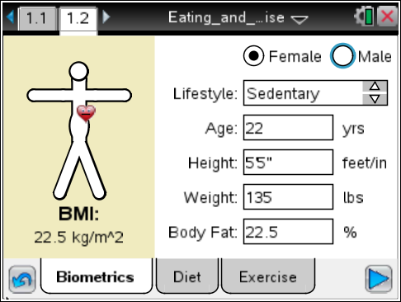
Next you will assess how the other biometrics influence how healthy your weight is. Reset the biometrics to a healthy start point. Then you will be able to investigate how eating and exercise influence the ability to maintain a normal, healthy weight.
Select Tab for 2: Diet  Look at the foods available for creating a healthy diet.  In this tab you see different categories of food, such as Breakfast, Lunch and Dinner. Within each category you can select quantities of different foods. Notice that, across the top, the total amount of Calories and Calories from protein, carbs, and fats are added up as you select foods. | 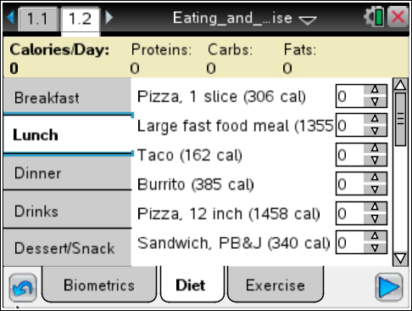
For example, if for Breakfast, you select (1) plain pancakes, this adds 146 Calories including protein, carbs and fat to your daily diet. If you choose to add (2) tbs of pancake syrup, this adds 96 Calories of carbs, and nothing else.

Create a diet using foods from all the available categories that looks appealing. (You will be able to create other variations later).
Select the Tab 3: Exercise.  A healthy lifestyle includes exercise. On this Tab, you will find several categories of exercise (such as Leisure and Sports), which each contain different types of activities. | 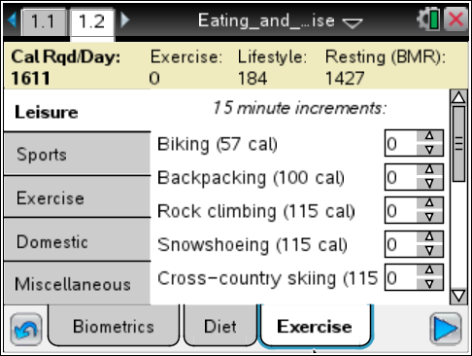
Notice, across the top the labels for Calories/Day, Exercise, Lifestyle and Resting (BMR). Calories/Day indicates how many total calories are burned through the three categories. Exercise calories are burned by your choice of activities and Lifestyle Calories are based on the biometrics you selected on the first tab. Resting calories, or BMR (or basal metabolic rate), are the number of calories your body would burn if you didn’t do anything else. These are the calories your heart burns to pump your blood and the calories your lungs use to keep you breathing. This number is also influenced by biometrics.

Q3. Which biometrics influence BMR?

Q4. Is BMR related to BMI? If so, how?

3. Create a set of activities and exercise that look interesting to you.
4. Select Play  to see a graph of the weight of a person using the selected biometrics, diet, activities and exercise. The top graph is a function of weight over time. The bottom graph shows Calories Consumed and Calories Burned over time.
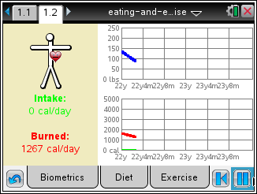
5. Sketch your graphs to the right. Have you modeled a healthy lifestyle? Why would you say that?  Repeat the lifestyle model.  6. Based on your first model, try to alter the biometrics, food activities and/or exercise to help you to answer the following questions. You may need to use the reset button  to create new models. Alternatively, you may add Diet or Exercise selections while the simulation is running to change its course. You may pause the simulation as needed. | Sketch of Graph

Q5. Can you create a model that does not gain or lose weight over time? What is the relationship between diet and exercise in this model?

Q6. Using the healthy model from Q5, what happens when you add an hour of exercise from the activities tab to that model? Is this still healthy? How do you know? | 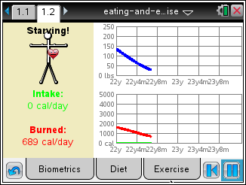
Q7. Can you adjust the Exercise heavy model from Q6 to make it healthy?

Q8. Which plays a bigger role in weight, diet or exercise or neither?

7. Set up a healthy model. Make note of how many total Calories/Day this is. You will need to explore the foods available under the Diet tab to answer the next set of questions.
8. Look at the list of available foods, and find one or several that combine to add about 100 Calories per day.
Q9. How is the simulation for this model influenced when you add 100 Calories of food to the diet every day? When you subtract 100 Calories?

9. Under Lunch you will find a Large Fast Food Meal.
Q10. How many Calories does a large fast food meal have?

Q11. How does the model change when you add an additional fast food meal every day? How can this be included in a healthy lifestyle?

