Open the TI-Nspire document Conditional_Probability.tns.  Sometimes additional information can help you narrow the probability that an outcome will occur. This activity allows you to investigate this situation and to see how extra information can make a difference. | 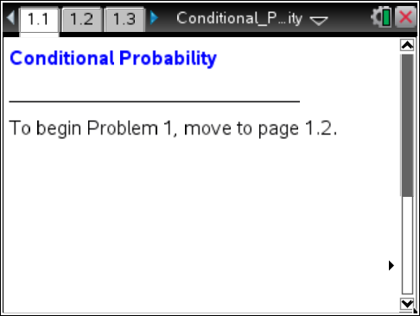

In 1992, Life magazine published an article entitled “If Women Ran America” which reported the results of a poll of U.S. men and women asked whether the problem of unequal pay for equal work is a serious one in our country. Suppose the poll was given to 44 people, 20 males and 24 females, and that 26 of the people polled agreed that the problem of unequal pay for equal work is serious.
1. Suppose further that 10 of the males agreed that the problem is serious.
a. Indicate which of the table cells below you could fill in with this information.

Gender/ problem | Yes | No | Row Totals
Male
Female
Column Totals

Move to page 1.2.

b. On this Lists & Spreadsheet page, enter 10 into the cell representing the number of males who agree the problem is serious, and compare the resulting table to your answer to part a.

2. a. If a person is chosen randomly from the 44 people, what is the probability that the person is a male?

b. What is the probability that the person is male and the person agrees that the problem is serious?

Move to page 1.3.

3. Page 1.3 shows both the table and a graphical representation of the data in the table. Select the bars in the graph.
- Based on the probabilities you see, which outcome is most likely, and what is the probability of that outcome?
b. The two blue bars are the same height. Do they represent the same probabilities? Why or why not?

4. What is the probability that a person chosen at random from those who agree the problem is serious is a male? Explain how you can get this answer from the table and from the graph.

5. Assume the row and column totals remain fixed (that is, there are a total of 44 people in the survey, 24 are female, and 26 of the 44 agree that the problem of unequal pay for equal work is serious. A person is chosen at random from the 44 people, and you know that the person chosen agrees that the problem of unequal pay for equal work is serious. Given this information, enter different values in the table to find the following:
a. The maximum probability that the person is a male. Explain why this is the maximum.

b. The minimum probability that the person is a male. Explain why this is the minimum.

Suppose 8 men agreed that the problem is serious. Enter 8 in the appropriate cell in the table.

Move to page 1.4.

6. Explain the differences in the two graphs.

7. Identify the graph you would use to answer each of the following questions, and then answer the question. A newspaper randomly chooses a person to be interviewed from the 44 who were given the poll. What is the probability that:
a. The person agrees that the problem of unequal pay for equal work is serious, given that the person is male.

- The person is male, given the person does not agree that the problem of unequal pay for equal work is serious.

- The person does not agree that the problem of unequal pay for equal work is serious.

d. The person does not agree that the problem of unequal pay for equal work is serious given that the person is female.

e. The person is male and the person agrees that the problem of unequal pay for equal work is serious.

f. The person is female or the person agrees that the problem of unequal pay for equal work is serious.

8. Some probability questions ask for the probability of a single outcome out of the total number possible. Some ask for the probability of a single outcome with a given condition. Others ask for the probability of an outcome that has compound (satisfies a and/or b) conditions. Categorize the situations from Question 7 into the table below according to the nature of the question.

Question | Single outcome  out of total possible | Single outcome  with a given condition | Outcome with  compound conditions
a
b
c
d
e
f

9. a. Describe how you would identify a probability question where the denominator is not the total number of outcomes.

b. If A and B are two distinct outcomes, what is the difference between the probability of A given B and the probability of B given A?

