Activity Overview  In this activity, students discover the Central Limit Theorem by simulating rolls of two, four, and seven number cubes via the random number generator. They find sample means and standard deviations and construct histograms of the sample distributions.  Topic: Sampling  - Central Limit Theorem  - Histograms and Distributions  - Means and Standard Deviations  Teacher Preparation and Notes  - Students should already be familiar with probability distributions, normal distributions, and the concept of simulations. Explain to students that rolling two number cubes is akin to selecting two members from a population of six, with replacement. Rolling four number cubes is akin to selecting four members, and so on.  - Ideally, there should be at least five groups of three students each. At a minimum, there should be three groups, so that students can compile at least 30 sample means (10 from each group). Alternatively, each group can generate 15-20 sample means instead of 10 as listed in the files and on the worksheet.  - Give each group a unique number (it can be any number of digits). They will use this number to set their random number seed, ensuring different random numbers are generated for each group.  - To download the student worksheet, go to education.ti.com/exchange and enter “9891” in the keyword search box.  Suggested Related Activities  To download any activity listed, go to education.ti.com/exchange and enter the number in the keyword search box.  - Central Limit Theorem (TI-84 Plus family) — 1957  - What’s Normal, Anyway? (TI-84 Plus family) — 9415  - Plotting a Normal Curve (TI-84 Plus family with TI-NavigatorTM) — 8573 | 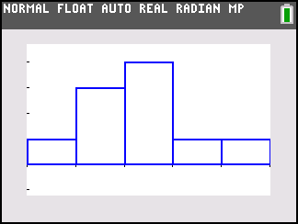  This activity utilizes MathPrintTM functionality and includes screen captures taken from the TI-84 Plus C Silver Edition. It is also appropriate for use with the TI-83 Plus, TI-84 Plus, and TI-84 Plus Silver Edition but slight variances may be found within the directions.  Compatible Devices:  - TI-84 Plus Family  - TI-84 Plus C Silver Edition  Associated Materials:  - IntroductionToCLT_Student.pdf  - IntroductionToCLT_Student.doc  Click HERE for Graphing Calculator Tutorials.

Problem 1 – Rolling Two Number Cubes
Have students look at the probability distribution of rolling a number cube one time. Ask how they would describe the distribution (uniform, nonnormal).  Students will use simulation to study sampling distributions of rolling two, four, and seven number cubes. Mostly they will work independently. Once they get started, walk around the room to assist and answer questions as needed. | 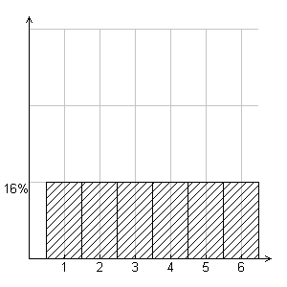
Break students into groups of three. If there must be groups of two, that will be okay, but three is ideal. Each student should have a graphing calculator and a student worksheet.

The worksheet explains the roles of the group members. There will be a total of three sets of simulations, so students can switch roles throughout the activity if they wish.

For Problem 1, when n = 2, the mean can be found mentally. This role will become more important in Problems 2 and 3.

Before students begin the simulation, have each student set the random seed (rand) to their group number. This command is found in the Probability menu. | 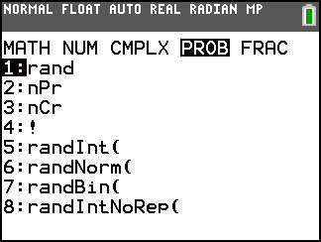
Let students perform the simulation of rolling two number cubes, finding the means, and recording them in list L1 and on the worksheet (listing them on the worksheet will make it easier to exchange information later). | 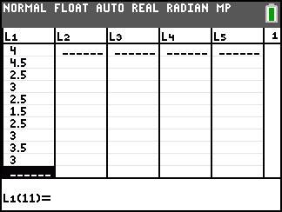
Students will be prompted to find the mean and standard deviation of their 10 sample means using the One-Variable Statistics command. | 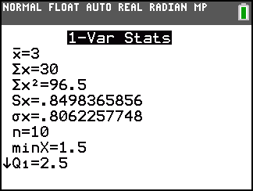
Students will also be prompted to create a histogram. For consistency and comparison with later histograms, make sure that they always use the window given on the worksheet.
One member should visit four other groups to copy their simulated sample means (from that group’s worksheet) into list L1. This is quicker than performing 40 more simulations.

Students will need to press   on the Home screen to recalculate the mean and standard deviation. They can press  to view the updated histogram. Once students are back in their groups, all members should copy the mean and standard deviation of the 50 sample means onto their worksheet. They should also make a rough sketch of the histogram.

Problem 2 – Rolling Four Number Cubes
In Problem 2, students are asked to repeat the process, but now for rolling four number cubes. The member responsible for calculating the mean of the four numbers will probably now wish to use the Home screen.  To clear list L1, students can highlight L1 at the top of the column and then press  .  Students can press   and select n/d to insert the fraction template. Press   and choose ►Dec to convert the answer to a decimal. | 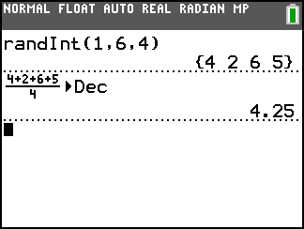
Problem 3 – Rolling Seven Number Cubes
Students are asked to repeat the process, but now for rolling seven number cubes. The histograms among the groups will not be exactly alike, but they should all be becoming more compact as the standard deviation increases. They should also have a somewhat normal distribution, centered around 3.5, the population mean. | 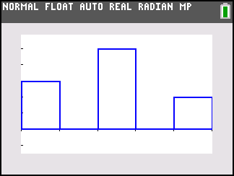
Problem 4 – Bringing it all Together
Once all the groups are finished, discuss the answers to the questions in Problem 4 and officially introduce the Central Limit Theorem (CLT). Point out that the distribution of sample means becomes normal as n increases, regardless of the shape of the distribution of the population. Here it was uniform. But it could also be normal, skewed, bimodal, or have no pattern. That is the beauty of the CLT. | 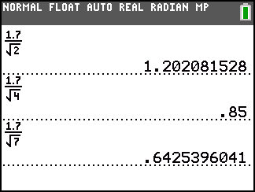

Solutions
1. The distribution is uniform and nonnormal.
2-7. Answers will vary.
8. They became narrower. More data is around 3 than 1 or 6.
9. They became smaller.
10. They get closer to 3.5.
11. About 1.202, 0.85, and about 0.643
12. Possible answer: For samples of size n, as n increases, the distribution of sample means approaches the normal distribution, the mean of the sample means approaches the population mean, and the standard deviation of the sample means approaches.

