Open the What_Makes_an_Animal.tns file.

What makes animals so special? What distinguishes the animal Kingdom from the other kingdoms? What do animals as seemingly different as cats, birds, and sea urchins really have in common?

In this lesson, you will learn some of the general characteristics of animals, and you will practice distinguishing one animal from another.
Zoology, the study of animals, covers the huge range of organisms in the Kingdom Animalia. There are more than 2 million species in this Kingdom, but they all have more in common with each other than with species from other kingdoms!

You will learn the five characteristics of all animals, and then use a dichotomous key to identify some of these animal species.
Move to pages 1.3 – 1.4.  1. Read the information about animals. Page 1.3 discusses the connection between animals and eukaryotic cells. Page 1.4 discusses how animals are multicellular.  Answer question 1 here and/or in the .tns file. | Press / ¢ and / ¡ to navigate through the lesson.
Q1. Name one multicellular eukaryote that is NOT an animal.

Move to page 1.6.
2. Read the information about why animals are heterotrophs.

Answer question 2 here and/or in the .tns file.

Q2. If an organism is not a heterotroph, it might be classified as a(n)________.

Move to pages 1.8 – 1.9.
3. Read the information on animal movement and animal development.

Answer questions 3–5 here and/or in the .tns file.

Q3. A mushroom must consume food (decaying plant material). Is it an animal? Explain.

Q4. Why is motility important for animals?

Q5. Does an organism need a backbone to be an animal? Explain.

Now that you have been introduced to the Animal Kingdom, you will use a tool, called a dichotomous key, that biologists use when identifying organisms. A dichotomous key asks a series of yes or no questions based on observable traits in order to identify an organism. A unique set of answers points to the correct animal. This can be adapted and used as a helpful tool for identification of organisms in the wild.

Move to pages 2.1 – 2.3.  4. Read the directions in the pop-up box for completing the simulation of the dichotomous key. To close the directions, can click the . Answer the questions for all nine animals. If the name that appears at the end of the questions does not match what you think the animal is, click the down arrow to go to revisit the questions. | 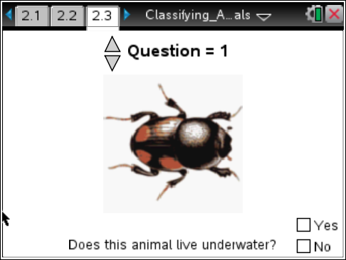
If needed at any time during the simulation, press b to view the directions again.
Answer questions 6–16 in the .tns file. Answer questions 17–19 here and/or in the .tns file.
Q17. For which three animals were you asked about having wings?
A. Butterfly C. Beetle
B. Frog D. Snail

Q18. For which two animals were you asked about a tail?
A. Lizard C. Frog
B. Fish D. Whale

Q19. Which of the organisms you classified met the five characteristics of animals?
A. Beetle D. Frog G. Snail
B. Butterfly E. Horse H. Starfish
C. Fish F. Lizard I. Whale

