Overview

The purpose of this activity is to use parametric equations to “unwrap” the unit circle. This process will allow students to obtain the graph of the function

Materials

• TI-Nspire™ handheld or Computer Software

Step 1—Preparing the document  1. Open a new document on the handheld by pressing c > New Document. Open a new document in the Teacher Software by clicking File > New TI-Nspire Document.  2. Select Add Notes.  3. Create a title page for the activity. | 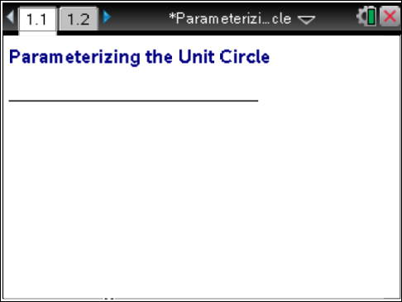
From this point on, directions for the Computer Software and the Handheld will be notated separately where appropriate.
4. Handheld: Add another Notes page by selecting /~ > Add Notes (or /I > Add Notes).
Computer Software: Add another Notes page by clicking Insert > Notes.
5. Handheld: Select MENU > Insert > Math Box (or press / M) to add a Math Box.
Computer Software: Select Document Tools > Insert > Math Box (or press Ctrl+M).

6. Add separate Math Boxes for each of the following parametric function definitions and press · after each function:  - x1(t) := cos(t) (On the handheld, you can press / t to obtain Ï.)  - y1(t) := sin(t)  - x2(t) :=t  - y2(t):=sin(t) | 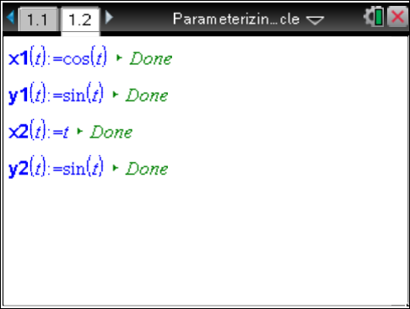
Note: If you do not want to see the > Done message at the end of each entry, select / MENU > Math Box Options > Math Box Attributes, and change the Input & Output to Hide Output.
7. Handheld: Set your TI-Nspire to radian mode by pressing c > Settings > Document Settings > Angle: Radian.
Computer Software: Select File > Settings > Document Settings and set the Angle to Radian.

8. Handheld: Select ~ > Page Layout > Select Layout, and select the option to split the whole page in half vertically, with the left side also split in half horizontally (resulting in three work areas).
Computer Software: Select Edit > Page Layout > Select Layout, and choose the appropriate icon to split the page in half vertically, with the left side also split in half horizontally (resulting in three work areas).
9. Add a Notes page to the lower left work area, and add a Graphs page to the right work area. The upper left work area is the Notes page you have already created and modified.  10. In the Graphs work area, set the Graphing Angle to Radian by pressing b > Settings > Settings. (The Geometry Angle can be left as degrees.) | 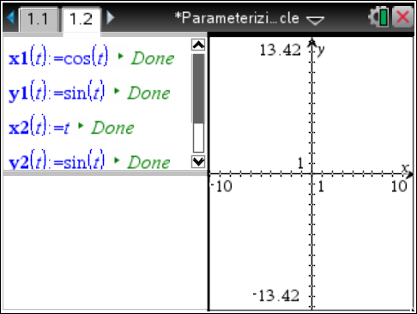
11. Change the window settings to [-1.5,6.78] x [-3.628, 3.628] by selecting MENU > Window/Zoom > Window Settings.
12. If necessary,
Handheld: To hide the function entry line, press / G or click on the chevron, .
Computer Software: To hide the function entry line, click on the chevron, .

Step 2—Add a Slider  13. Handheld: While still in the graphing work area, select MENU > Actions > Insert Slider. Position the slider near the top right portion of the graph screen. Rename the slider variable n.  Computer Software: Select Document Tools > Actions > Insert Slider.  14. Handheld: Select / > MENU > Settings, change the slider settings as indicated in the screens to the right, and click OK.  Computer Software: Right-click in the slider box, select Settings, change the slider settings as indicated in the screens to the right, and click OK. | 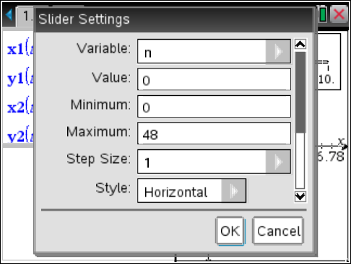  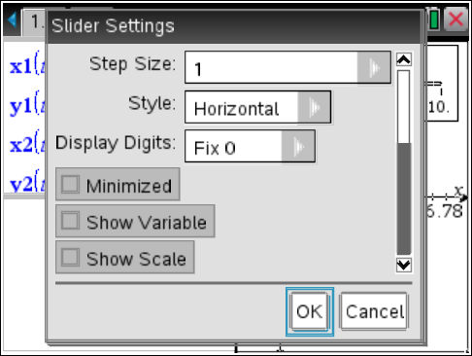
The figure to the right shows the slider created with the settings given above. | 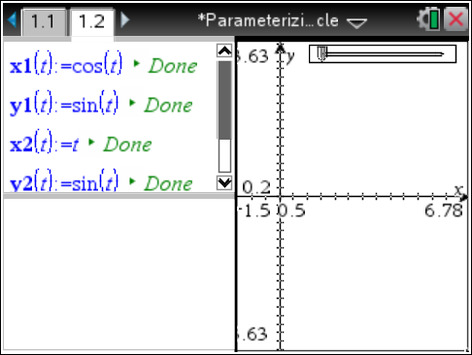

Step 3—Setting up the Other Notes Pane
15. In the bottom Notes work area, insert the following Math Boxes. (Remember to press · after each one.)
- To make it easier to change functions, add:
  - tstep :=
  - tmin := 0

- For the parametric plot, add:
  - x1plot := seq(x1(t*tstep),t,tmin,n)
  - y1plot := seq(y1(t*tstep),t,tmin,n)
  - x2plot := seq(x2(t*tstep),t,tmin,n)
  - y2plot := seq(y2(t*tstep),t,tmin,n)

- To focus attention on the last points plotted, add:
  - x3plot := {x1(n*tstep),x2(n*tstep)}
  - y3plot := {y1(n*tstep),y2(n*tstep)}

- (Optional) Change Math Box Attribute: Hide output.
- (Optional) Slide the lower left quarter out of sight.
The figure to the right shows the set-up of the bottom Notes work area. | 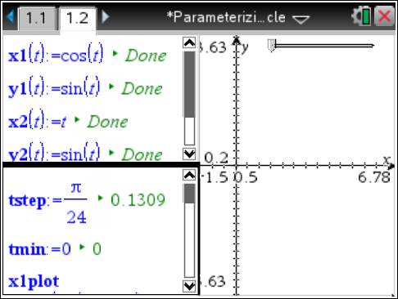
Step 4— Complete the Set-Up of the Graphs Work Area  16. Handheld: In the Graph work area, select MENU > Graph Entry/Edit > Scatter Plot. For scatter plot s1, press h, and select x1plot for the x-value and y1plot for the y-value.  Computer Software: Select Document Tools > Graph Entry/Edit> Scatter Plot. For scatter plot s1, click on the round “var” button at the top of the screen and select x1plot for the x-value and y1plot for the y-value. | 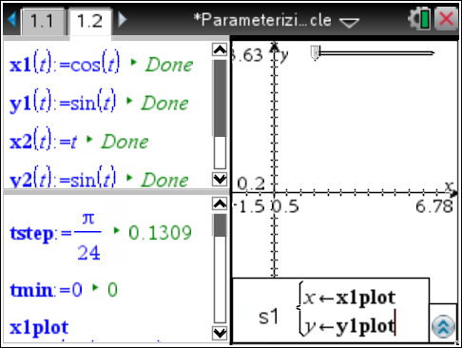
17. Handheld: Press / G to re-open the entry line. Move up using the arrow (£) to s1(x, y), and select / MENU > Attributes.  Computer Software: Right-click on s1(x, y), and select Attributes. | 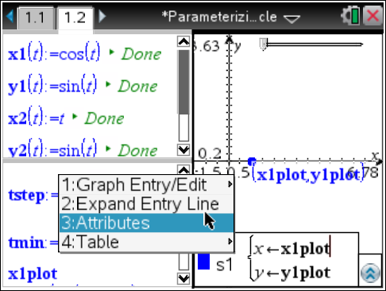
18. Choose the thin point and the connected graph from the Attributes menu. | 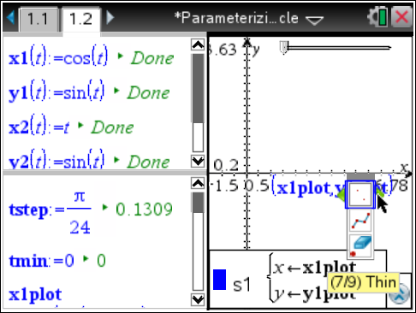
19. The following is a list of the coordinates and attributes for the three scatter plots:
- Scatter plot s1: (x1plot,y1plot); Attributes: thin point, connected graph.
- Scatter plot s2: (x2plot,y2plot); Attributes: thin point, connected graph.
- Scatter plot s3: (x3plot,y3plot); Attributes: large solid point.

Note: If you change the parametric function definitions, x1(t) and y1(t), it might be necessary to adjust the graph window, slider range, tstep, and tmin.

20. Handheld: To join the two points with a dotted segment, select MENU > Geometry > Points and Lines > Segment, and click on each of the two plotted points to form the line segment.
Computer Software: Select Document Tools > Geometry > Points and Lines > Segment, and click on each of the endpoints to make a line segment.
21. Handheld: Move your cursor over the line segment, select / > MENU > Attributes, and choose thin line and dotted.
Computer Software: Right-click on the line segment, select Attributes, and choose thin line and dotted.
22. Handheld: Hide the endpoints of the line segment by moving your cursor over each of the two endpoints and selecting / > MENU > Hide.
Computer Software: Hide the two endpoints by right-clicking on each of them and selecting Hide.
23. Handheld: Hide the labels of the scatterplots by moving your cursor over each label and selecting / > MENU > Hide.
Computer Software: Hide the labels of the scatterplots by right-clicking on each label and selecting Hide.

Note: You might want to adjust your screen so the graph on the right is larger.  Handheld: Select ~ > Page Layout > Custom Split. You will see a wheel in the center of the page; press the arrows  ( ¡ ¢ ) to move the column to the desired location and press · to set the column in place.  Computer Software: Position your cursor on the vertical line separating the two vertical panes. When you see the double-sided arrow, click and move the column to the desired location and release to set the column in place.  As you move your slider, your screen should look like the one to the right. | 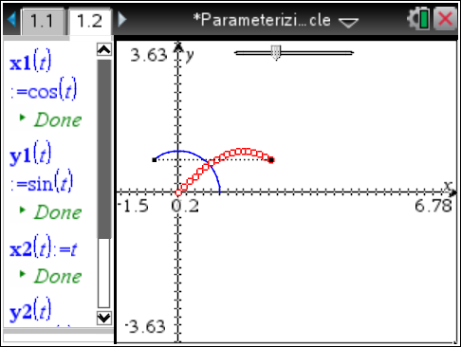
Notes:
- As students “unwrap” the unit circle, have them pause to see the relationship between the graph of the unit circle and the graph of the sine function.
- Guide students to discover that the y-coordinate of the unit circle is the same as the
y-coordinate of the sine function.
- Ask students what the variable t represents in both graphs.
- You might want to have students rewrite y2(t) as y2(t) = cos (t) to see the unit circle unwrap to create the cosine function.

