Open the TI-Nspire document Electric_Hockey.tns.  In this simulation you will see how electric charges interact with each other. Depending on the type of electric charge, the interaction will lead to different kinds of motion. This simulation involves a fictitious hockey game where an electric charge is moved toward the goal. | 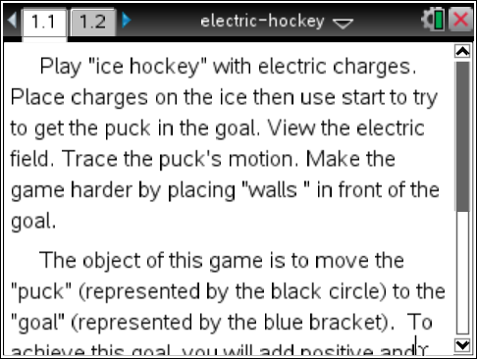
Launch the simulation.
Read the text in Tab 1.1 and then move on to Tab 1.2. Place a positive charge on the screen by selecting this button . Next, drag the positive charge near the main positive charge already onscreen. Reset the simulation by selecting
Tech Tip: After you select , place your finger over the charge and drag it to the desired location. Lift your finger to drop the charge.
Q1. Describe what happens.

Part 1: Exploring Electric Fields
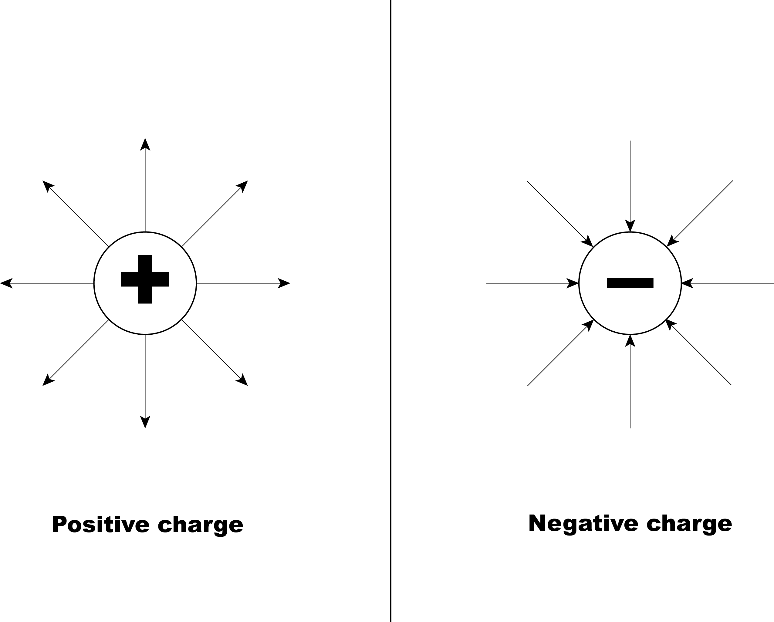
Every electric charge has an electric field around it. For a positive charge, the electric field lines point outward. For a negative charge, the electric field lines point inward.
- Move the positive charge that you placed onscreen around the main positive charge. You’ll see a field line appear as you move the positive charge. Now, stop moving the charge and select the Play button . | 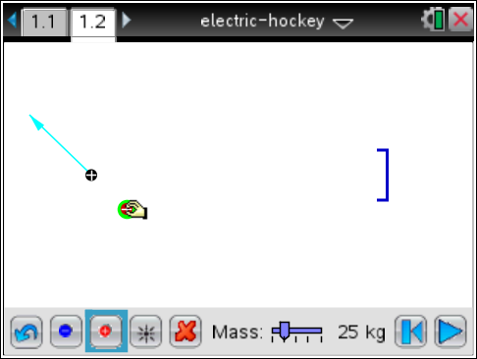
Q2. Describe what happens.

Q3. Select the Rewind button . Repeat Step 1 for different locations of the positive charge around the main charge. Write a general statement that describes what happens when you place two positive charges near each other.

- Select the Reset button . Now place a negative electric charge by selecting . Select and move the negative charge near the main positive charge. | 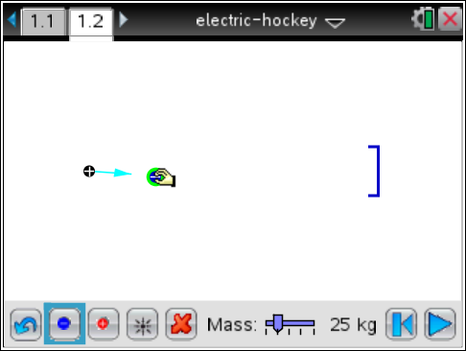
Q4. Describe what happens to the electric field lines of the main positive charge.

- Place the negative charge near the main positive charge and select the Play button . | 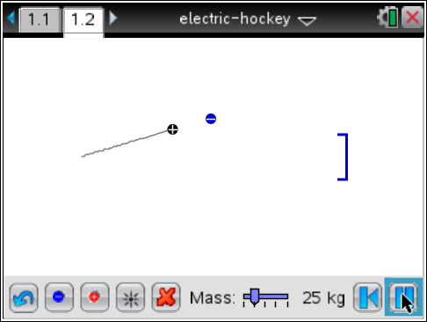
Q5. Select the Rewind button . Repeat Step 3 for different locations of the negative charge around the main charge. Write a general statement that describes what happens when you place two different charges near each other.

Part 2: Moving Charges
Electric charges have the property that like charges (either two positive or two negatives) repel each other, meaning that these charges move away from each other. Unlike charges (one positive and one negative) attract each other, meaning that they move toward each other. You can see how the electric field lines show the behavior of these charges. |  | 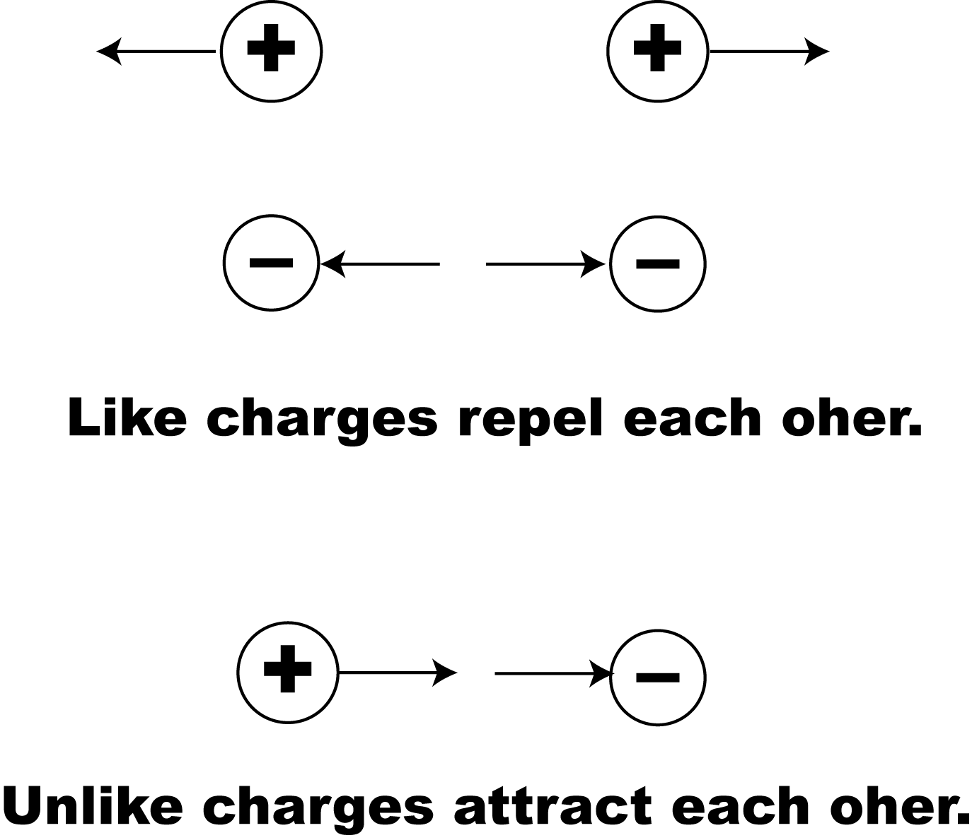
- Select the Reset button . Now place one positive charge onscreen. You want to arrange this charge in such a way that when you run the simulation, the main positive charge hits the goal at the other end of the screen. |  |  | 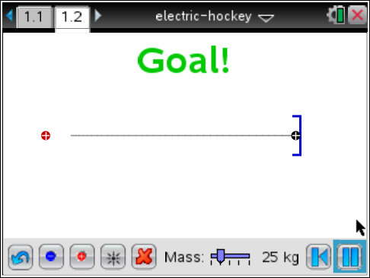
Q6. Describe the method you used to score a goal.

Q7. Now place several more positive charges onscreen and try the same method. Describe what happens.

Q8. What happens as you add more positive charges?

- Select the Rewind button . Now vary the mass of the main positive chart. Use the slider to increase and decrease the mass. |  |  | 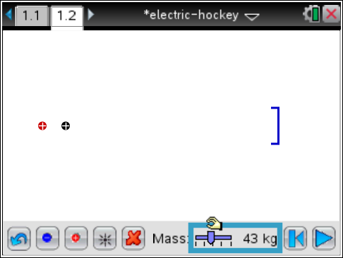
Q9. Describe what happens to the motion of the main positive charge.

Because an electric charge has mass and can be pushed from a stationary position to a state of motion by an electric, then a charge can pushed by electric force. The electric force equation shown above is dependent on the amount of charge (q). The direction of motion depends on whether the charge is positive or negative. | 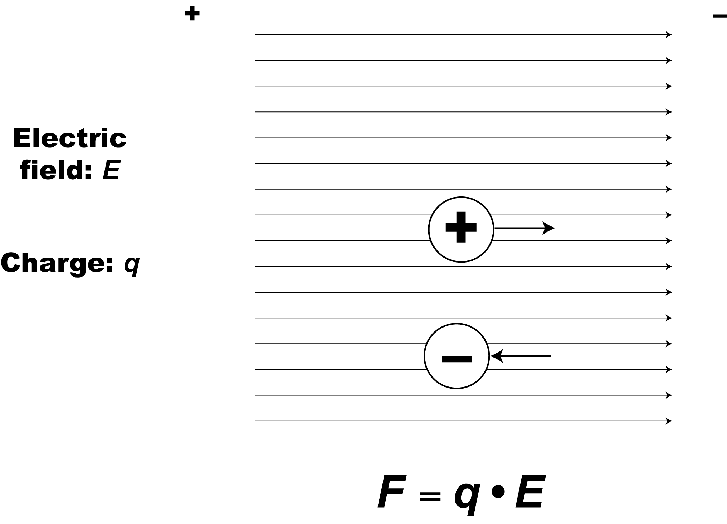
- Select the Reset button . Now place a number of negative charges onscreen to create an electric field that pulls the main positive charge toward the goal. |  |  | 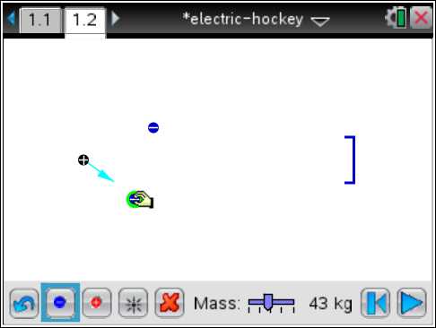
Q10. Describe your method for getting the positive charge into the goal.

Part 3: Changing the Direction of Motion
- Select the Reset button . Now place a number of positive charges onscreen to create the following situation:  - The charge moves toward the goal.  - The charge is blocked and prevented from getting to the goal. |  |  | 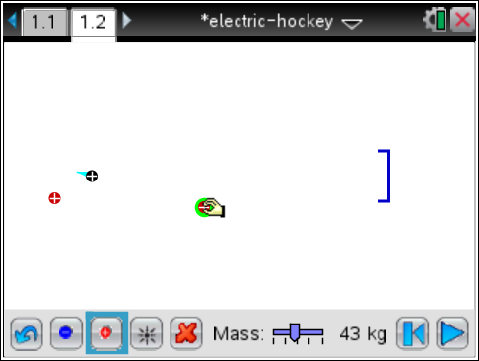
Q11. Describe your method for preventing the charge from hitting the goal.

- Select the Reset button . Now place a number of positive and negative charges onscreen to create the same condition as Step 7. |  |  | 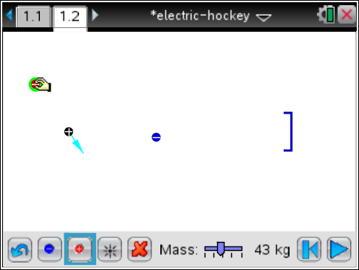
Q12. Describe your method for preventing the charge from hitting the goal.

Q13. Create an arrangement of charges that has the puck follow this path toward the goal.
