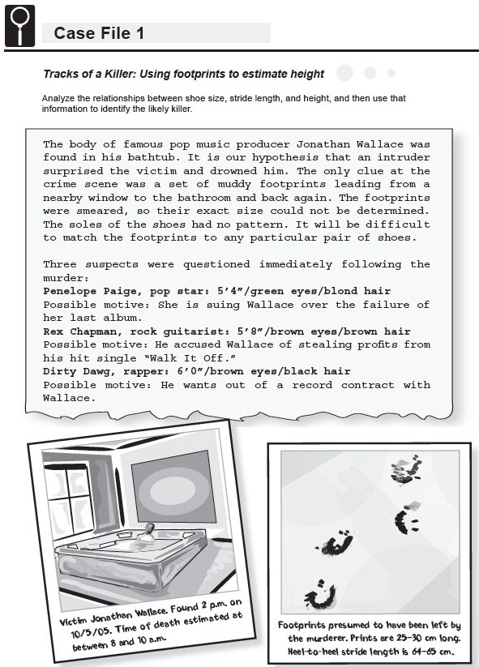

Science Objectives
- Determine if there is a relationship between the length of a person’s stride and his or her height.
- Determine if there is a relationship between the size of a person’s shoes and his or her height.
- Efficiently gather data to test for correlations between height, shoe size, and stride length.
- Use a linear regression model of the data to predict height based on stride length.

Activity Materials
- TI-NspireTM Technology  - Case_1_Tracks_of_a_Killer.tns file | - metric tape measure or meter stick  - chalk or tape
Procedure
Open the TI-Nspire document Case_1_Tracks_of_a_Killer.tns.

In this data-gathering activity, you will analyze the relationship between shoe size, stride length, and height, and then use that information to identify the killer.
Part 1 – Collecting Data
Move to pages 1.3–1.6.
1. Measurement 1: Use the tape measure or meter stick to measure each person’s height without shoes to the nearest centimeter (cm). Record the data in the Evidence Record next to the person’s name on this sheet.
2. Measurement 2: Have each person remove his or her right shoe. Turn the shoe over and use a ruler to measure the distance from the tip of the toe to the end of the heel. Record the length of the person’s shoe to the nearest centimeter in the Evidence Record on this sheet.
3. Measurement 3: Mark a starting line with chalk or tape. Have each person stand with the backs of his or her heels at the edge of the starting line. Starting at this point, each person should take 10 normal-length walking steps in a straight line (see the diagram on page 1.6). After the 10th step, the person should stop and bring his or her heels together. Mark the final position of the back of the person's heels, and measure the distance to the nearest cm between that mark and the edge of the starting line. Calculate the average stride length by dividing this distance by 10. Record each person's average stride length to the nearest cm in the Evidence Record on this sheet.
4. When all of the data are collected, compile a complete record for all individuals on the Evidence Record on this sheet.

Part 2 – Entering the Data into TI-Nspire
Move to page 2.1.  5. Enter the data, recorded in the Evidence Record, on page 2.1.  - Select the first cell in the Height column and enter the height of the first student.  - Move to the first cell in the ShoeL column and enter the length of the first student’s shoe.  - Move to the first cell in the Stride column and enter the average length of the first student’s stride. |  |  | 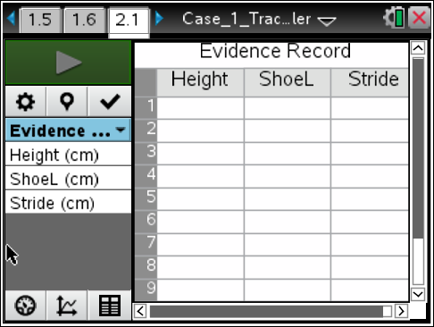
d. Continue to enter data for all remaining students recorded in the Evidence Record.
Part 3 – Analyzing the Data
Next, you will determine the equation for the straight line that fits your data the best. It is important to have an equation that describes the relationship between height and stride length and height and shoe length. If you have an equation, and the equation has a good correlation, then you can predict the height of any person based on the length of the person's stride or shoe length.

A linear regression is a mathematical formula that is used to determine the equation for a straight line that best fits data points. To use a linear regression, we have to assume that the relationship between height and stride length is linear and that height and stride length are related by an equation, Stride Length = (m)(Height) + b, where m and b are constants. The TI-Nspire can use the linear regression analysis tool to quickly calculate the m and b for your data.
6. On page 2.1, Select the “Graph View” tab. You will see a graph of average stride length vs. student height.
- If your points are connected, press Menu > Options > Point Options, uncheck Connect Data Points, and click OK.
7. Perform a linear regression of the average stride length vs. student height data.
- Press Menu > Analyze > Curve Fit and choose Linear.
This calculates the equation for the straight line that best fits your data. The screen will display the m (slope) and b (intercept) values that make the linear equation fit the data. The correlation value tells you how well the line fits the data. The closer the value is to 1, the better the line fits the data.
- Record the linear regression equation in the Evidence Record and on page 2.5 of the .tns file. Also record the calculated correlation value.
8. Repeat Steps 6–7 to determine whether or not there is a relationship between student height and shoe length. Graph student height on the x-axis and shoe length on the y-axis. Select the axis title, and then choose the variable you would like to graph.
9. Record the equation and correlation value (r ²) in the Evidence Record here and on page 2.5.
10. Answer the questions in the Case Analysis, using your results.

Evidence Record
Student Name | Measurement 1  Height (cm) | Measurement 2  Shoe Length (cm) | Measurement 3  Stride Length (cm)

Graph | Equation | Correlation Value (r ²)
Stride Length vs. Height
Shoe Size vs. Height

Case Analysis
Move to pages 3.1 – 3.9.
Answer the following questions below, on your handheld, or both.
Q1. Should a linear model be used to best represent your data? Explain why or why not.

Q2. What is the correlation value for the straight line that best describes your data for student stride vs. height? Do you think the straight line fits the data well?

Q3. Based on your data, is there a linear relationship between student height and shoe length?

Q4. Do you think that it is possible to infer a person’s height from his or her shoe size? Explain your answer.

Q5. Using the relationship between height and stride length that you calculated, determine the approximate heights of people with the following stride lengths:
a. 0.75 m

b. 0.45 m

c. 0.50 m

Q6. Using the relationship between height and stride length that you calculated, predict the stride length of a person who is not a student in your class (for example, your teacher, your principal, or a student in a different class) based on his or her height. Then measure the person’s actual stride length. How close was your prediction to the actual stride length?
Q7. Suppose you measure the stride length of a set of footprints, and you predict that the person who made the footprints is 1.75 m tall, Later, you find out that the person who made the footprints is actually only 1.52 m tall. Give possible reasons why your prediction was incorrect.

Q8. Using the relationships that you calculated, determine which of the three suspects most likely left the footprints to and from Jonathan Wallace's bathroom. Show all your calculations. (Hint: In the equation that you wrote down, x is stride length and y is height.)

