Open the TI-Nspire document Parametric_Ball_Toss.tns.  In this activity, you will determine how the path of a ball thrown up in the air is related to the graph of the height of the ball above ground as a function of time. | 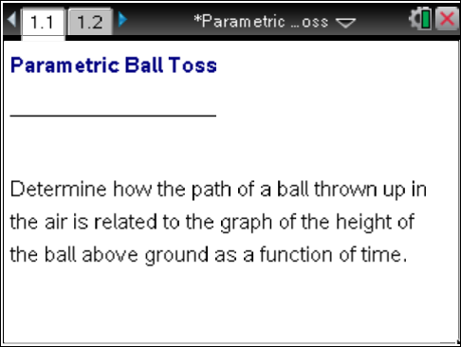

Move to page 1.2. | Press / ¢ and / ¡ to navigate through the lesson.
At time t = 0, a ball is tossed straight up into the air. The graph on the right represents the height of the ball as a function of the time, t. The point to the left of the graph near the slider represents the ball in the air.
1. Drag the slider to observe the height of the ball, in feet, as a function of time, t, in seconds. Explain the shape of the function.

2. The height of the ball as a function of time is modeled by the parametric equations and
a. From what height was the ball thrown? How did you obtain this answer?

b. Where could the person throwing the ball have been standing? How do you know?

3. As you drag the slider, observe the path of the ball to the left of the graph. Explain the shape of the path.

You might want to utilize the scratchpad to help you answer some of the questions below. Press » to access the scratchpad. By pressing » again, you can toggle back and forth between the Calculator page and the Graphs page.
4. a. After how many seconds did the ball hit the ground? How do you know?

b. Explain a different method that you could have used to obtain your answer.

5. a. What is the maximum height that the ball reached?

b. How many seconds did it take the ball to reach that height?

c. How did you obtain these answers?

6. Two seconds after the ball was thrown up in the air, how many feet above the ground was it?

7. How many seconds did it take the ball to reach a height of 63 feet? How many seconds later does it reach that height again? Explain why the ball is able to reach a height of 63 feet twice.

8. Fill in the information in the table below:
Time (sec) | 0 | 0.5 | 1 | 1.5 | 2 | 2.5 | 3
Height (ft)

9. Using the information from the table above, determine the average speed of the ball during the indicated time interval:
a. 0 to 0.5 seconds ________ b. 0.5 to 1 second ________

c. 1 to 1.5 seconds ________ d. 1.5 to 2 seconds ________

10. What do the signs of your answers to question #9 tell you about the position of the ball?

11. Does the ball slow down or speed up as it reaches its maximum height? Why?

12. How could you modify the equations for and to model a ball that was being thrown from a height of 4 feet? from ground level?

13. How do these changes affect the time it takes for the ball to reach its maximum height? How do these changes affect the time it takes the ball to hit the ground? Explain why these answers make sense.

