Open the TI-Nspire document Balancing_Act.tns.  In this simulation, you will observe the forces at work in a teeter-totter. You will find ways of balancing the teeter-totter using the same mass on both sides or different masses distributed in such a way to achieve balance. | 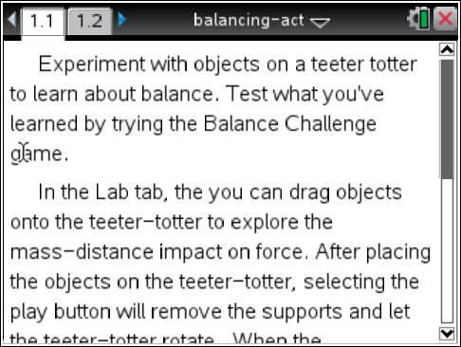
Launch the simulation.
When you start the simulation, the teeter-totter has blocks under either end to keep it from moving up and down. You then place people on either side of the teeter-totter at distances from the fulcrum. By default there is a 20-kg person in the space to the right. Selecting the blue arrows above the person will bring up other people and object of different masses.

Part 1: Exploring Balance
- Place two 20-kg people at the farthest end of each side of the teeter-totter. Press the Play button .  Q1. Describe what happened. | 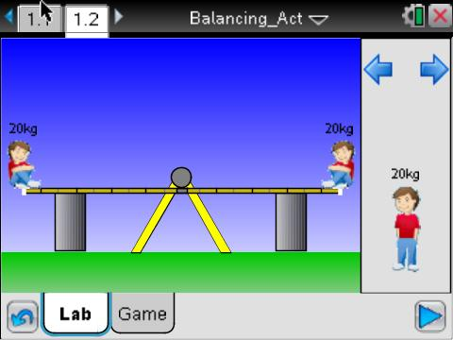
Notice that the teeter-totter has nine different tic marks on either side. These are the nine positions that a person can be placed on the teeter-totter. Since you placed the two 20-kg people on the farthest ends, they are each at position 9. (Note: You can place people at position zero, but for this activity we will be using the non-zero positions.)

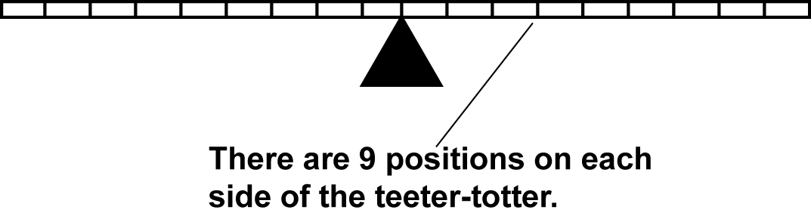
- Now place the two 20-kg people at position 8 on each side of the teeter-totter. Repeat with positions 7, 6, 5, 4, 3, 2, 1, and 0. Complete the table shown in Question 2. | 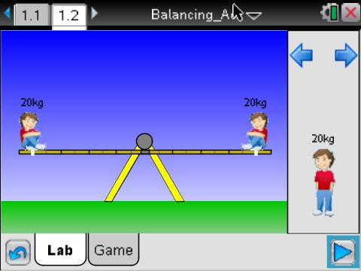
Q2. Complete the table shown below. For example, when the 20-kg people are the same distance apart, the result is B, a balanced lever. These entries in the table have been filled in. Move the people to the different positions and mark the result with an “R” (when the teeter-totter tilts down on the right) or “L” (when the teeter-totter tilts down on the left).

 | Position on right
 | 1 | 2 | 3 | 4 | 5 | 6 | 7 | 8 | 9
Position on left
1 | B
2 |  | B
3 |  |  | B
4 |  |  |  | B
5 |  |  |  |  | B
6 |  |  |  |  |  | B
7 |  |  |  |  |  |  | B
8 |  |  |  |  |  |  |  | B
9 |  |  |  |  |  |  |  |  | B

Q3. Based on your data, write a general statement that describes what happens when you place an equal amount of mass at equal distances on a teeter-totter. Then describe what happens to get an R or an L in the data table.

Part 2: Exploring Balance Using Different Masses
A teeter-totter is an example of a simple machine. The horizontal part is called a lever and the point about which the lever rotates is called the fulcrum. When mass is evenly distributed, the lever is horizontal.

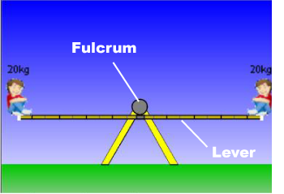
- You’ve seen what happens when you place the same amount of mass at different distances from the fulcrum. Now let’s see what happens when you place different masses on either side. Select the Reset 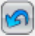 button to clear the screen. | 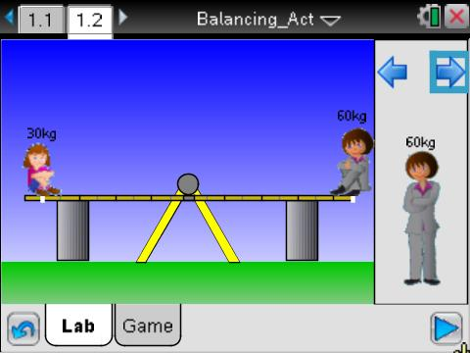
Q4. Complete the table shown below for a 30-kg person on the left and a 60-kg person on the right. Use the same symbols—B, R, and L—to indicate the tilt or balance of the lever. Use the right or left icons on the upper right to change your object.

 | Position on right for 60-kg person
 | 1 | 2 | 3 | 4 | 5 | 6 | 7 | 8 | 9
Position on left for 30-kg person
1
2
3
4
5
6
7
8
9

Q5. Look at your table. You will see that although the amount of mass on each side of the lever is different, there are some arrangements where the lever is balanced. For those cases, multiply the position on the lever by the mass of the person for each side of the lever. What do you notice?

Q6. Why do you think there were some cases where you could not get a Balance?

Part 3: Creating Balance
Suppose there are two different masses (m₁ and m₂) spaced at different distances (d₁ and d₂) from the fulcrum, but the arrangement is such that the lever is balanced.

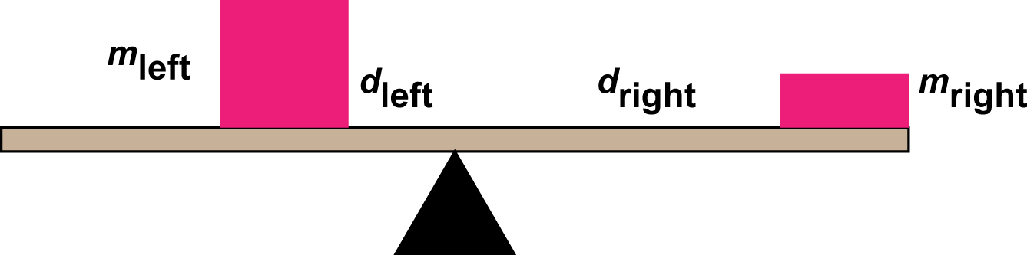

You have seen from your explorations that this balance can be expressed mathematically:

- Select the Reset button. Next, place a 30-kg and a 20-kg person on either end of the teeter-totter at position 9 and select Play. | 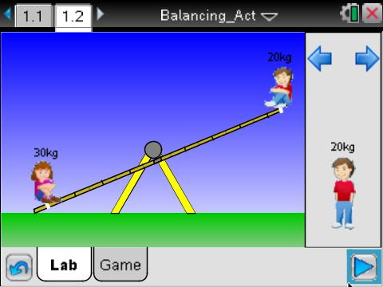
Q7. Use the equation above to calculate all the places where the two people can be placed to achieve balance. Verify your results by moving the people to those positions. Describe your results.

Q8. Select the Reset button. Next, place a 20-kg at farthest end of the teeter-totter and another 20-kg person, 3 units away from the fulcrum on the same side as the other person. Where would you need to place an 80-kg person to balance the lever? | 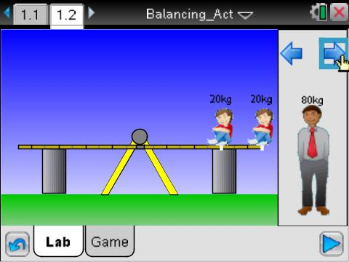
Q9. What is the mass of an object, 6 units from the fulcrum that balances a 30-kg person, 1 unit from the fulcrum on the other side? Use the formula to find the mass, and verify your results using the simulation. | 