You are encouraged to create the document for this activity.  Use the instructions for Creating a Document: Creating Perpendicular Bisectors. Follow the steps to create the document and then answer the questions below. If your teacher decides that you should not create the document, open the TI-Nspire document Creating_Perpendicular_Bisectors.tns. | 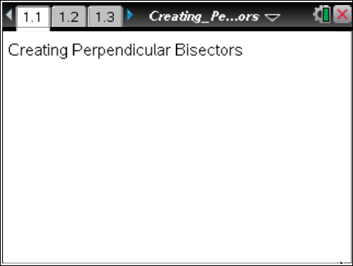

- Consider methods 1–5. Which of the methods allows you to change the length of the bisected segment so that it remains perpendicularly bisected?

- Classical constructions allow the use of only a straight edge and compass. Explain why each method is or is not considered a classical construction.

Move to page 1.2. | Press / ¢ and / ¡ to navigate through the lesson.
- a. Change the length of the segment in the upper part of the screen by grabbing one of the endpoints. What do you observe? | 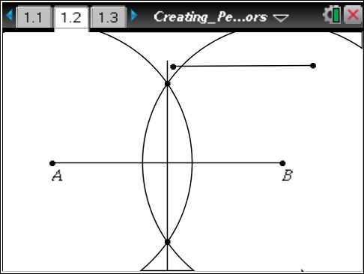
b. In a classical construction of a perpendicular bisector, you are instructed to open your compass to a length that is more than half the length of the given segment to be bisected. Explain why this instruction is necessary.

Move to page 1.3.  - a. Double-click in the text box that contains the number. Type in a different number. Press ·. Repeat this process several times. Describe what happens. | 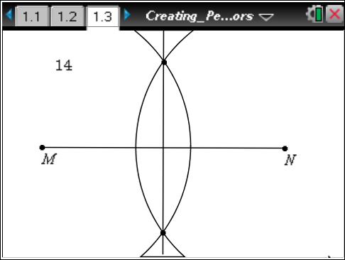
b. Estimate the length of the bisected segment.

c. Choose a radius that is bigger than the length of the segment. What happens? (Note: You may have to grab the screen in a white space and use the NavPad to see what is going on above and below your handheld screen.)

- What is the difference between method 3 and method 5?

- If the intersection points of the two circles are labeled D and E, what kind of triangles are ΔMDN and ΔMEN? Explain how you know.

- Of the five methods, which do you prefer? Why?

