Open the TI-Nspire document Watersheds.tns.  A watershed is an area of land that drains to a particular body of water. Agriculture, deforestation, road-building, and urban sprawl are human activities that change the amount of vegetation within a watershed. As you will see in this simulation, less vegetation in a watershed means a change in the actions of water and wind, the agents of erosion that wear away at the earth’s surface. When scientists measure water quality in a watershed, one of the factors they consider is turbidity. |  | 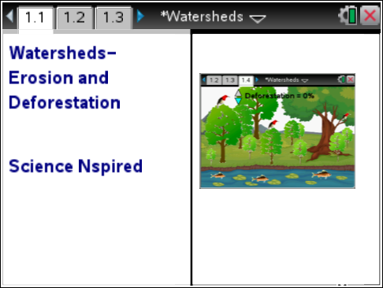
Turbidity is a measure of the clarity of the water due to the amount of undissolved solids in the water.

In this activity, you will be studying the effects of deforestation on the turbidity of the water and on the living things in a watershed.

Move to page 1.2. Answer question 1 below and/or in your .tns file.
Q1. Predict what will happen to the turbidity of a stream as the trees and vegetation along the banks are removed.

Move to page 1.3.
1. Read the description of the deforestation simulation for page 1.4.

Move to page 1.4.  2. After reading the directions for the simulation, you can close the pop-up Directions box by selecting . You can view the directions again by selecting b > Watersheds > Directions.  3. Use the Deforestation arrows to increase/decrease the amount of trees and ground cover in this watershed. Remember, you should observe water clarity (turbidity), number of plants and animals, and erosion of the stream bank. |  | 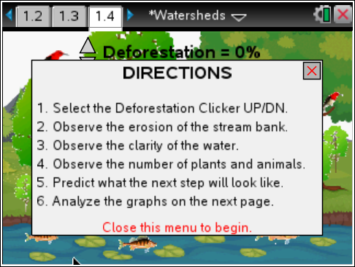  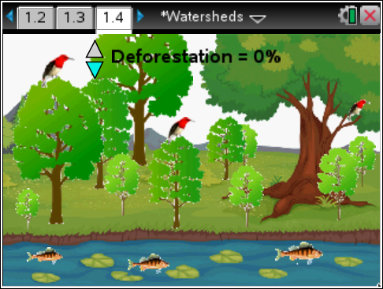
 | Tech Tip: To read the directions again, select 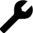 > Watersheds > Directions. You may need to back-out to the main Tools Menu to see the desired menu option.
Move to pages 1.5 – 1.6.
4. Use the spreadsheet of the data on page 1.5 and the graph on page 1.6 to review the quantitative data collected and answer the questions.
 | Tech Tip: To scroll through data in the spreadsheet on screen 1.5, press your finger anywhere on the screen and drag it up or down.
Move to pages 1.7 – 1.9. Answer questions 2-4 below and/or in your .tns file.
Q2. What happens to the turbidity of the stream as the percent of deforestation increases?

  - Turbidity increases.
  - Turbidity decreases.
  - Turbidity stays the same.

Q3. Is there a positive correlation or an inverse relationship between deforestation and the turbidity of the water? Explain your reasoning.

Q4. Based on your qualitative observations, what was happening to the stream banks as the percent of deforestation increased?

Move to pages 1.10 – 1.12. After analyzing the graph, answer questions 5 and 6 below and/or in your .tns file. Then, answer question 7 below.
Q5. What happens to the populations of living things in this stream's watershed as the percent of deforestation increases?

- Population increases.
- Population decreases.
- Population stays the same.

Q6. Is there a positive correlation or an inverse relationship between deforestation and the habitat populations? Explain your reasoning

Q7. Propose a hypothesis for how turbidity affects the aquatic life in a watershed.

