Overview

In this activity, you will generate a set of random tosses of two dice, record the sum of the faces, and create a dotplot of the results.

Materials

• TI-Nspire™ handheld or Teacher Software

Step 1—Preparing the document  1. Open a new document on the handheld by pressing c > New Document. Open a new document in the Teacher Software by clicking File > New.  2. Select Add Notes. | 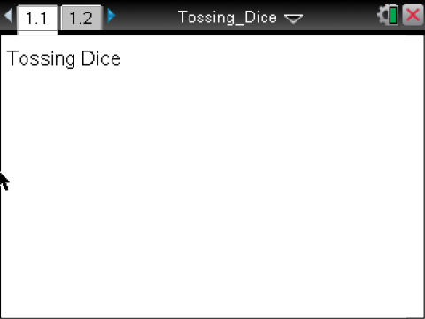
3. Type Tossing Dice on the Notes page.
Note: To obtain capital letters, press the g key, then the letter.
4. Press ~ > File > Save As Ö and type the file name Tossing Dice. Press e to ¾ , and press ·.
5. To control the number of decimals in the calculations, press Doc > Settings & Status > Settings > General > Display Digits. Use the scroll bar on the right to select Fix2 and press ·.
6. To add a new page, press / ~ > Add Notes.

Step 2—Generating Random Tosses and Summing
7. Press / M to create an interactive math box. With the cursor inside the box, type faces:={ . Inside the brace, type 1,2,3,4,5,6} to represent the faces of a die. Press ·.

Note that pressing · might automatically send you to a new line and a new math box. If it does not, press · again, and follow the steps to create a new math box.
8. To "toss" two dice, press / M to create another math box. Type r:=RandSamp(faces,2), and press ·.  - You should see two randomly generated faces of the dice.  9. Create a math box as above, type sumf:=sum(r), and then press ·.  - You should see the sum of the two faces you generated above. | 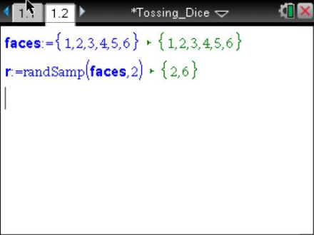
To accumulate a set of sums of the random faces, you must first start a list.  10. Type sum_faces:={, and press ·.  - You should see an empty list.  11. Type sum_faces:=augment(sum_faces,{sumf}), and press ·.  - You should see a list with the sum for the two random faces.  12. To add sums to the list, move the cursor to the second line, and place the cursor right after the equal sign before the r, r:=|RandSamp(faces,2).  13. Press · to see a second pair of faces and a second sum added to the list.  - Each time you press ·, you will generate a new toss of the dice, and the sum of the faces will be added to the list.  Note: Do not press · more than two or three times. Finish the directions, then answer the questions on the worksheet, which will indicate how many sample sums you want. | 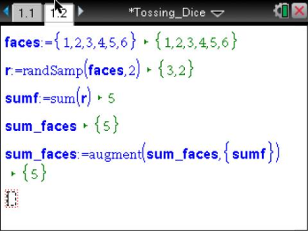  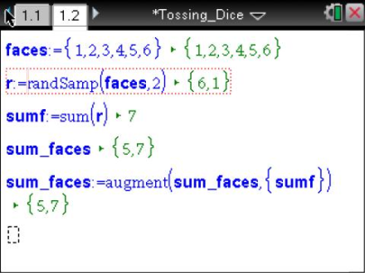
Step 3—Creating a Dotplot  14. To create a dotplot on the same screen as the random dice, split the screen by pressing ~> Page Layout > Select Layout > Layout 2, which has two vertical panels.  15. Move the cursor to the new screen, select MENU > Add Data & Statistics. | 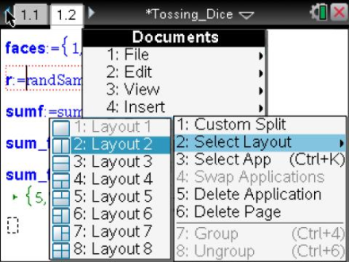
16. Move the cursor to the text Click to add variable, click, and select sum_faces. Press ·.  Note that the opening Data & Statistics screen is a random display of the data from the Lists & Spreadsheet. | 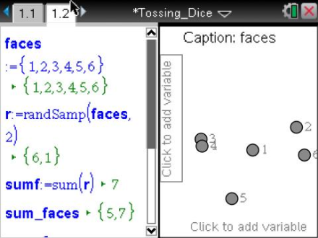
17. To set the window, select MENU >Window/Zoom > Window Settings…  - Because the sum of the faces has to be between 2 and 12, set the window a bit larger with minimum 0 and maximum 14.  - Click OK. | 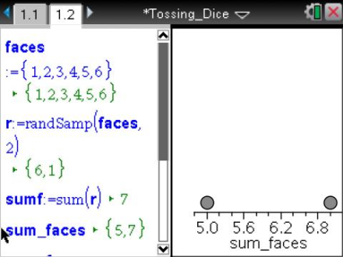
18. To add sums to your list, move the cursor in the left panel to a position after the equals sign and before the RandSamp and press ·.  - Each time you press ·, you add another sum to the dotplot.  Note that if enough additional points are added, the screen will rescale.  19. Go to the Tossing Dice Student worksheet, and follow your teacher's directions to answer the questions. | 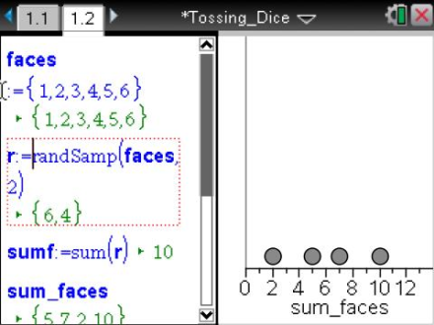
20. To save your document on the handheld, press /». To save your document on the computer, select File > Save or press CTRL + s.

