Activity Overview  In this activity, students use a combination of algebra and graphing to discover the properties of logarithms. Given an equation such as b = a² and a table of values for a, students define x = log a and y = log b and graph the resulting sets on the coordinate plane, graphically “taking the log of both sides.” Finding the equation of this graph and working backwards reveals an equation that expresses one of the properties of logarithms. Seeing a power function transformed into a linear function visually reinforces the effect of the log. Problems 1 and 2 cover the Power and Product Properties, respectively; Problem 3 covers the Quotient Property in addition to introducing log-log “paper”, a grid with a logarithmic scale on each axis.  Topic: Exponential & Logarithmic Functions  - Derive algebraically the rules for products, quotients, and powers of logarithmic expressions.  - Verify graphically the rules for products, quotients, and powers of logarithmic expressions.  Teacher Preparation and Notes  - This activity is appropriate for students in Algebra 2 or as a review for Precalculus. Prior to beginning this activity, students should be familiar with the definition of a logarithm and have experience with simple exponential equations of the form a^{x}=b, as well as the exponent rules.  - Before beginning the activity, students should transfer the CabriTM Jr. file LOGLOG to their graphing calculators. Students should also clear all lists from the list editor by pressing  ☹ and selecting ClrAllLists.  - To download the student worksheet and CabriTM Jr. file, go to education.ti.com/exchange and enter “99606” in the keyword search box.  Suggested Related Activities  To download any activity listed, go to education.ti.com/exchange and enter the number in the keyword search box.  - Exponential Reflections (TI-84 Plus family) — 12276  - Wrapping It All Up (TI-84 Plus family) — 4290 | 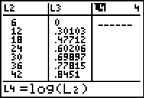  This activity utilizes MathPrintTM functionality and includes screen captures taken from the TI-84 Plus Silver Edition. It is also appropriate for use with the TI-83 Plus and TI-84 Plus but slight variances may be found within the directions.  Compatible Devices:  - TI-84 Plus Family  Software Application:  - CabriTM Jr.  Associated Materials:  - PropertiesOfLogarithms_Student.pdf  - PropertiesOfLogarithms_Student.doc  - LOGLOG.8xv  Click HERE for Graphing Calculator Tutorials.

Problem 1 – The Power Property of Logarithms
In this problem students will explore how to simplify the logarithm of a power, like log a².  They will start by defining a new variable b = a², making a table of values for a and b using the calculator’s List feature.  L1: 10 values of a within the logarithm domain  L2: values of b using the formula L1² (  ○) |  | 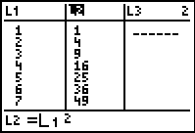
Students will set up a scatter up with the settings given on the worksheet. They should make sure that all functions in the □ screen have been turned off before viewing the plot.  Students may relate this graph to half of a parabola. |  | 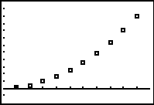
Now they will define two new variables, x and y, letting x = log a and y = log b.  L3 values of x using the formula log(L1) (  )  L4 values of y using the formula log(L2) (  ) |  | 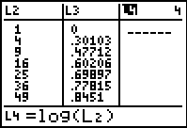
Now students will change Plot1 to set up a scatter plot of with L3 as the Xlist and L4 as the Ylist.  Students should notice that the plot forms a straight line. Ask them what appears to be different about this plot as compared to the previous one (spacing of points). This will prepare them for Problem 3. |  | 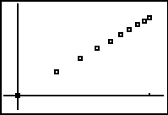
Students are directed to find the equation of a line through these points with the LinReg command. The command should appear on the Home screen as LingReg(ax+b) L3, L4. |  | 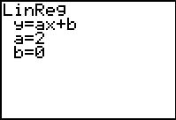
If using MathprintTM OS:  When entering the command for the regression equation, students can enter Y1 by either (1) press    and select Y1 or (2) press   and select Y1. |  | 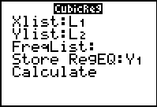
The equation that results is y = 2x.
The worksheet shows students how to rewrite this equation in terms of a, which gives an example of the Power Property of Logarithms. Be sure that students fully understand this property before moving onto Problem 2.
Note: When using the Regression commands, students do not need the Stat Diagnostics displayed. To turn this off, press   [D] and select DiagnosticOff. Then press  on the Home screen. This should be done before using LinReg. |  | 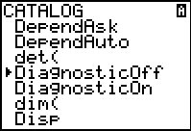
If using MathprintTM OS:  The Diagnostic feature can be turned off from the Mode screen. Students can press  and press enter on OFF next to STATDIAGNOSTICS. Then press   to return to the Home screen. |  | 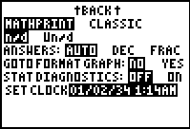
Problem 2 – The Product Property of Logarithms
Students will follow the process of Problem 1 to explore how to simplify the logarithm of a product, like log 6a.  They will start by defining a new variable b = 6a.  Students need to clear all the data from L2-L4, but not from L1. To clear these lists, they can move to the top of a column and press  .  L1: 10 values of a within the logarithm domain  L2: values of b using the formula 6∗L1 (   ) |  | 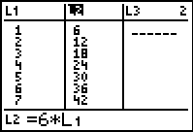
Students will change Plot1 to set up and view a scatter plot of L1 as the Xlist and L2 as the Ylist.  They are to make a prediction as to what the slope and y-intercept of the line is, and then use the LinReg command to find the actual values. |  | 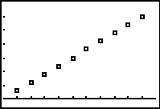
Now they will define two new variables, x and y, letting x = log a and y = log b.
L3 values of x using the formula log(L1) (  )
L4 values of y using the formula log(L2) (  )
After viewing the scatter plot with L3 as the Xlist and L4 as the Ylist, students should see that the data appears linear. They should also notice that the points form the same pattern as they did in Problem 1.  Using the LinReg command, students will find the equation of a line through these points. They should have found that the equation of the line was y = x + 0.778151.  10^{0.778151} ≈ 6  The worksheet gives an opportunity for students to rewrite this equation in terms of a, which then gives an example of the Product Property of Logarithms. Be sure that students fully understand this property before moving onto Problem 3. |  | 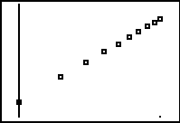
 |  | 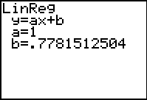
Problem 3 – The Quotient Property of Logarithms
In this problem, students will use log-log “paper” to simplify the expression log $\frac{8}{a}$.  To see an example of log-log paper, launch the CabriTM Jr app and open the file LOGLOG. Students should see that the line of the grid resemble the spacing of the scatter plots of L3 vs. L4. |  | 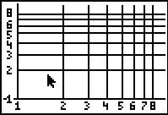
Explain to students that log-log paper is made by taking the log of each value of x and y and then renumbering the axes. They should note that the spaces between the lines are not equal. That is because the distance from 1 to 2 on a log scale is equal to log 2 units, and the distance from 1 to 3 is equal to log 3 units.
They will first define b = $\frac{8}{a}$.  To plot the points from the function y = $\frac{8}{x}$ on the log-log paper, students are to only use the points with whole number coordinates. There will be four points (1, 8), (2, 4), (4, 2), and (8, 1). |  | 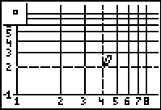
To plot a point, students need to press  for the F2:Creation menu and select Point. When the lines of the intersection are flashing, students should press .
They should see that the shape of the graph is linear.
To draw a line through the points, students need to press  for the F2:Creation menu and select Line. When the point is flashing, students should press , move to the next point and when it flashes press .  The equation of this line with respect to the linear scale (not the log scale) is y = 0.90309 – x.  10^{0.90309} ≈ 8 |  | 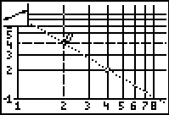
The worksheet gives an opportunity for students to rewrite this equation in terms of a, which then gives an example of the Quotient Property of Logarithms.

To close the activity, explain to students that base 10 logarithms were used throughout this activity for convenience only. These properties apply to logarithms with any base.
Solutions – Student Worksheet
1. half of a parabola  2. straight line  3. y = 2x  4. straight line  5. Slope = 6 and y-intercept = 0  6. y = 6x  7. y = x + 0.778151 | 8. 0.778151  9. log(6)  10. 10^{0.778151} ≈ 6, log(6) ≈ 0.778151  11. log-log paper is made by taking the log of each value of x and y and then renumbering the axes  12. straight line  13. log(8)  14. 0^{0.90309} ≈ 8, log (8) ≈ 0.90309

