Open the TI-Nspire document Complex_Number_ Multiplication.tns.  In this activity, you will compute the product of two complex numbers, discover the pattern in the powers of and consider the product of complex conjugates. In addition, you will visualize a complex number in polar form and use this representation to characterize complex multiplication geometrically.  . | 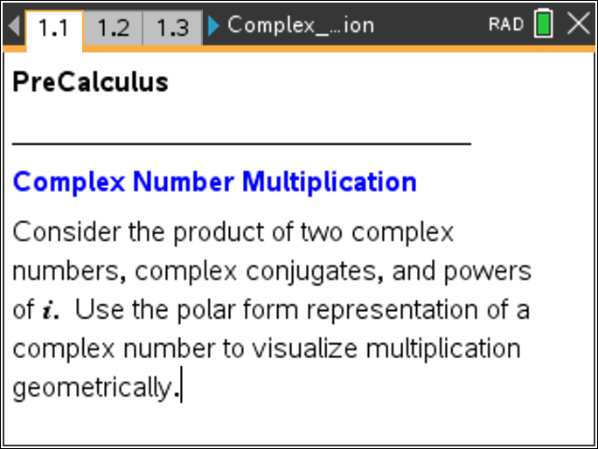

Move to page 1.2.

1. This Notes Page contains three interactive Math Boxes for the complex numbers and and the product
a. Redefine and/or as necessary to complete the following tables. Note: to redefine or , edit the Math Box following the assignment characters, .

 Tech Tip: To access on the handheld, press ¹ to obtain a list of mathematical symbols. Use the arrow keys to highlight and press ·.

b. Let and Write the product, symbolically in terms of the constants and
Move to page 1.3.

2. This Notes Page contains two interactive Math Boxes to produce a sequence of the powers of That is, it constructs a sequence of the form The variable end is the largest value the sequence variable will assume, in this case the last power of .
a. Change the value of the variable end as necessary to complete the following tables. Note: the variable end is defined in a Math Box. To redefine the value of end, edit the Math Box following the assignment characters, .

 | 1 | 2 | 3 | 4 | 5 | 6 | 7 | 8

 | 9 | 10 | 11 | 12 | 13 | 14 | 15 | 16

b. In words, describe the pattern in the powers of

c. Without using your calculator, use your answer in part 2b to find and

Move to page 1.4.

3. This Notes Page contains three interactive Math Boxes for the complex number its complex conjugate (denoted ), and the product
a. Change the value of as necessary to complete the following table. To change the value of , edit the Math Box following the assignment characters,

b. For , find
c. Recall that a complex number can be represented by a point in the complex plane. For find and interpret this value.

Move to page 2.1.

For any complex number , the absolute value, or magnitude, is
The absolute value is the distance from the origin to the point representing in the complex plane. The argument of the complex number is the angle (in radians) formed between the positive real axis and the position vector representing The angle is positive if measured counterclockwise from the positive real axis.
4. On Page 2.1, the complex number is represented by a point and a position vector. The value of the absolute value, and the argument are given on this page. Drag and position as necessary to answer the following questions.
Describe the location of the point representing in the complex plane if:
a. and

b. and

c. and

d. and

e. and

f.

g.
Move to page 3.2.

Any complex number with and can be written in polar form as Page 3.2 illustrates the product of two complex numbers in polar form.

5. The complex numbers and are represented by triangles. When you drag either the point or the point , the product is automatically computed, and the triangle representing is updated. Note that a copy of the triangle representing is rotated so that the vertex lies along the hypotenuse of the triangle that represents Move and around the first quadrant, and observe the absolute value and argument for the three complex numbers.
a. Write an equation which seems to define in terms of and

b. Write an equation which seems to define in terms of and

Move to page 4.1.

On Page 4.1, click on the arrows to step through the process of multiplication. This figure might provide further insight about the relationship among the absolute values and arguments.

Tech Tip: To animate the figure, select the slider, press / b, and select Animate.
 Tech Tip: To animate the figure, tap and hold the slider and select Animate.
Move to page 5.1.

6. Use this Lists and Spreadsheet page to test your hypotheses. Consider various values for and (cells A1 and A2) in polar form and try to prove your guess.

