Open the TI-Nspire document DNA_Replication.tns.  All living organisms carry their genetic information in DNA. As those organisms grow or reproduce, it is important that they can replicate this DNA without making errors. The human genome is more than 3 billion base pairs long; imagine copying that much information without making a single mistake! The very elegant manner in which DNA replicates is generally the same for all organisms, from bacteria to you! | 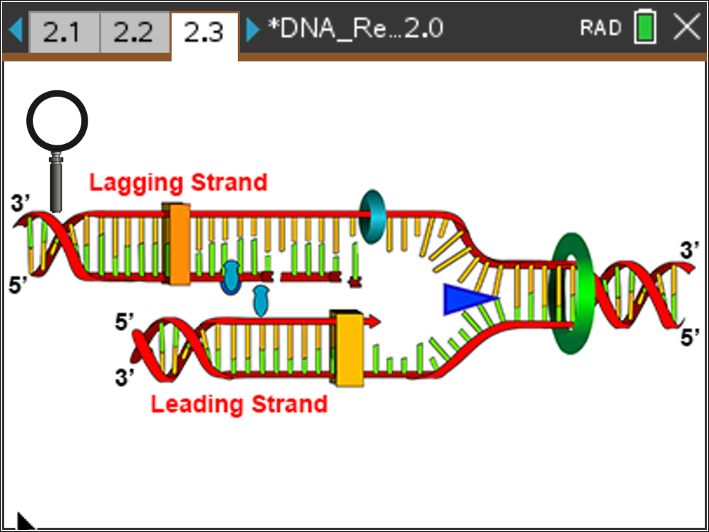
Move to pages 1.4 – 1.5. | Press /¢ and /¡ to navigate through the lesson.
1. In this lesson you will learn about DNA replication by interacting with some simulations that will demonstrate some of the key features of DNA replication. Before you start with that, you'll answer some questions to help you start thinking about DNA replication.
Answer questions 1–2 here and/or in the tns file.
Q1. Why is it important to replicate DNA without errors? What might happen if there were errors in DNA replication?

Q2. When should DNA be replicated? What life events would include DNA replication?

Move to pages 1.6 – 1.7.  2. Read the information on page 1.6 about semi-conservative DNA replication. On page 1.7, you will see a simulation of two rounds of DNA replication. Click the right arrow to view the rounds of replication.  Answer questions 3–5 here and/or in the tns file. | 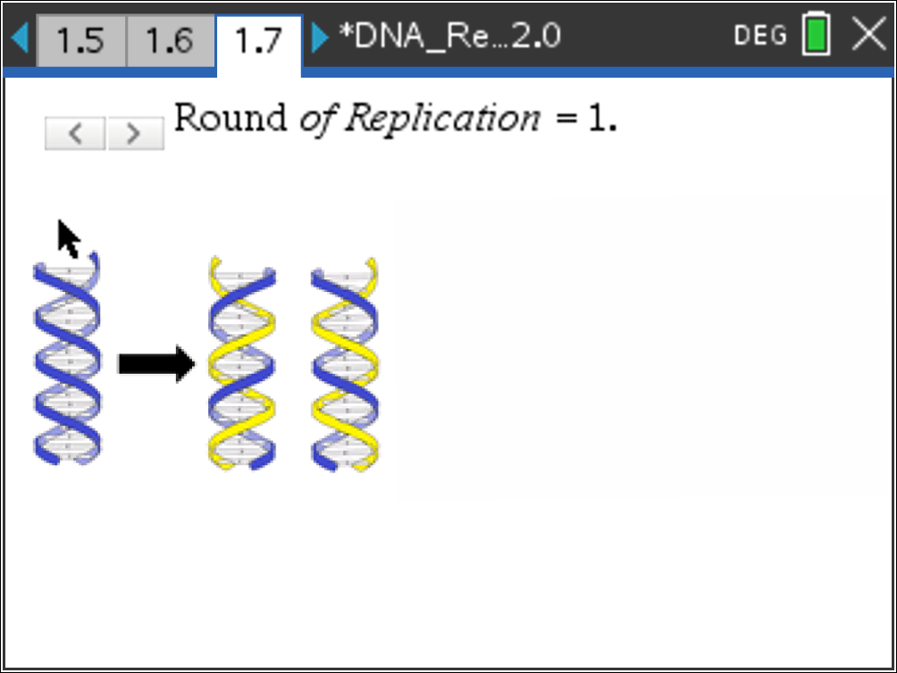
Q3. If one double helix of DNA replicates 3 times, how many double helices will there be?

- 4
- 6
- 8
- 10
Q4. What happens to the original template DNA after a round of replication? Explain.

Q5. DNA polymerase, the enzyme that replicates DNA, can add about 1,000 bases per second to the growing DNA strands. How many seconds would it take DNA polymerase to replicate one set of human chromosomes (3,000,000,000 bases long)?

Move to pages 2.1 – 2.3.  3. Read the information on pages 2.1 and 2.2 about the enzymes that are used in DNA replication. On page 2.3, read the directions given and then explore the enzymes that are involved in the replication of DNA. | 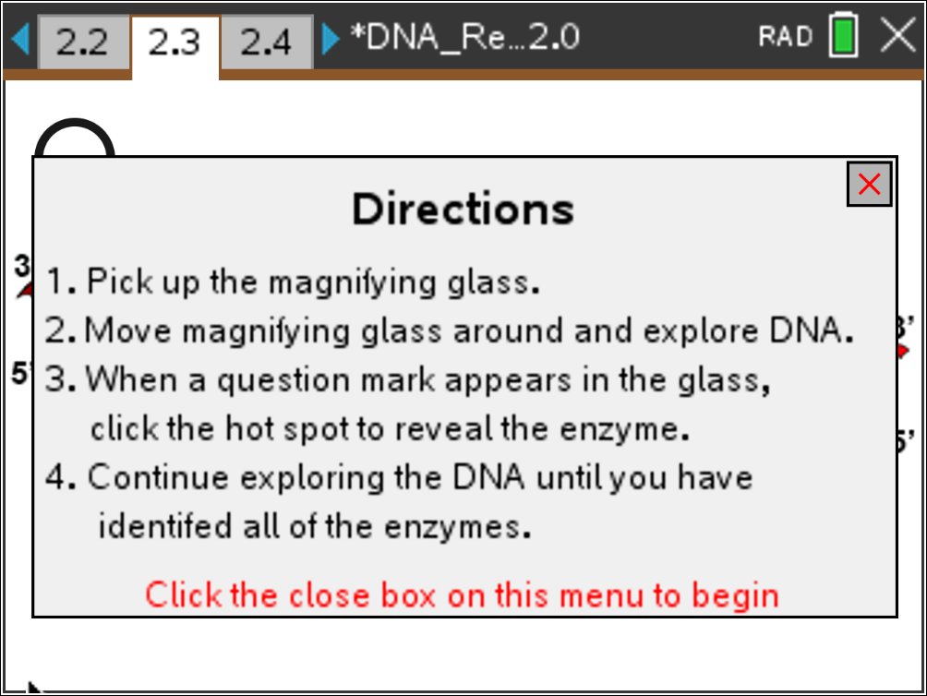
Click to close the directions and view the simulation. If needed at any time during the simulation, press b to view the directions again.
Answer questions 6–10 here and/or in the tns file.
Q6. Which enzyme acts first in DNA replication?

- Helicase
- Primase
- Polymerase
- Ligase

Q7. DNA replication uses two different polymerases. Why do you think that is?

Q8. What is the difference between the leading strand and the lagging strand?

Q9. What is the purpose of primase?

- Recruits other enzymes for replication
- Creates an RNA primer that Polymerase III can elongate
- Elongates the replicating DNA
- Connects DNA fragments together
Q10. Which enzyme(s) add(s) new DNA nucleotides to an existing strand? (Select all that apply.)

- Primase
- Ligase
- Polymerase I
- Polymerase III

Move to pages 3.1 – 3.3.
4. Read the information on pages 3.1 and 3.2 about Okazaki Fragments. On page 3.3, you will use a simulation of DNA replication. This will show how Okazaki fragments are built and then joined. Drag the circle along each segment slowly, following the directions. Be sure to read the information that appears as you drag the circle. (Tip: if you need to reset, move the circle back to ‘starting point’ on each slider bar to ‘rewind’ and start again)
Answer questions 11–14 here and/or in the tns file.
Q11. Replication of the leading and lagging strands requires different enzymes.

A. Agree
B. Disagree

Q12. Which order best describes the order that these enzymes will act during normal replication?

- Polymerase I, Polymerase III, Ligase, Primase
- Primase, Polymerase III, Ligase, Polymerase I
- Polymerase III, Primase, Polymerase I, Ligase
- Primase, Polymerase III, Polymerase I, Ligase

Q13. How is replication of the leading and lagging strands different?

Q14. Why are there no Okazaki fragments on the leading strand?

