Open the TI-Nspire document Relatives_of_the_Sine_Law.tns.  In this activity, you will examine several variations of the Law of Sines and determine the type(s) of triangles for which each variation is true. | 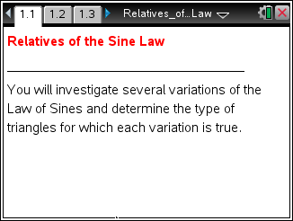

The Law of Sines states: or for any triangle ABC with angles A, B, and C and sides AB = c, AC = b, and BC = a.
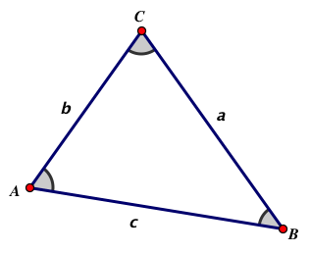
Read page 1.2, and move to page 1.3.

1. Consider . Drag vertices A, B, and C to gather data, and then complete the conjecture below:

If , then ABC is ________________________________________.

2. Verify your conjecture using algebra, the Law of Sines, the Law of Cosines, or other “trig identities.”

Read page 2.1, and move to page 2.2.

3. Consider . Drag vertices A, B, and C to gather data, and then complete the conjecture below:

If , then ABC is ________________________________________.

4. Verify your conjecture using algebra, the Law of Sines, the Law of Cosines, or other “trig identities”.

Read page 3.1, and move to page 3.2.

5. Consider . Drag the points A, B, and C to gather data, and then complete the conjecture below:

If , then ABC is ______________________ or __________________.

6. Verify your conjecture using algebra, the Law of Sines, the Law of Cosines, or other “trig identities”.

Read page 4.1, and move to page 4.2.

7. Propose another variation (relative) of the Sine Law and then investigate the type(s) of triangles for which your variation is true.
Hint: Consider a variation involving both sine and cosine, or one involving the tangents of the angles of the triangle.

