Open the TI-Nspire document Variables_on_Both_Sides.tns.  This activity lets you use a number line to compare the values of two variable expressions. | 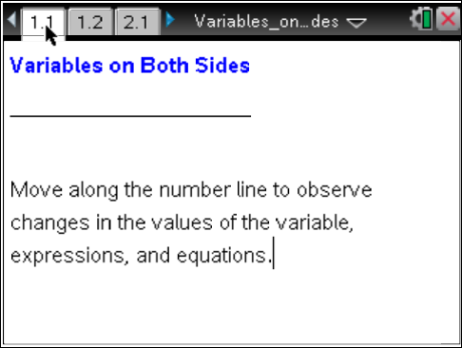

Move to page 1.2. | Press / ¢ and / ¡ to navigate through the lesson.
1. As you grab the point and move the arrow beneath the number line, what changes? What stays the same?

2. a. Describe the differences in the values of the expressions on the left side and the right side.

b. Move the arrow to try several new values for x. What is true about the difference in the values of the expressions?

3. Gail says that if she were asked to solve the equation 2x + ⁻4 = 2x + 1, she could find a value of x that would be a solution. Eric says, “That’s impossible.” Who is correct? Justify your answer.

Move to page 2.1.

4. a. Examine the expressions on the left and right sides. Describe the differences between the expressions and their values.

b. Find x so that the difference between the two expressions is 8.

c. Find x so that the difference between the two expressions is 4.

5. Gail says that if she were asked to solve the equation 2x + –4 = 3x + 1, she could find a value of x that would be a solution. Eric says “That’s impossible.” Who is correct? Justify your answer.

6. Predict what would happen if the 2 on the left side of the equation were a 3. Explain your reasoning. Change the 2 to a 3 and see if you are correct.

Move to page 3.1.

7. As you move the arrow for point x, what changes? What stays the same?

8. How many solutions are there to the equation 4x + 3 = 2(2x +1) + 1? Explain your reasoning.

9. Simplify the right side of the equation by distributing and combining like terms. Does this support your response to #8?

10. Describe the characteristics of an equation that would have the solution given below. (Hint: Review the equations that you have explored in this activity.) Also, write an example of an equation for each solution.
a. no solution (empty set)

b. one solution

c. infinitely many solutions

