|  |  |
| --- | --- |
| **Math Objectives**   * Students will explore the family of logarithmic functions of the form $f\left(x\right)=c∙ \log_{b}\left(x+a\right)$ and describe the effect of each parameter on the graph of $y=f(x)$. * Students will determine the equation that corresponds to the graph of a logarithmic function. * Students will understand how a vertical shift in the graph of a logarithmic function is related to properties of logarithmic functions. * Students will look for and express regularity in repeated reasoning (CCSS Mathematical Practice). * Students will look for and make use of structure (CCSS   Mathematical Practice).  **Vocabulary**   * Logarithmic function • natural logarithm • translation * parameter • reflection   **About the Lesson**   * This lesson involves the family of logarithmic functions of the form $f\left(x\right)=c∙\log_{b}\left(x+a\right)$. * As a result, students will: * Manipulate parameters, and observe the effect on the graph of the corresponding logarithmic function. * Make a general statement about the effect of each parameter on the graph of the logarithmic function. * Match specific logarithmic functions with their corresponding graphs. * Relate properties of logarithmic functions to vertical translations of their graphs.   **Teacher Preparation and Notes**.   * This activity is done with the use of the TI-84 family as an aid to the problems.   **Activity Materials**   * Compatible TI Technologies: TI-84 Plus*, TI-84 Plus Silver Edition*, TI-84 Plus C Silver Edition, TI-84 Plus CE   *\* with the latest operating system (2.55MP) featuring MathPrintTM  functionality.* | **Tech Tips:**   * This activity includes screen captures taken from the TI-84 Plus CE. It is also appropriate for use with the rest of the TI-84 Plus family. Slight variations to these directions may be required if using other calculator models. * Watch for additional Tech Tips throughout the activity for the specific technology you are using. * Access free tutorials at <http://education.ti.com/calculators/pd/US/Online-Learning/Tutorials>   **Lesson Files:**  *Student Activity*  Transformations of Logarithmic Functions_84CE_Student.pdf  Transformations of Logarithmic Functions_84CE_Student.doc |

|  |  |
| --- | --- |
| In this activity, you will examine the family of logarithmic functions of the form  where and are parameters. You will turn on the **Transformation App** on your handheld to manipulate these parameters. |  |

# ____________________________________________________________________________

# Discussion Points and Possible Answers

**Tech Tip:** To change the parameters throughout this activity using the **Transformation App** on the handheld, you will be using the arrow keys. Up and down move you from parameter to parameter, left and right change the value of each parameter. While on the graph, you can press Setup (graph) to manually change the parameters, including using decimals, or just type in the number you want while your cursor is on the parameter. You can use up to two functions in the app and they can be typed into $Y_{1}$ or $Y_{2}$.

The parameter  is the base of the logarithmic function and  Using the transformation app, change the value of a parameter by entering the equation for each question into Y1 and Y2, and pressing the arrow keys to manipulate each parameter of the function on the graph. At the end of this activity, you can use your graphs from the handheld to match each function with its corresponding graph.

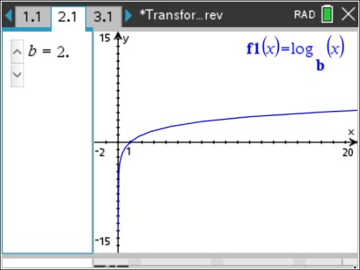 **Question 1**

1. Graph the following function into Y1: .

Press the arrows to change the value of $B$, and observe the changes in the graph of $Y_{1}$.

1. Explain why for every value of $B$ the graph of $Y_{1}$ passes through the point 

**Sample Answers:** The graph of $Y_{1}=\log_{B}{x}$ passes through the point (1,0) for all values of $b>0$ since

$Y_{1}\left(0\right)=\log_{B}{1}=0$. The *x* -intercept is 1. There is no

*y* - intercept.

1. For $B>1$, describe the graph of $Y_{1}=\log_{B}{x}$.

**Sample Answers:** The graph is always increasing. As *x* increases without bound, the values of $Y_{1}$ also increase without bound. As *x* gets closer to zero from the right $\left(x →0^{+}\right)$, the values of $Y_{1}$ decrease without bound, go to $-∞$. The graph is smooth with no sharp edges or corners, and

is also continuous with no jumps or breaks.

Note: For some values of *B*, the graph of $Y_{1}$ might not appear to be decreasing quickly near 0. However, the function values do continue to decrease such that $Y_{1} → -∞$. Consider asking students to construct a table of function values as *x* gets closer to 0.

1. For $0<B< 1$, describe the graph of $Y_{1}=\log_{B}{x}$.

**Sample Answers:** The graph is always decreasing. As *x* increases without bound, the values of $Y_{1}$ decrease without bound, go to $-∞$. As *x* gets closer to zero from the right $\left(x → 0^{+}\right)$, the

values of $Y_{1}$ increase without bound, go to $∞$. This graph is also smooth and continuous.

Note: For some values of *B*, the graph of $Y_{1}$ might not appear to be increasing quickly near 0. However, the function values do continue to increase such that $Y_{1} → ∞$. Consider asking students to construct a table of function values as *x* gets closer to 0.

1. Find the domain and range of function $Y_{1}= \log_{B}{x}$ for all possible values of $B$.

**Sample Answers:** The domain is $x>0$, and the range is all real numbers: $\left(-∞, ∞\right)$.

1. Describe the behavior of the graph of $Y_{1}= \log_{B}{x}$ near the *y –*axis in words and using limit notation.

**Sample Answers:** For $B>1$: as *x* approaches 0 from the right, the values of the function decrease without bound and the graph gets closer and closer to the *y* -axis, but never touches it (0 is not in the domain of the function). $\lim_{x → 0^{+}}{Y_{1}= -∞}$

For $0<B<1$: as *x* approaches 0 from the right, the values of the function increase without bound and the graph gets closer and closer to the *y* -axis, but never touches it. $\lim_{x → 0^{+}}{Y_{1}= ∞}$

The *y* -axis, or the line $x=0$, is a vertical asymptote to the graph of $y= \log_{B}{x}$.

Note: This would be a great time to discuss with the students what happens when $b=1$.

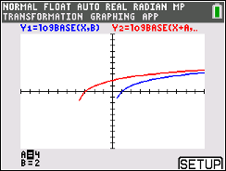

**Question 2**

2. Graph the following function into $Y_{2}$: $Y_{2}= \log_{B}{(x+A)}$. For various   
 (fixed) values of $B$, click the arrows to change the value of $A$, and   
 observe the changes in the graph of $Y_{1}$. Describe the effect of the   
 parameter $A$ on the graph of $Y_{2}= \log_{B}{(x+A)}$.

**Sample Answers:** For $A>0$, the graph is translated horizontally, or moved, left *a* units. For $A<0$, the graph is translated right *a* units.

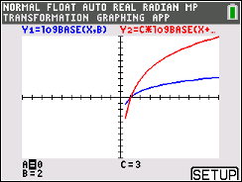

**Question 3**

3. Graph the following function into $Y_{2}$: $Y_{2}= C∙\log_{B}{(x+A)}$. For   
 various (fixed) values of $A$ and $B$, click the arrows to change the   
 value of $C$, and observe the changes in the graph of $Y_{1}$. Describe   
 the effect of the parameter $C$ on the graph of $Y_{2}= C∙\log_{B}{(x+A)}$.

**Sample Answers:** For $\left|C\right|>1$, the graph is stretched vertically. For $\left|C\right|<1$, the graph is contracted vertically. If $C<0$, the graph is reflected across the *x* -axis.

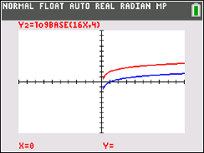

**Question 4**

4. Consider a logarithmic function of the form $Y_{1}= \log_{B}{(Dx)}$ where   
 *D* is a constant. Turn off the Transformation App by selecting   
 Quit-App on the $y=$ screen. Graph each function given and   
 answer the following questions.

* 1. Display the graphs of $Y_{1}= \log_{4}\left(x\right)$ and

$Y_{2}= \log_{4}{(16x)}$.

1. How is the graph of $Y_{2}$ related to the graph of $Y_{1}$?

**Sample Answer:** The graph of $Y_{2}$ is a vertical shift, up 2 units, of the graph of

$Y_{1}$.

1. Using the properties of logarithms, rewrite the function $Y_{2}$ in terms of $Y_{1}$ to justify your answer.

**Sample Answer:** This equation,

, illustrates the vertical shift, or translation.

1. Describe the two equivalent transformations that $Y_{2}= \log_{4}{(16x)}$ performs on the parent function $Y_{1}= \log_{4}{x}$.

**Sample Answer:** The vertical shift, or translation, of 2 was equivalent to a horizontal dilation by a factor of .

* 1. 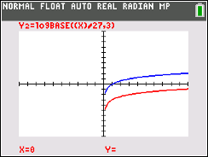Display the graphs of $Y_{1}= \log_{3}{(x)}$ and

$Y_{2}= \log_{3}\left(\frac{x}{27}\right)$.

1. How is the graph of $Y_{2}$ related to the graph of $Y_{1}$?

**Sample Answer:** The graph of $Y_{2}$ is a vertical shift, down 3 units, of the graph of $Y_{1}$.

1. Using the properties of logarithms, rewrite the function $Y_{2}$ in terms of $Y_{1}$ to justify your answer.

**Sample Answer:**   
This equation, , illustrates the vertical shift, or translation.

1. Describe the two equivalent transformations that $Y_{2}= \log_{3}\left(\frac{x}{27}\right)$ performs on the parent function $Y_{1}= \log_{3}{x}$.

**Sample Answer:** The vertical shift, or translation, of -3 is equivalent to a horizontal dilation by a factor of 27.

1. Without using your calculator, match each equation with its corresponding graph below. *\*Note that these are screenshots from the TI-Nspire CX handheld, but students should focus on the graph itself.*

|  |  |
| --- | --- |
| (a) $f\left(x\right)= \log_{3}{(x+4)}$ | (b) $f\left(x\right)= \log_{1/4}{(x)}$ |
| (c) $f\left(x\right)= -\log_{4}{(x-2)}$ | (d) $f\left(x\right)= -3\log_{1/2}{(x+1)}$ |
| (e) $f\left(x\right)= \log_{e}{x}=\ln{x}$ | (f) $f\left(x\right)=5\log_{1/5}{(x+5)}$ |

**Sample Answers:** (a) $→$ (iv), (b) $→$ (iii), (c) $→$ (vi), (d) $→$ (v), (e) $→$ (ii), (f) $→$ (i) Note: Ask students to explain their reasoning.

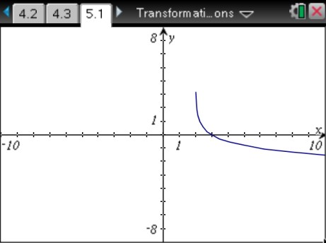(i) (ii)

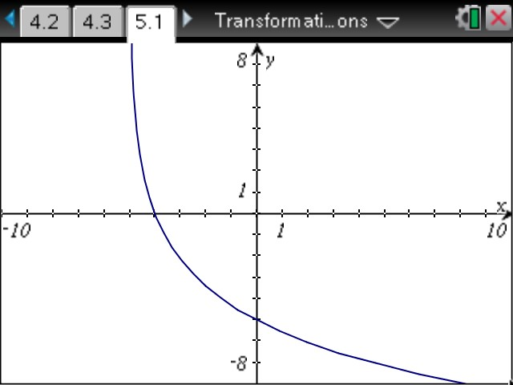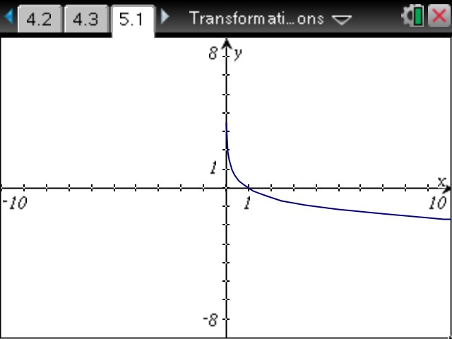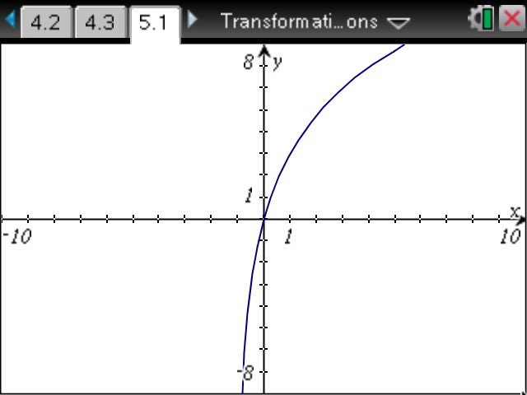

(iii) (iv)

(v) (vi)

**Extensions**

1. Ask students to display the graph of various logarithmic functions and to find the domain. For example, consider $y= \log_{3}{(2-x)}$ and $y= \log_{5}\left(x^{2}\right)$.
2. Ask students to display and compare the graphs of $y=\ln{x}$ and $y=\ln{(-x)}$.
3. Ask students to display the graph of $y= \log_{b}\left(b^{x}\right)$ for various values of *b* and to explain the result.

# Wrap Up

Upon completion of the lesson, the teacher should ensure that students are able to understand:

* How to graph a logarithmic function of the form $f\left(x\right)=c∙\log_{b}{(x+a)}$.
* How to explain the concepts of reflection and translation.