Open the TI-Nspire document Transformers_in_the_Classroom.tns.  In this investigation, you will trace around an object creating a set of coordinates that represent the given shape. You then will manipulate the lists so that you can transform the shape in several different ways. | 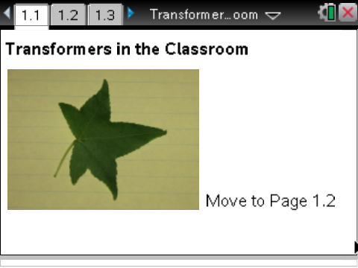

Move to page 1.3. | Press / ¢ and / ¡ to navigate through the lesson.
1. On this page, you will use the buttons at the top of the page to Reset the drawing tool and to turn it on.
- On your first try, you can just grab the point (with / a), and then move it to the start of your tracing.
- Once you have the point at one of the corners of the object, turn the tool on, and grab the point as before.
- Now carefully and slowly trace all around the object, ending at the point that you started.
- If you mess up the trace, then just press the Reset, reposition the point, turn the tool back on, and grab the point and trace again.
- Using the e will help you move from the buttons to the point to trace.
- After you are finished tracing, move on to the next page.
Move to page 1.4.

2. On this page, you will see the coordinates that represent the outline of the shape. That is, you have digitized it. Examine the points in your spreadsheet.
Move to page 1.5.

3. On this page, you will set up a plot of the shape you digitized.
- Use the Scatter Plot, and select the xlist for x and the ylist for y.
- If this plot does not look close enough to the original, return to the image page, and Reset so you can trace again.

Tech Tip: Use / G to open the Entry Line if it has closed on you. Right-click (/b) to change the Graph Type to Scatter Plot, if this goes away.

Move to pages 1.6 through 1.8.

Now, Transform your figure! We have several options: Dilations, Rotations, Reflections, and Translations.

4. On Page 1.7, create a set of data from your xlist and ylist for the original figure so the figure is dilated.
- To dilate a shape, you will need to change the x and y values by multiplying by a number larger than 1 (to make the shape larger) or a number between 0 and 1 to shrink it.
- In Columns C and D at the top of the column, name these lists with names like bigx and bigy or smallx and smally, depending on how you want to dilate.
- Then move to the formula cell marked by a diamond, and type, for example, =xlist*0.5 into the smallx column and =ylist*0.5 in the smally column (assuming you what to dilate the shape by 50%).
5. Decide what you type of dilation you want and by what factor you want to dilate.

Tech Tip: Make sure you are on the correct row and cell to name the list and to calculate on it. Names go on the very top cell and calculations are placed in the next row (the diamond row).
On page 1.8, we want to look at the plot of both figures, the original and the dilated one. You might need to adjust your Window to see both figures.
6. You will need to set up a new plot on s2 to show your new figure and the original. Make sure you use your new list names as created earlier (smallx, smally).
Tech Tip: Select MENU > Window > Zoom – Data or > Zoom – Out, if you need to adjust even more.

Move to pages 1.9 through 1.11.

7. To reflect your figure, you will need to change the xlist, ylist, or both depending on which axis you want to reflect over. Assemble your plan and how you will carry it out.
8. As you create your new lists in the spreadsheet on Page 1.10, make sure you use unique names and then use the xlist and ylist in your calculation on the diamond line.
9. On Page 1.11, set up two scatter plots: the original shape (xlist,ylist) and the new plot to show the reflection. Recall that you will need to use /G to open the Entry Line if it closes on you, and you will probably need to adjust the Window again.

Move to pages 1.12 through 1.14.

10. On page 1.13, name the new list(s), and calculate what is needed to translate the figure. Make sure you use unique names.
11. Set up the two plots as before on Page 1.14, and adjust the Window as needed.

Move to pages 1.15 and 1.16.

12. Finally, we will rotate the figure. Determine what new lists you will create on Page 1.15, and give them with unique names and create as required for the rotation you want.
13. Set up the two plots as before and adjust the Window as needed.

Move to Problems 2 and 3, repeating the process above.

