Open the TI-Nspire document Getting_A-round_Area.tns.  In this activity, you will develop a rule for finding the area of a circle, the “covering of a shape,” using the circumference of a circle (2πr). | 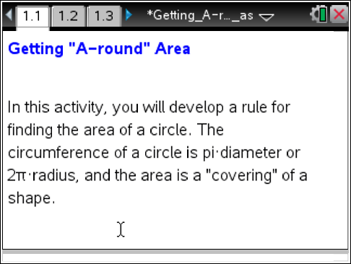

You have probably already found the area of different kinds of polygons (closed shapes with straight sides) by using square tiles. Area is essentially a covering of the “space” inside the polygons measured in square units.
Finding areas of round shapes is a bit more of a challenge, especially when trying to cover the round shape with square tiles. The square tiles just won’t fit “nicely”. In this activity, you’ll try another method to find the area of a circle. You will make the circle into another shape—one that’s easier for calculating area.
You will need to know how to find the circumference (the distance around the outside, the perimeter) of a circle by using the formula 2πr, where r is the radius of the circle.

Move to page 1.2.

- If you were to move the pie-shaped sections of the circle to form another 2-dimensional shape where we could find the area more easily, what might this shape look like? Draw a sketch to show this new shape.

2. On Page 1.2, select any “open” point on a section of the circle, and drag it below the circle to form another shape.
a. After you move all 4 sections, what does the new shape appear to look like? Does it look similar to the shape you suggested in question 1?

b. Where does the circumference of the circle show up in the new shape? Draw a sketch below and show where the circumference appears in the new shape.

c. Using this shape as a reference and its area rule, what might be an area formula for a circle? Explain your thinking.

Move to page 1.3

3. Perhaps only having 4 sections in the circle didn’t allow you to make a very convincing shape. Let’s try using 8 sections and see what happens. Move the 8 sections in this circle by grabbing and dragging to form a shape.
a. What does this shape look like? How does it differ from what was created using the 4 pieces?

b. Using this shape as a reference, what might be an area formula for a circle?

c. How is circumference connected to the area rule?

4. Imagine cutting each of the 8 pieces of the circle in half so there are 16 pie-shaped pieces.
a. If you rearranged those pieces in a similar way as you did above, what shape would you make? How might it differ from the previous ones?

b. How does putting more congruent pie-shaped pieces in the circle change the overall appearance of the shape you make with the re-arranged pieces?

c. Does the area rule you made for the circle change if you put more and more pieces in the circle?

5. How can you use this activity to help explain the area formula for a circle?

