Open the TI-Nspire document Coded_Messages.tns.  People have been passing secret messages since the time of Julius Caesar. This activity focuses on a specific coding of secret messages that utilizes matrix multiplication. | 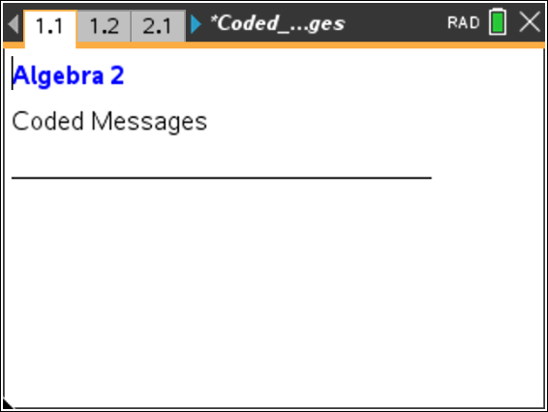

The secret word is represented by a 2 × 2 matrix, where each numeric element represents a letter. The secret word is encrypted by multiplying it by the encryption key, which contains random numeric elements that code the word. Your goal is to decode the secret word using the encryption key. This relationship can be modeled by the following equation:

Your teacher’s coded word is . Your teacher’s encryption key is .

1. The coded word can be decoded by isolating the secret word matrix. What inverse operation solves the equation for the secret word matrix?

2. Calculate the inverse of the encryption key.

3. Obtain your teacher’s secret word matrix by multiplying the coded word matrix by the inverse of the encryption key. For example,
.

Move to page 2.1. |  | Press / ¢ and / ¡ to navigate through the lesson.
4. Turn your teacher’s secret word matrix into an actual word using the decode( ) command. Click inside the parentheses and insert a 2 × 2 matrix template by pressing t and selecting the
2 × 2 matrix template. Enter the secret word matrix and press ·. Write your teacher’s word below. If the word is unreadable, recheck your calculations in questions 2 and 3.

Move to page 1.2.
5. It is now time for you to create your own secret message. First, double-click the “encryption key” matrix and change the current values to four random integers. Then choose a secret word that contains four letters. Click on the empty box in the code(ʺ ʺ) command, type your word, and press ·. The resulting matrix is your coded word matrix. Record your encryption key and coded word matrix below.
a. Your encryption key: Your secret word matrix:

b. Calculate your coded word matrix by multiplying your encryption key by your secret word matrix.

Move to page 2.1.
6. Give your encryption key and coded matrix to a neighbor to decode. Your neighbor will give you an encryption key and a coded word matrix, which you can record below. Your goal is to determine your neighbor’s secret word.
a. Your neighbor’s encryption key: Your neighbor’s coded word matrix:

b. Calculate the inverse of your neighbor’s encryption key.

c. Calculate your neighbor’s secret word matrix by multiplying the coded word matrix by the inverse of the encryption key. For example,
.

d. Turn your neighbor’s secret word matrix into an actual word using the decode( ) command. First, change the encryption key by double-clicking the matrix. Enter your neighbor’s encryption key, which you recorded in question 6a. Then enter the secret word matrix into the decode( ) command. Click inside the parentheses and insert a 2 × 2 matrix by pressing t and selecting the 2 × 2 matrix template. Enter the secret word matrix and press ·. Write your neighbor’s word below.

