Open the TI-Nspire document Parabolas_and_Matrices.tns.  In this activity, you will use matrices and their inverses to solve systems of equations and find equations for parabolas. | 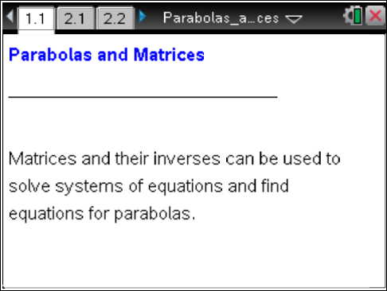

Let’s review how you can use matrices to help you solve systems of equations.
First, write the system as a matrix equation of the form , where A is the coefficient matrix, X is the variable matrix, and B is the constant matrix.
Then, multiply both sides of the equation by the inverse of the coefficient matrix, as shown to the right. (Be careful with the order in which you multiply the matrices!)
Let's try an example.
1. Write this system as a matrix equation. In the 3 X 3 coefficient matrix, enter the coefficients of all three equations. In the 3 X 1 constant matrix, enter the three values of the constants
→ .
2. To solve for x, y, and z, multiply both sides of the equation above by the inverse matrix and simplify. (We will use the functionality of the TI-Nspire to obtain the inverse matrix.)
Fill in the appropriate information below.

Move to page 2.1. | Press / ¢ and / ¡ to navigate through the lesson.
3. On Page 2.1, enter only the expression from the right side of the equation above, and press ·. Press e to move from one entry to the next. In the spaces provided below, copy what you entered on page 2.1 and also fill in the solution matrix.
Move to page 2.2.

4. Check your solutions in the original system of equations. Show your work below.

5. Solve the system below, using an inverse matrix. Use a Calculator application to perform your calculations.
- Press /~ > Add Calculator.
- Select MENU > Matrix & Vector > Create > Matrix, and choose a matrix with 3 rows and 3 columns.
- Enter the data, and press OK or ·. (To move from one entry to the next, press e.)
- Press the right arrow (¢) to move outside the matrix.
- To obtain the inverse matrix, raise this matrix to the -1 power by pressing lv1.
- Insert a multiplication symbol to the right of this inverse matrix.
- Add a new matrix with 3 rows and 1 column. Enter the data and press · to find the product.

a. In the spaces below, fill in the data that you entered into the matrices on your handheld.
b. Fill in your solution matrix in the spaces below.
Move to page 3.1.

6. Explain how you could use an inverse matrix to find the equation of a parabola that passes through the points (–1, 5), (2, –1), and (3, 13).
(Hint: Recall that quadratic equations are of the form To write the equation of the parabola, you must use the three given points to set up a system of equations and solve for a, b, and c.)

7. Use the Calculator application on Page 3.1 to perform your calculations, and then fill in the information below:
- System of equations: | - Matrix equation:
- Solution: | - Equation of parabola:

Move to page 3.2.

8. On this page, press / G to open the function entry line and enter the quadratic equation from Question 7. Check to make sure that the equation passes through all three points. Confirm the solution by substituting the values for a, b, and c into your system of equations and verifying the results.
9. Use an inverse matrix to write the equation of the parabola that passes through the points (-1, 3), (1, –3), (2, 0). Write the equation below, and graph the parabola to check that it passes through the three points. Confirm the solution by substituting the values for a, b, and c into your system of equations and verifying the results.

