Overview

The purpose of this activity is to build a tns document that can be used to investigate reflections and symmetries of curves defined parametrically.

Materials

• TI-Nspire™ handheld or Computer Software

Step 1—Preparing the document  1. Open a new document on the handheld by pressing c > New Document. Open a new document in the Teacher Software by clicking File > New TI-Nspire Document.  2. Select Add Notes.  3. Type Parametric Symmetry.  Note: To obtain capital letters on the handheld, press the g key, then the letter.  4. Save the file as Parametric_Symmetry. | 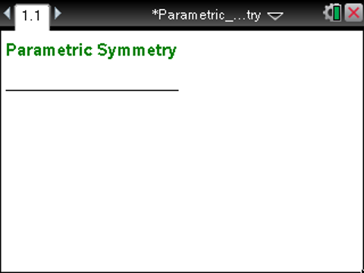
From this point on, directions for the Computer Software and the Handheld will be notated separately where appropriate.  5. Add a new page, and select Add Graphs.  6. Set the document to graph parametric functions by selecting MENU > Graph Entry/Edit > Parametric. | 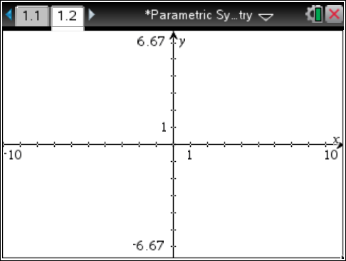
Step 2—Add a Parametric Equation  1. On the function line, type the equations for and an appropriate interval for and a value for tstep. Press · to display the graph. In the example below, , and tstep = 0.13 (the default interval and the default value for tstep). | 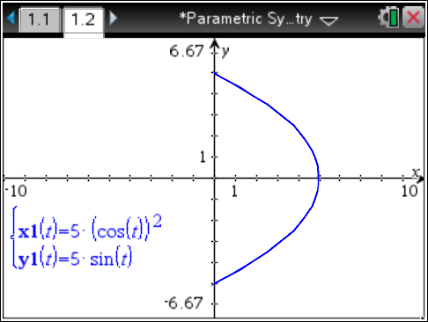
2. If necessary, move or hide the graph label.
- To move the label, hover over it until the hand and the word label appear. Click and drag it to where you would like to place it.
- Handheld: To hide the label, select MENU > Actions > Hide/Show.
- Computer Software: To hide the label, right-click or press Ctrl and click on the label, and select Hide.
Step 3—Add a Reflection  1. Insert a Notes page, and type “Reflect about the y-axis.” | 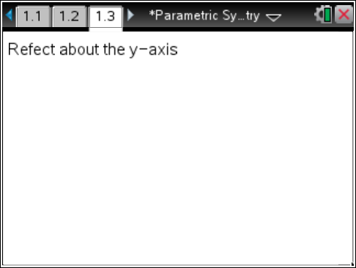
2. Handheld: To copy Page 1.2, switch to Page Sorter view by selecting ~ > View > Page Sorter. Select Page 1.2, ~ > Edit > Copy. Then select Page 1.3, ~ > Edit > Paste.
Computer Software: In the Page Sorter View (left column), click Page 1.2, and select Edit > Copy. Click on Page 1.3, and select Edit > Paste.
3. Select MENU > Graph Entry/Edit > Parametric to set Page 1.4 to parametric graphing.

4. To graph the reflection of the original function about the y-axis, enter the following in the function entry line: for x2(t), type -x1(t); and for y2(t), type y1(t). Press ·.  - Use the up and down arrows to move between the entry lines.  5. Hide the label for the new function. | 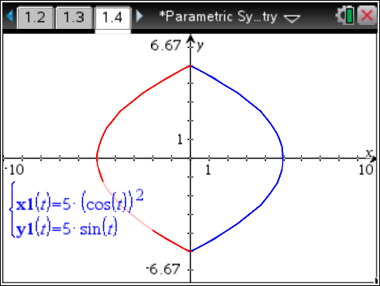
6. Insert a Notes page, and type two lines:  x2(t) = -x1(t)  y2(t) = y1(t)  Note: To bold the letters, highlight them and select MENU > Format > Bold. | 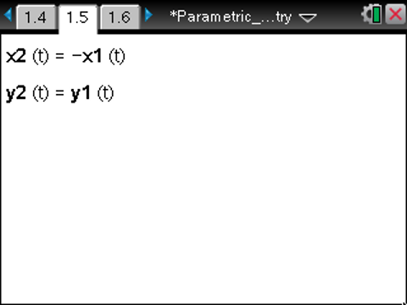
Step 4—Repeat  1. Insert a new problem, add a Notes page, and type “Reflect about the x-axis”. | 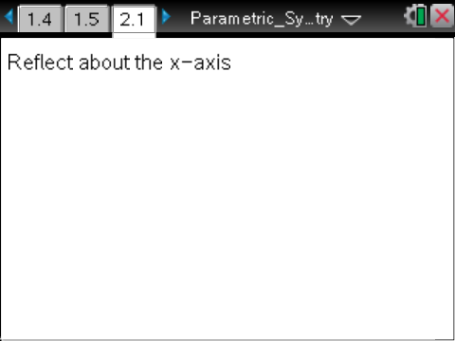
2. Repeat steps 10 and 11 for Page 2.1.  3. Expand the function entry box, and enter the function  - Hide the label for the new function. | 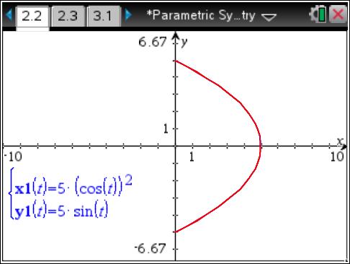
4. Insert a Notes page, and type  x2(t) = x1(t)  y2(t) = -y1(t) | 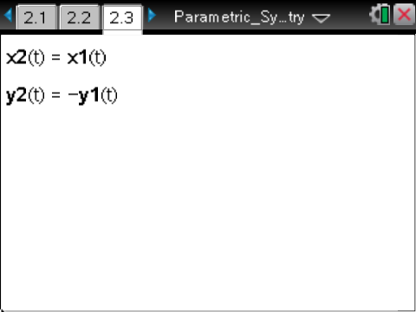
5. Insert a new problem, add a Notes page, and type “Reflect about the origin”. | 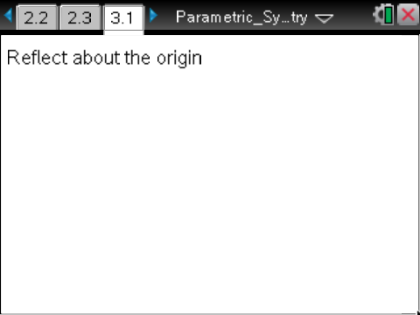
6. Repeat steps 10 and 11 for Page 3.1.  7. Expand the function entry box, and enter the function  - Hide the label for the new function. | 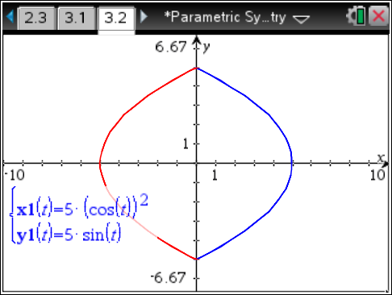
8. Insert a Notes page, and type  x2(t) = -x1(t)  y2(t) = -y1(t) | 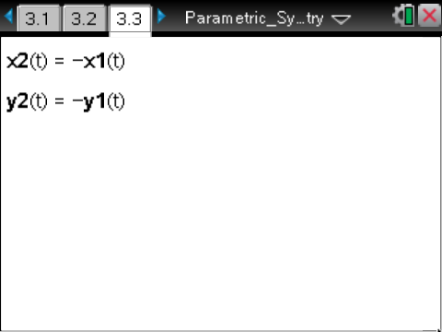
9. Insert a new problem, add a Notes page, and type “Reflect about the line y = x”. | 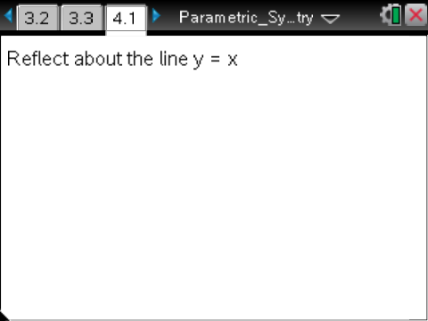
10. Repeat steps 10 and 11 for Page Page 4.1.  11. Expand the function entry box, and enter the function  - Hide the label for the new function. | 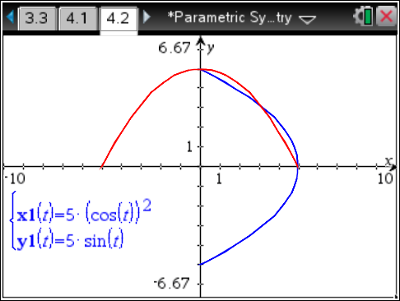
12. Insert a Notes page, and type  x2(t) = y1(t)  y2(t) = x1(t) | 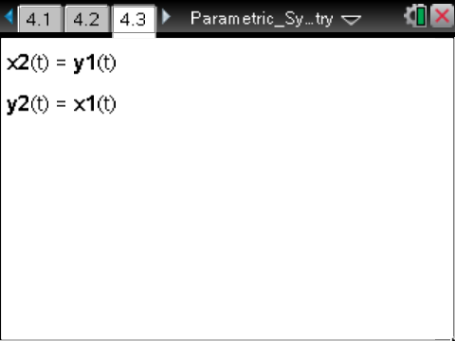
Suggested Uses of the .tns File

1. Students can explore the results of transformations on parametric functions both graphically and symbolically. The .tns design allows students to observe the graphical results of a transformation before viewing the symbolic results, affording opportunities to predict the effects on the symbolic representation of the original function. This could lead to predictions and generalizations of the transformation functions.

2. A teacher could provide students with a parametric curve and a transformed curve and have them attempt to transform the original curve into the second curve using the transformations available in the file.

3. Students can explore inverse relationships using the .tns file. One cannot reflect a non-invertible function over the line y = x using the regular graphing utility, as the reflection would not be a function; therefore, there is not a way to define the reflection explicitly. However, using parametric functions makes it possible to explore the reflection. For example, one could consider the function f(x) = sin x. Parametrically defined, this function is in . One can also define the reflection of this function over the line y = x parametrically: .  This relation can be graphed parametrically, allowing students to view the reflection of the original function. | 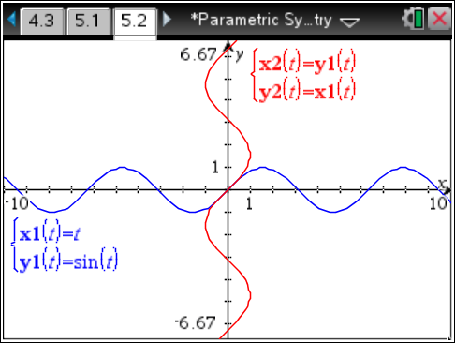
4. Students can use the .tns to observe the result of reflecting a closed curve over the axes, about the origin, or over the line  y = x. For example, the parametrically defined closed curve can be reflected about the axes, the origin, and the line y = x. Then, students can make predictions about and observe the results of the reflections. | 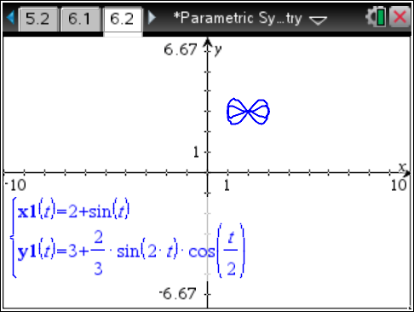
 | 