Open the TI-Nspire™ document Characteristics_of_Exponential_Functions.tns.  How does the graph of f(x) = 2^{x} compare to the graph of f(x) = 5^{x}? What characteristics do they have in common? How are they different? In this activity, you will explore the characteristics of these and other exponential functions. | 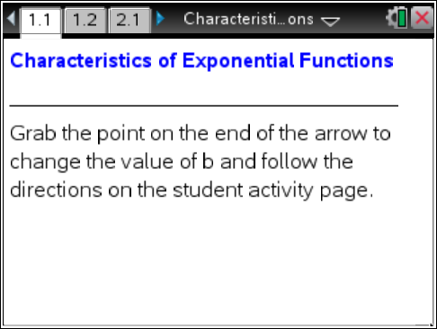

Move to page 1.2.

- a. Describe some characteristics of the graph f(x) = 2^{x}, including the domain and range.

b. Grab and move the point to increase the value of b. What happens to the graph as b increases? Do any of the characteristics you described stay the same? What changes?

- a. Why do the graphs of f(x) = 3^{x} and f(x) = 5^{x} both pass through the point (0, 1)?

b. Would it ever be possible to have a graph of the form f(x) = b^{x} that does not pass through the point (0, 1)? Why or why not?

- Why is the graph of f(x) = b^{x} a horizontal line when b = 1? Justify.

- Predict what will happen to the graph of f(x) = b^{x} when the value of b is between 0 and 1 (0 < b < 1).

Move to page 2.1

- a. Test your prediction from question 4. Describe the characteristics of the graph of f(x) = b^{x} when b is between 0 and 1.

b. Explain any differences between this graph and the graph of f(x) = b^{x} when b is greater than 1.

- a. Eric noticed that the graph of f(x) = b^{x} increases when b is greater than 1 (b > 1), and the graph of f(x) = b^{x} decreases when b is between 0 and 1 (0 < b < 1). How could he mathematically justify this?

b. Cheryl wondered when f(x) = b^{x} would equal 0. Use the TI-Nspire document on your handheld to investigate. What would you say to Cheryl?

- For each function below, sketch the graph. Identify the domain, range, y-intercept, and at least one other point on the graph.

a. f(x) = 10^{x} | b. f(x) = (0.1)^{x} | c. f(x) = (1)^{x}
D: | D: | D:
R: | R: | R:
y-intercept: | y-intercept: | y-intercept:
another point: | another point: | another point:

