Open the TI-Nspire™ document Slope_As_Rate.tns.  The ratio of the vertical change to the horizontal change between any two points on a given line is called the slope of that line. This activity investigates the idea of slope as a rate of change. | 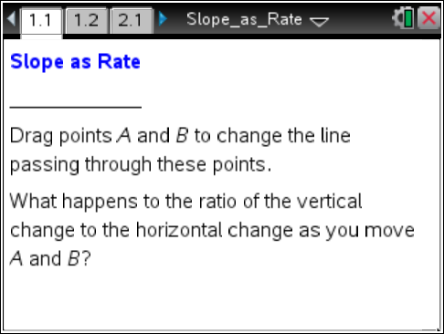

Move to page 1.2.
If a line is not vertical, then its slope tells us the rate of change in the y-coordinate to the change in the
x-coordinate as we move from one point on the line to another point.
1. Move point A on page 1.2 to (–8, –5). Move point B to four different locations that make the slope of the line exactly equal to 0.6.

Coordinates of point B | Vertical Change  (from A to B) | Horizontal Change  (from A to B) | Change in y-coordinate  Change in x-coordinate

2. Make a new line by moving both points A and B so that the slope is equal to -1.5, and the horizontal change in x-coordinates between A and B is 6.
a. What is the vertical change in y-coordinates?

b. Suppose two other points C and D are on the same line. The x-coordinate of C is 100 less than the x-coordinate of point A and the x-coordinate of D is 100 units greater than x-coordinate of point A. What is the difference in the y-coordinates of points C and D?

- Which point has the larger y-coordinate? Explain your reasoning.

Move to page 2.1.
If we are moving from left to right along a line, the slope of that line tells us how much the y-coordinate will change (and in what direction) for every 1-unit increase in x-coordinate.
3. Why does this make sense?

Move to page 2.2.
4. Move point A along this line. Why is the vertical change shown always 0.6?

5. Now try rotating the line to different slope positions.
a. What will be true about the vertical change corresponding to a positive 1-unit horizontal change anywhere along a line of slope m?

b. James has a line where the y-coordinate decreases at a rate of 3 units for every 1 unit increase in x-coordinate. He believes the slope of the graph is –1/3. Is he correct? Explain why he is correct or where his thinking was incorrect.

- Miriam has a line where the y-coordinate decreases at a rate of 2 units for every 1-unit increase in x-coordinate. She is trying to decide whether the slope is 2 or –2. Sketch a graph to convince Miriam which slope is correct.

- Sal has a line where all the y-coordinates are the same. He says that the slope of the line is 0. Jay says the slope of the line is undefined. With whom do you agree, and why?

- Ronah is looking at a graph of a line where the x-axis represents time in hours and the y-axis represents distance in miles. In what units would the slope of the line be measured? Draw a graph at which Ronah could be looking and explain the context of the situation.

- The graph below shows Retha's distance traveled in miles for the first part of her trip. At what rate is she traveling?

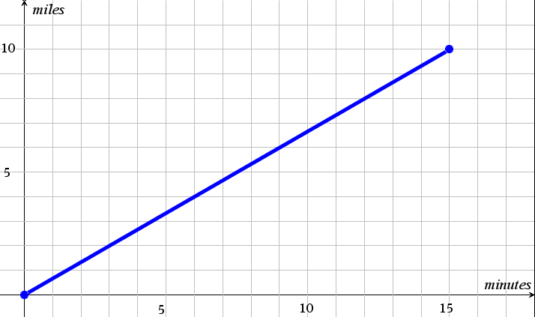

Move to page 3.1.
Two slope triangles have been created on the given line.
6. Complete the table for the given coordinates of A, B, C, and D.

Change in y-coordinates
Change in x-coordinates
A (–12, –3) | B (–8, –2)
C (–4, –1) | D (12, 3)

7. a. What do you notice about the slope of the line that contains points A and B?

b. The line that contains points A and B also contains points C and D. What happens when you calculate the slope of the line using points C and D?

8. a. What do you expect will happen to the ratio of the vertical change to the horizontal change in the first slope triangle if you move A to a new location?

b. Move A to a new location. What is the ratio of the vertical change to the horizontal change?-

9. What relationship do the slope triangles have to each other?

10. A line has a slope of 4. One of the points on the line is (2, 5). Name another point that lies on the line and show how you determined the coordinates of the second point.

11. What is the slope of the line that contains the points (–1, –3), (2, 3), and (3, 5)?

12. A line has a slope of 2. Name two points that lie on the line and show how you determined the coordinates of the points.

