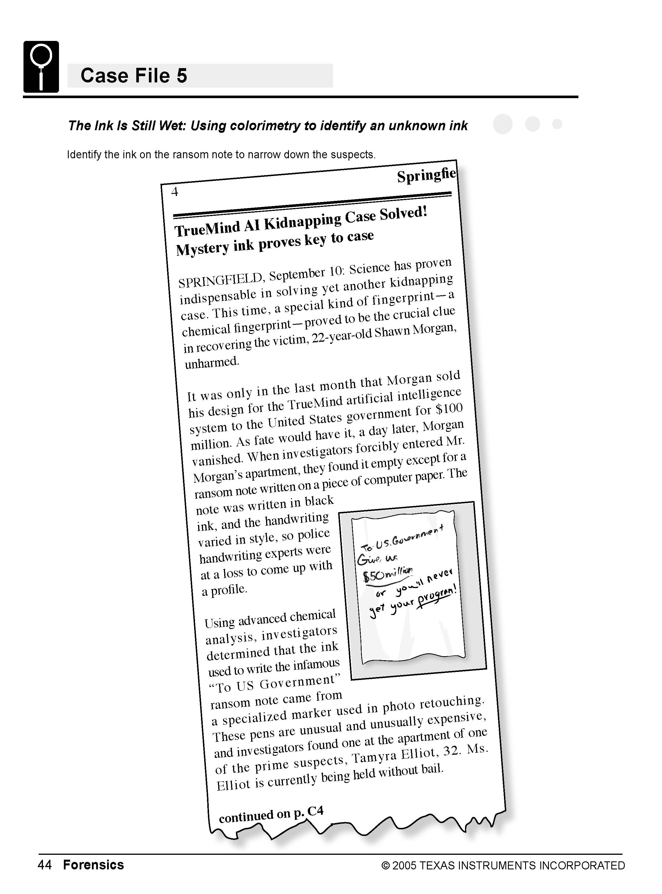

Science Objectives
- Identify an unknown ink by its light absorbance characteristics.
- Measure a solution’s absorbance of different colors (wavelengths) of light.

Activity Materials
- TI-NspireTM technology  - Case 5 The Ink is Still Wet.tns file  - Vernier EasyLink™ or TI-Nspire Lab Cradle  - Vernier Colorimeter  - colored wax pencil  - distilled water | - lint-free tissues  - 6 cuvettes  - 5 dropper bottles, with 10 mL samples of different diluted black inks  - 1 dropper bottle, with 10 mL of diluted unknown black ink
Procedure
Open the TI-Nspire document Case 5 The Ink is Still Wet.tns.  In this data-gathering activity, you will identify an unknown ink by its light absorbance characteristics, measure a solution’s absorbance of different colors (wavelengths) of light, and then use that information to identify the kidnapper. |  | 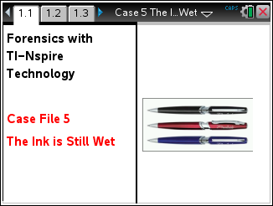
Part 1 – Preparing for Analysis
Move to pages 1.2–1.6.
CAUTION: Obtain and wear goggles during this experiment. Be careful not to ingest any solution or spill any on your skin. Inform your teacher immediately in the event of an accident.
Remember the following:
- All cuvettes should be clean and dry on the outside.
- Handle a cuvette only by the top edge or ribbed sides, not the transparent sides.
- All solutions should be free of bubbles.
- Label the lid of the cuvette so the label does not interfere with the beam of light.
1. Prepare the blank, each of the five standards, and the unknown for analysis. Your teacher will have prepared the solutions for you.
- Rinse an empty cuvette twice with about 1 mL of distilled water.
- Use the colored wax pencil to write a zero on the lid of the cuvette.
- Fill the cuvette 3/4 full with distilled water. Seal the cuvette with the lid. Dry the outside of the cuvette with a tissue.
- Repeat Steps 1a–1c, using the five standard solutions provided by your teacher and the unknown, rather than distilled water, and labeling the lids of the cuvettes appropriately (1 through 5 for the standard solutions and 6 for the unknown).
2. On page 1.5, connect the Colorimeter to the TI-Nspire using the Vernier EasyLink or Lab Cradle
3. Calibrate the Colorimeter.
- Open the Colorimeter lid. Place the blank (cuvette 0, containing distilled water) in the cuvette slot of the Colorimeter. Make sure that one of the transparent faces of the cuvette is pointing toward the white reference mark. Close the lid of the Colorimeter.
- Press the < or > button on the Colorimeter to select a wavelength of 635 nm (Red).
- Press the CAL button until the red LED begins to flash. Then release the CAL button. When the LED stops flashing, the calibration is complete.
Part 2 – Collecting Data
Move to page 1.7-1.10  4. You are now ready to collect absorbance data at 635 nm for the solutions.  - Start data collection on page 1.5 by pressing the button.  - Place cuvette 1 in the Colorimeter. Make sure the cuvette is clean, dry, and has a transparent face pointing toward the reference mark. |  |  | 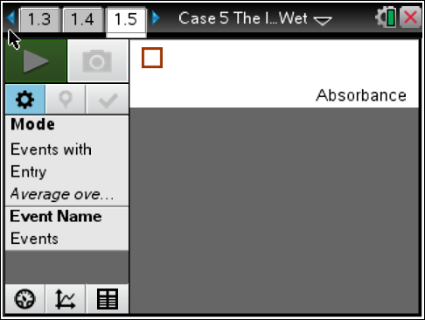
- After closing the lid, wait for the absorbance value displayed on the monitor to stabilize, then using your cursor move to the keep icon and click on it.
- Enter the sample number (from the lid) and select OK.
- Remove the cuvette from the Colorimeter.
- Repeat Steps 4b–4e for the remaining samples in cuvettes 2 through 6, which includes the five known solutions and the crime scene sample.
5. Stop data collection by clicking when you have collected data for all the samples.

Part 3 – Analyzing the Data
Move to page 2.1-3.5
6. In your Evidence Record on this worksheet and/or on page 2.1 in the .tns file (as directed by your teacher), record the absorbance values displayed in the data table from page 1.5. On page 1.5, also store your run by clicking  button. You should see run 1 should change to run 2.
7. Measure the absorbance of each solution at the three other wavelengths (or colors) that the Colorimeter can measure.
- Repeat Steps 4–7 for the 565 nm (green) wavelength setting on the Colorimeter.
- Repeat Steps 4–7 for the 470 nm (blue) wavelength setting on the Colorimeter.
- Repeat Steps 4–7 for the 430 nm (violet) wavelength setting on the Colorimeter.
8. Discard the solutions as directed by your teacher.

Evidence Record
Sample | Type of Ink; Appearance in Alcohol | Absorbance at 635 nm | Absorbance at 565 nm | Absorbance at 470 nm | Absorbance at 430 nm
1
2
3
4
5
6 | Unknown

Unknown is most likely ________________________________

Case Analysis
Answer the following questions here, in the .tns file, or both.
Q1. How did you identify the unknown?

Q2. Why did the inks show different absorbance patterns if they all appeared to be the same color?

Q3. Do you think you would have seen the same large variations in absorbance if all the samples had been red ink or all the samples had been blue ink instead of black? Why or why not?

