Open the TI-Nspire document Exploring_Area_of_Irregular_Polygons.

How can figures such as rectangles, parallelograms, and triangles help us find the areas of irregular polygons? This activity will let you use these three basic shapes to explore this idea.

Move to page 1.2.
On the next pages there are figures that can be used to “build” irregular polygons.
Guidelines:
- A copy of each figure at the top can be moved by grabbing the closed circles.
- Each figure can be rotated by grabbing the X.
- It is easier to reposition the figures if you do not overlap the closed circles from different figures.

1. What is the fewest number of figures needed to exactly cover the outlined polygon?

2. Can the outlined polygon be exactly covered using some combination of the rectangle and triangle figures? Make a sketch to support your answer.

3. Can the outlined polygon be exactly covered using one rectangle, one triangle, and one parallelogram figure from the top? Make a sketch to support your answer.

4. Jamal says that the outlined polygon can be built using only one kind of figure many times. Do you agree or disagree? Why or why not?

5. If the area of the rectangle is 8 square units, then what is the area of the:

a. parallelogram?

b. triangle?

c. outlined polygon?

Move to page 1.3.
6. Using each type of shape at least once, move shapes to exactly cover the outlined polygon. Make a sketch of the screen.

Move to page 1.4.
For Questions 7–9, use the scale that is shown on page 1.4.

7. Move the figures to “build” a polygon that has an area of 20 square centimeters. Make a sketch of
your polygon.

8. Mark said he can use the given figures to build a polygon with an area of 15 square centimeters. Maribel disagrees with him. Who is correct and why?

9. Move the figures to “build” a polygon that has an area of 6 square centimeters. Make a sketch of your polygon.

Move to page 1.5.
Guidelines:
- A copy of each figure at the top can be moved by grabbing the closed circle.
- Use the open circles to change the dimensions of the figure.

10. Use the figures at the top to exactly cover the outlined polygon shown on the screen. You may change the dimensions of the figures you use. Make a sketch of your screen.

11. How can polygons such as rectangles, parallelograms, and triangles be used to help determine the area of irregular polygons? Use the figure at the right to help illustrate your answer. | 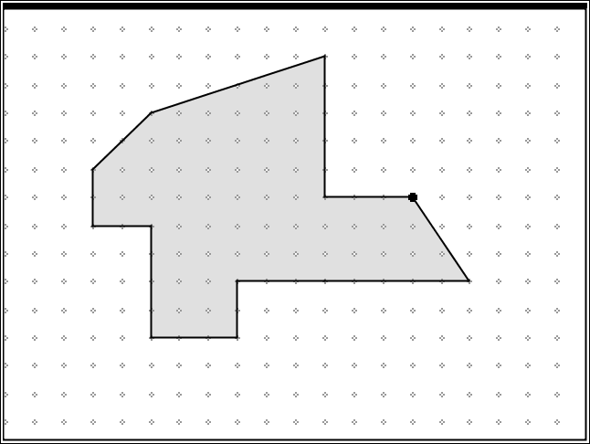
Move to page 1.6 & 1.7.
12. Determine the area of the surface of the deck that surrounds the pool, showing your work below.
a. b.
