Open the TI-Nspire document Angles_for_a_Solution.tns.  In this investigation, you will explore the nature and needs of supplementary, complementary, vertical, and adjacent angles. | 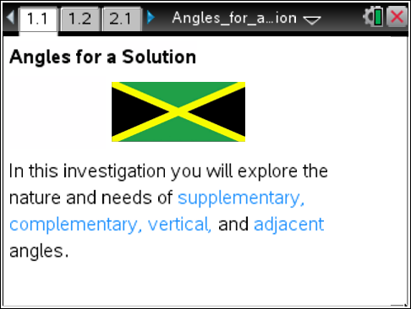

The power of knowing the rules and definitions of mathematics is, in part, to reduce one’s workload. For example, in a figure with several angles, you need not measure all of the angles to “know” the system. If you collect a few strategic measures, you can apply facts about supplementary, complementary, vertical, and adjacent angles to determine the remaining measures in the system.

Move to page 1.2.

On the following pages, find the measures of the missing angles. Be sure to explain your rationale for determining the missing angles using the fact(s) for these angles. Also, show the mathematical steps used to determine the angle measures.
Place your work on a new page on your handheld (press / I ) or on paper as you feel appropriate.

Tech Tip: To add a new Calculator page, press  and select Calculator.

Move to page 2.1.

1. Given the measures of angles (m∠) DEC = 56° and DEB = 124°, find the m∠AEB and m∠AEC.

Move to page 3.1.

2. Given the measures of angles BAH and FAE, determine the m∠HAF, m∠EAD, m∠DAC, and m∠CAB.

Move to page 4.1.

3. Given the measures of angles EGF and DGC, determine the m∠EGC, m∠EGD, m∠CGB, m∠BGA, m∠AGF, and m∠AGD.

Move to pages 4.2 through 4.9.

4. On each page, type your measures in the space below each question.

Move to page 5.1.

5. Given three angle measures, determine the measures of the remaining angles. Don’t forget to explain which fact(s) allowed you to determine each measure.

Page 6.1. (Optional)

6. Wait for teacher instruction if this page is assigned.

