Open the TI-Nspire document Circuit Construction Kit.tns.
In this simulation you will build various electrical circuits, while measuring the amount of current and voltage. You will also learn about series and parallel circuits.

Read the information on page 1.1
Move to page 1.2.
Step 1: Place six wire segments as shown. Select Wire and then move the wire to the desired location. |  | 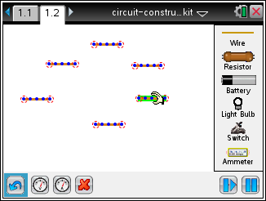
Step 2: Arrange the wires as shown, connecting the four corners. You will need to lengthen some wires. To do this, select the endpoint of the wire until it is highlighted in green, then drag it to the desired length. |  | 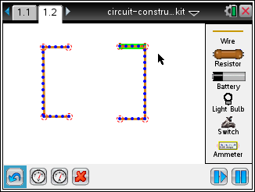
Step 3: Now place a resistor in the top opening and a battery in the bottom opening, as shown. Make sure the resistor and battery snap into wires  Select the Play button . |  | 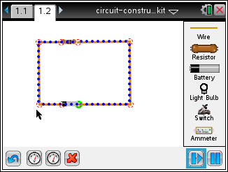
Tech Tip: Use to undo a move or delete a circuit element. For example, if you accidentally connect two wires, you can undo the connection. Select the red circle connecting the wires and select . To delete a wire segment, select the middle of a segment until the wire is highlighted in green. Then select .
Q1. Describe what happens.

Part 1: Exploring Electric Circuits
This circuit diagram shows three key components of a circuit: (1) a closed loop of wire, where electric current flows, (2) a battery, which is the source of the electric current, and (3) a resistor, which affects the amount of current in the circuit. |  | 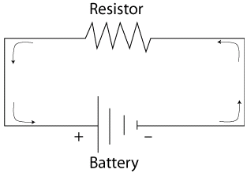
The amount of current flowing through the circuit is denoted by I; the amount of resistance R; and the amount of force pushing current through the circuit is denoted by V, the voltage. |  | 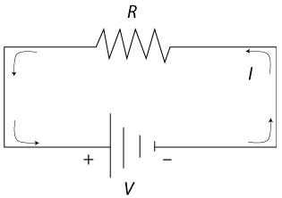
- Measure the current and voltage in this circuit by selecting one of the buttons. The one on the left is for voltage and the one on the right is for current.  To measure voltage, place the two leads for voltage on top of the connections on either side of the resistor. Center the lead circles over the red connection circles in such a way that the readout is positive. To measure current, place the single lead over the circuit. Voltage is measured in volts and current is measured in amperes. |  | 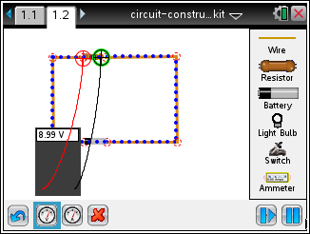
Current will continue flowing through the circuit, unless the connection between any of the wires is interrupted.  In fact, you don’t always want current flowing through a circuit. For that reason, a switch is another important component of a circuit. When the switch is closed, the current flows; when the switch is open, the current stops flowing. |  | 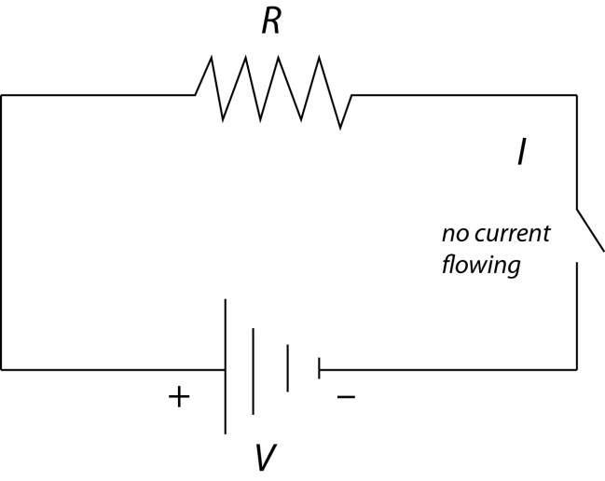
- Add a switch to the circuit. Highlight one of the points connecting two pieces of wire and select to disconnect the wires. Bring a switch onscreen and connect it to the circuit. By default the switch is open. Select the circle next to “Closed” to close the circuit.  (Open Circuit Icon) (Closed Circuit Icon) |  | 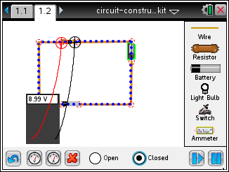
 | Tech Tip: To disconnect two wires, select the red circle connecting the wires and select . After the switch is inserted into the circuit, select the switch to bring up the buttons to open or close it.
Q2. How can you tell that the circuit is open or closed other than the change in the icon?

The units of measurement for R are Ohms, and recall that the units for V are Volts and I are Amperes.  In fact, the relationship among the three variables is summarized in this formula: |  | 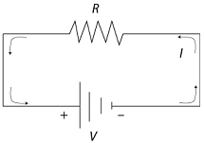
Q3. Calculate the resistance in the circuit.

Part 2: Creating a Series Circuit
One of the most common uses for an electric circuit is to power an electrical device. And one of the most common electrical devices is a light. In this circuit a light is connected. This light has its own resistance (R) and its own voltage (V) and has current (I) flowing through it. |  | 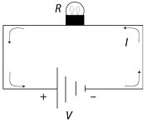
- Replace the resistor with a light bulb. Select the resistor and select to remove it. Select the light bulb button and place it in the open space. Grab and drag the wires from either side and connect to one the end of the light bulb. Then select the switch. Select the open circle next to “Open” or “Closed” to turn the switch on and off. |  | 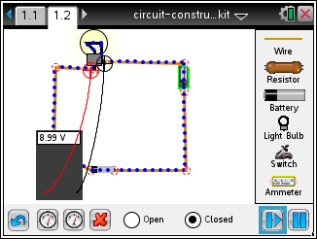
Tech Tip: You may need to move the leads of the voltmeter away from the circuit in order to connect the light bulb to the wires.
Q4. Describe what happens when you turn the switch on and off.

Q5. How much current is flowing through the bulb? What is the voltage?

Q6. Calculate the resistance.

- Now connect a second bulb next to the first one. You’ll need to add another piece of wire. Try to get your screen to look like this.. |  | 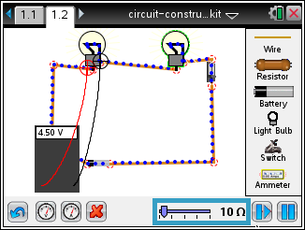
This is an example of a series circuit. Adding two bulbs doubles the resistance. However, the voltage across the two resistors is the same. This is summarized in this formula. |  | 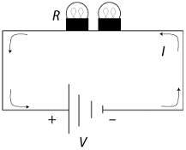
Q7. Use the previous values for voltage and the calculated value for resistance to calculate the current.

Q8. Run the simulation to check the calculated value for the current.

Q9. Suppose the circuit now had 10 bulbs. What would be the current?

Q10. What happens to the current the more electrical devices are added to a series circuit?

Part 3: Creating a Parallel Circuit
Another way to arrange the two bulbs is in what is called a parallel circuit. In this arrangement the current is split into two currents, I₁ and I₂.  This leads to this formula: |  | 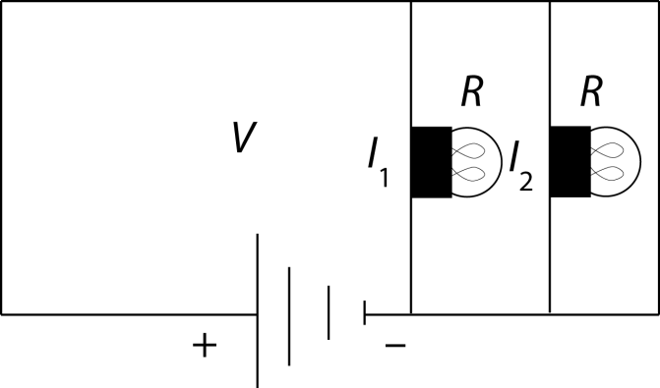
- Create the following parallel circuit. For simplicity, select the Reset button to start from scratch. |  | 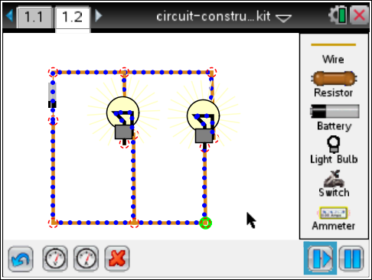
Q11. Use the previous values for voltage and the calculated value for resistance to calculate the separate currents I₁ and I₂.

Q12. Run the simulation to check the calculated values for the currents.

- Now add two switches to each part of the circuit with a bulb, as shown here. Make sure all switches are open. |  | 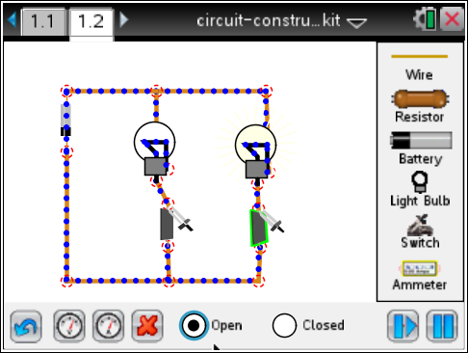
Q13. What happens when all switches are closed?

Q14. What happens when one of the switches next to a bulb is off? How is this different from the series circuit?

