Open the TI-Nspire document MVT_for_Derivatives.tns.  The Mean Value Theorem states: If f is continuous on the interval  [a, b] and differentiable on the open interval (a, b), then there must exist at least one number c in the interval (a, b) such that . In this activity, you will explore a visual representation of the theorem and consider some of its applications. | 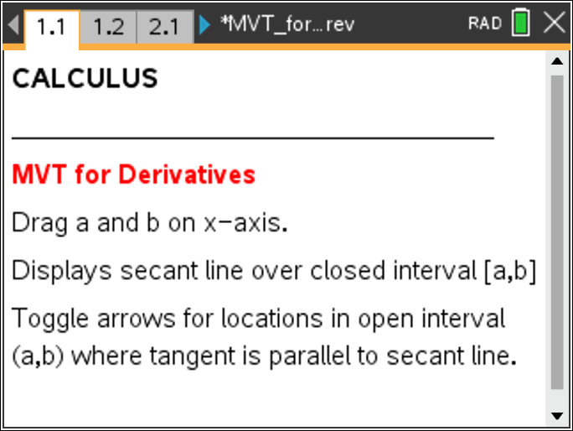

Move to page 1.2.

1. The screen displays a graph of the function f with a secant line drawn on the closed interval [a, b]. Drag the point a and/or the point b along the x-axis to change the interval and note changes in the secant line.
- The slope of the secant line is displayed as m. Determine the slope of the secant line on the interval (you may want to add a calculator page for your calculations).
[–3, 2] _______________ [–1, 3] ________________

- This slope can be interpreted as the average rate of change of the function values f over the interval [a, b]. Explain how this is related to the conclusion of the Mean Value Theorem as written above.

2. Press the up arrow to see locations in the open interval (a, b) where the tangent line is parallel to the secant line displayed for the interval [a, b].
- What does the slope of the tangent line represent?

- Continue dragging the point a and/or the point b to explore different intervals. Is it always possible to find at least one point where the tangent line is parallel to the secant line?

- Explain how this is related to the conclusion of the Mean Value Theorem as written above.

Move to page 2.1.
3. Drag the point a and/or the point b to change intervals for this continuous and differentiable function. Press the up arrow to see locations in the open interval (a, b) where the tangent line is parallel to the secant line.
- Can you find an interval [a, b] where there is more than one value in (a, b) such that the instantaneous rate of change is equal to the average rate of change?
If so, give an example.

b. Can you find an interval [a, b] where there are no points in (a, b) such that the instantaneous rate of change is equal to the average rate of change?
If so, give an example.

4. Cal says that according to the Mean Value Theorem, it is not possible to find a polynomial function such that:, , and for all x in the interval [0, 2].
Explain how Cal might support his argument both numerically and graphically.

Move to page 3.1.

5. Press the up arrow to display locations in the open interval (a, b) where the tangent line is parallel to the secant line for this new function.
  - Move a and b to display a secant line for the interval [–5, –3]. Is there a tangent line shown?

  - Explain what this result means in terms of rates of change.

  - Is this a violation of the Mean Value Theorem? Explain why or why not.

  - Drag points a and b to display each of the intervals and complete the table below:
Interval | Does a parallel tangent line exist? | Is the function differentiable on the open interval?
[-3, 0]
[-3, 2]
[-1, 2]

e. Explain what these results tell you about applying the Mean Value Theorem.

