Open the TI-Nspire document Internal_Energy_and_Work.tns.  The change in total energy of a system is equal to the heat applied to the system minus the work done. You are going to look at work and determine the definition of work in this activity. In one complete cycle, an engine returns back to the state from which it started. But not all the energy added to the engine in each cycle is converted into work. What happens to the remaining energy? | 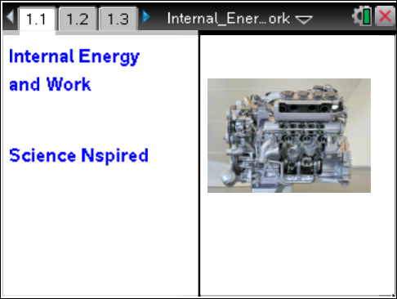

Explore the relationship between work and the volume of the cylinder at constant pressure. How do these compare? | Press / ¢ and / ¡ to navigate through the lesson.
Move to pages 1.2 and 1.3.  1. Read the explanation of the simulation on page 1.2, and then begin the simulation on page 1.3. Click on the play button in the top right hand corner and observe the variables on the screen. Think about what the graph is showing on the right window. To get a clean set of data, press the down arrow on the reset. | 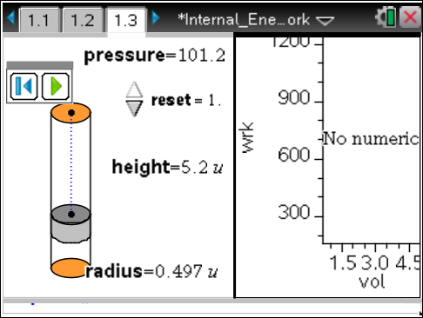
Move to page 1.4. Answer the following question here or in the .tns file.
Q1. Examine the diagram. What is the relationship between the change in height and the work done on the piston?

Move to page 1.5.
2. Next, determine the effect of the radius on the simulation. Move back to simulation, grab the top circle of the cylinder, and change the radius by dragging it. Then reanimate and determine the best fit line for work and height. Compare the slopes of each equation generated. Click on the pause button to stop the simulation before moving ahead.
Move to page 1.6. Answer the following question here or in the .tns file.
Q2. Does the radius of the cylinder affect how much work is done on the piston?

Move to page 1.7.  3. Plot work vs. volume. To find the volume of a cylinder, calculate the area of the base (or piston) and multiply this number times the height of cylinder. | 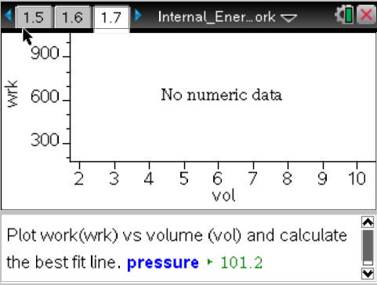
Move to pages 1.8–1.10. Answer the following questions here or in the .tns file.
Q3. What does the slope represent in the linear equation generated for work vs. volume?

Q4. How does the slope compare to the pressure of the system? Test your hypothesis.

Q5. Write the linear equation generated for work vs. volume in terms of W (work), V (volume), and
P (pressure).

Move to page 2.1.  The work done to compress the gas is calculated by multiplying the pressure times the change in volume.  W = P × ΔV  To calculate volume of a cylinder, find the area of the circle (π × r²) times the height (h) of the cylinder.  V = π × r² × h | 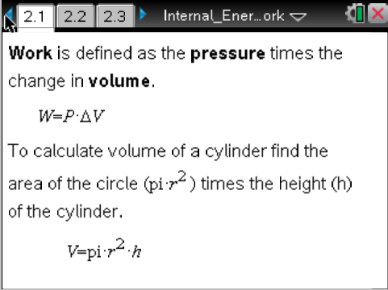
Move to pages 2.2 and 2.3. Answer the following questions here or in the .tns file.
Q6. A cylinder at a pressure of 101.2 kPa with a volume of 0.500 m³ is increased in volume to 3.00 m³. The pressure remains constant. How much work must be done on the system?

Q7. A cylinder with a radius of 1.00 m has a change in piston height of 2.00 m. If the pressure in the cylinder is 200.0 kPa and is kept constant, how much work is done to the system?

Move to page 2.4.  4. Examine the diagram on page 2.4 to see how much work must be done to expand the cylinders. | 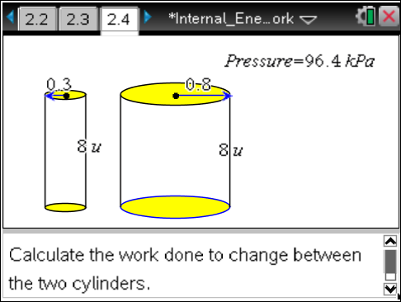
Move to page 2.5. Return to page 2.4 for reference and answer the following question here or in the .tns file.
Q8. How much work is done to expand the cylinders on page 2.4?

Move to page 3.1.  5. The total internal energy (U) of system is described by the heat (Q) of the system and the work (W) done on that system.  The change in internal energy is equal to change in heat minus the change in work. | 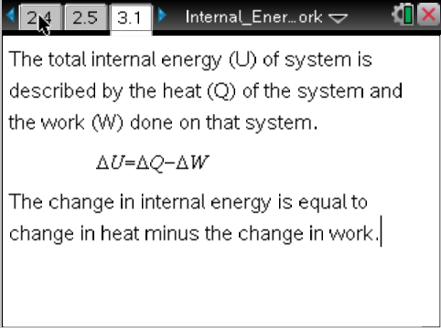
Move to page 3.2. Answer the following question here or in the .tns file.
Q9. Energy in the amount of 2.0 kJ is placed into a system. If a cylinder at 101.2kPa moves a .050m radius cylinder 0.100m, how much heat is released from the system?

