Open the TI-Nspire document Electric_Fields.tns.  How do charges exert forces on each other without touching or having an obvious connection between them? Michael Faraday pondered this question in the early nineteenth century, and his answer led to the concept of the electric field. This concept later became one of the foundational ideas of James Maxwell’s theory of electromagnetism. In this activity you will explore electric fields near one or two point charges. Look for patterns which express the nature of the field near the charges. | 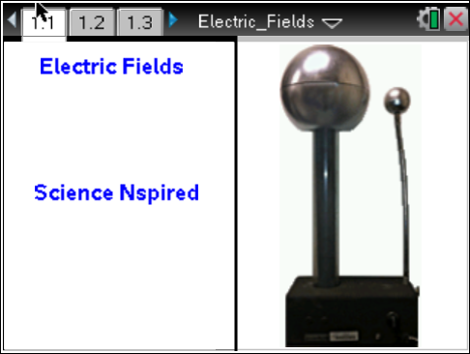

Move to page 1.2.
A charge affects the space surrounding it by causing an electric field. When another charge is in the presence of this electric field, a force acts on it. An electric field is a vector quantity which measures the electric force per unit charge at a location in space. The electric field points in the direction of the force on a positive charge. On the next page you will see a solid circle which represents a charged object. You can change the magnitude and the sign of the charge. A point with an arrow attached to it represents the electric field at its location.
Move to page 1.3.
Read the instructions for the simulation  1. You can drag the point around the screen to explore the pattern of the electric field (the arrow). The distance between the point and the charge and the magnitude of the electric field are displayed on the screen. |  | 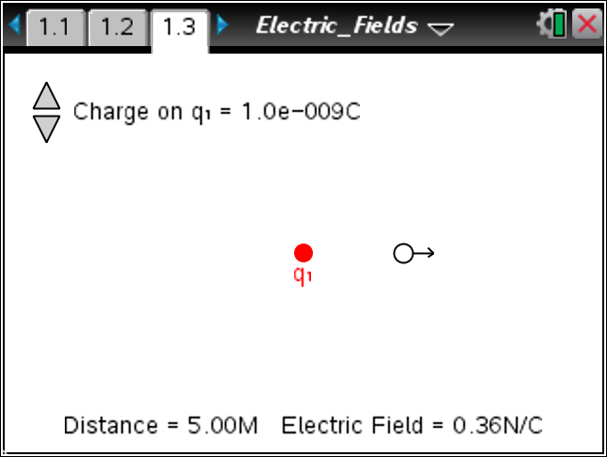
Tech Tip: To access the Directions again, select > Electric Fields > Directions.
Tech Tip: To access the Directions again, select b or Document Tools () > Electric Fields > Directions.
Use the simulation to answer the following questions on the activity sheet.
Q1. Set the charge, q, to +5 nC. Drag the point with the arrow around the screen. Describe the patterns you see in the electric field. In what direction does the field point? How does the magnitude of the field change as the distance between the point and the charge changes?

Q2. Double the magnitude of the charge so that it is +10 nC. What effect does this have on the magnitude of the electric field?

Q3. Move the point so that it is approximately 2.00 m away from the charge, and record the magnitude of the electric field. Now move the point so that it is approximately 4.00 m away, and record the new magnitude of the electric field. By what factor does the electric field change when the distance is doubled?

Q4. Move the point so that it is approximately 6.00 m away from the charge. Record the magnitude of the electric field and compare this to the magnitude when the point is 2.00 m away. By what factor does the electric field change when the distance is tripled? What relationship does this suggest between the magnitude of the electric field and the distance from the charge?

Q5. Change the charge so that it is a negative charge. How does this affect the electric field vector? Move the point around the screen and describe the pattern of the electric field near a negative charge.

Move to pages 1.4 – 1.6. Answer the following questions here or in the .tns file.
Q6. The electric field vector near a single point charge always points __________.
A. directly away from any charge  B. directly toward any charge | C. directly away from a single positive charge and directly toward a single negative charge  D. tangent to a circle surrounding a charge
Q7. The magnitude of the electric field near a single point charge is __________.
A. independent of the magnitude of the charge  B. directly proportional to the magnitude of the charge | C. proportional to the square of the magnitude of the charge  D. inversely proportional to the magnitude of the charge
Q8. The magnitude of the electric field near a single point charge is __________.
A. directly proportional to the distance from the charge  B. directly proportional to the square of the distance from the charge | C. inversely proportional to the distance from the charge  D. inversely proportional to the square of the distance from the charge
Move to page 2.1.
Read the background information about this simulation.
Move to page 2.2.  Read the directions for the simulation.  2. This page simulates the electric field near two positive charges. The field at any point is the vector sum of the contributions from each of the charges. Use the Mark button to place a copy of each vector. Build up a pattern which gives a visual representation of the electric field. |  | 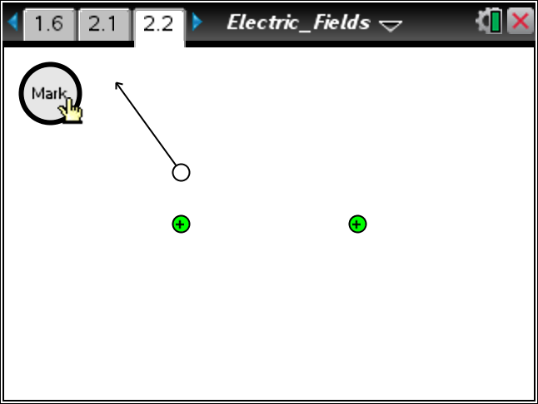
Tech Tip: To clear the electric field, select > Electric Fields > Clear Field.
Tech Tip: To clear the electric field, select b or Document Tools () > Electric Fields > Clear Field.
Use the simulation to answer the following questions.
Q9. Describe the overall pattern you observe of the electric field surrounding the two positive charges.

Q10. Where is the electric field the strongest?

Q11. Where is the electric field the weakest?

Q12. What do you observe when you place the point mid-way between the two charges? How much force would a charge placed at this position experience?

Q13. Imagine a line drawn from the top to the bottom of the screen which passes through the midpoint between the charges. Move the point along this line, and describe the direction of the electric field along it.

Move to page 3.1.
Read the instructions for the next page.
Move to page 3.2.  Read the directions for the simulation.  3. The left charge is positive and the right charge is negative, but they have the same magnitude. Drag the test point and select the Mark button at regular intervals to leave an image of the vector and build up a pattern of the electric field. |  | 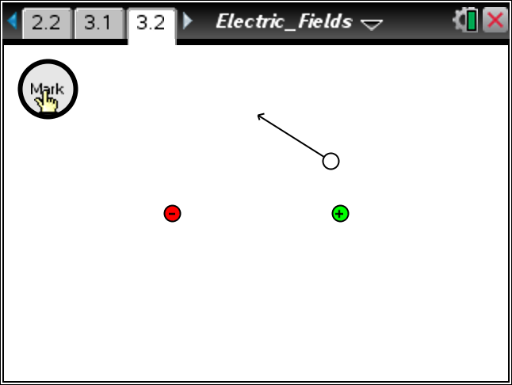
Use the simulation to answer the following questions.
Q14. Describe the overall pattern you observe of the electric field surrounding the two positive charges.

Q15. Where is the electric field the strongest?

Q16. Where is the electric field the weakest?

Q17. Describe the electric field between the charges.

Q18. Imagine a line drawn from the top to the bottom of the screen which passes through the midpoint between the charges. Compare and contrast the field on the left side of this line with the field on the right side of the line?

Q19. Electric field lines are drawn as smooth, continuous curves which begin on positive charges and end on negative charges. The lines never cross one another. The lines are drawn close together where the field is strong and farther apart where it is weaker. Using the patterns you have observed in this activity, sketch the electric field lines near a single positive charge, a single negative charge, two positive charges, and two charges with opposite signs.

